N E W S R E L E A SE

FOR IMMEDIATE RELEASE- May 19, 2023
Zoe Calkins, Communications Director Arkansas Division of Workforce Services zoe.calkins@arkansas.gov

Arkansas’ Unemployment Rate Drops to 2.8% in April
Little Rock, Ark., May 19, 2023- Today, the Arkansas Division of Workforce Services, in conjunction with the Bureau of Labor Statistics, announced Arkansas’ seasonally adjusted unemployment rate declined two-tenths of a percentage point, from 3.0% in March to 2.8% in April. Down to 3.4% in April, the United States’ jobless rate decreased one-tenth of a percentage point over the month.
Arkansas Civilian Labor Force Summary:
- In April, Arkansas’ civilian labor force increased by 2,945. There were 4,831 more employed and 1,886 fewer unemployed in the State, pushing the unemployment rate down to a new record low of 2.8%. Employment has increased for seven consecutive months, with the labor force participation rate increasing to 57.5% in April.
- Compared to April 2022, there are 12,869 more employed Arkansans. The unemployment rate is down three-tenths of a percentage point over the year, while the labor force participation rate remains two- tenths of a percentage point lower than last April.
Arkansas Nonfarm Payroll Job Summary:
- In April, nonfarm payroll jobs increased to 1,360,700, setting a new record high. Jobs in Leisure and Hospitality rose 6,900, mostly in Food Services (+5,500). Jobs in Construction increased 1,900, a typical season expansion. Financial Activities, Professional and Business Services, and Government added 1,100 jobs each.
- Compared to April 2022, nonfarm payroll jobs are up 33,800. The largest increases were in Leisure and Hospitality (+9,100), Trade, Transportation, and Utilities (+6,500), Private Education and Health Services (+5,700), Construction (+5,300), and Manufacturing (+2,300).

Arkansas Civilian Labor Force (Seasonally Adjusted)

 | April 2023 | March 2023 | April 2022 | Change from March 2023 | Change from April 2022
Civilian Labor Force | 1,378,367 | 1,375,422 | 1,369,620 | 2,945 | 8,747
Employment | 1,339,385 | 1,334,554 | 1,326,516 | 4,831 | 12,869
Unemployment | 38,982 | 40,868 | 43,104 | -1,886 | -4,122
Unemployment Rate | 2.8% | 3.0 % | 3.1% | -0.2% | -0.3%
Labor Force Participation Rate | 57.5% | 57.4 % | 57.7% | 0.1% | -0.2%
Source: U.S. Bureau of Labor Statistics, Current Population Survey. More information about the data is available at https://www.bls.gov/cps/definitions.htm

Arkansas Nonfarm Payroll Jobs (Not Seasonally Adjusted, In Thousands)
Industry Sector based on 2022 North American Industry Classification System (NAICS) | April 2023 | March 2023 | April 2022 | Change  from March 2023 | Change  from April 2022
Total Nonfarm Payroll Jobs | 1360.7 | 1349.8 | 1326.9 | 10.9 | 33.8
Goods Producing | 229.5 | 228.1 | 222.1 | 1.4 | 7.4
Mining, Logging, & Construction | 66.4 | 64.5 | 61.3 | 1.9 | 5.1
Mining & Logging | 4.9 | 4.9 | 5.1 | 0.0 | -0.2
Construction | 61.5 | 59.6 | 56.2 | 1.9 | 5.3
Specialty Trade Contractors | 37.8 | 36.6 | 35.6 | 1.2 | 2.2
Manufacturing | 163.1 | 163.6 | 160.8 | -0.5 | 2.3
Durable Goods | 79.6 | 79.8 | 77.9 | -0.2 | 1.7
Nondurable Goods | 83.5 | 83.8 | 82.9 | -0.3 | 0.6
Service Providing | 1131.2 | 1121.7 | 1104.8 | 9.5 | 26.4
Trade, Transportation, & Utilities | 273.4 | 274.7 | 266.9 | -1.3 | 6.5
Wholesale Trade | 54.1 | 53.6 | 50.0 | 0.5 | 4.1
Retail Trade | 142.8 | 144.0 | 143.5 | -1.2 | -0.7
Transportation, Warehousing, & Utilities | 76.5 | 77.1 | 73.4 | -0.6 | 3.1
Information | 12.7 | 12.5 | 12.6 | 0.2 | 0.1
Financial Activities | 70.3 | 69.2 | 70.1 | 1.1 | 0.2
Finance & Insurance | 55.8 | 55.1 | 55.6 | 0.7 | 0.2
Real Estate, Rental, & Leasing | 14.5 | 14.1 | 14.5 | 0.4 | 0.0
Professional & Business Services | 152.9 | 151.8 | 151.7 | 1.1 | 1.2
Professional, Scientific, & Technical | 49.5 | 48.7 | 47.6 | 0.8 | 1.9
Management of Companies | 40.0 | 40.4 | 36.3 | -0.4 | 3.7
Administrative & Support Services | 63.4 | 62.7 | 67.8 | 0.7 | -4.4
Private Education & Health Services | 203.6 | 203.6 | 197.9 | 0.0 | 5.7
Educational Services | 19.2 | 19.2 | 18.2 | 0.0 | 1.0
Health Care & Social Assistance | 184.4 | 184.4 | 179.7 | 0.0 | 4.7
Ambulatory Health Care | 64.7 | 64.1 | 62.1 | 0.6 | 2.6
Social Assistance | 37.3 | 37.4 | 37.1 | -0.1 | 0.2
Leisure & Hospitality | 131.6 | 124.7 | 122.5 | 6.9 | 9.1
Arts, Entertainment, & Recreation | 13.7 | 12.8 | 13.2 | 0.9 | 0.5
Accommodation & Food Services | 117.9 | 111.9 | 109.3 | 6.0 | 8.6
Accommodation Services | 11.8 | 11.3 | 11.1 | 0.5 | 0.7
Food Services | 106.1 | 100.6 | 98.2 | 5.5 | 7.9
Other Services | 73.4 | 73.0 | 71.3 | 0.4 | 2.1
Government | 213.3 | 212.2 | 211.8 | 1.1 | 1.5
Federal Government | 21.0 | 20.9 | 20.5 | 0.1 | 0.5
State Government | 78.6 | 78.2 | 78.6 | 0.4 | 0.0
State Government, Educational Services | 32.4 | 32.0 | 32.2 | 0.4 | 0.2
State Government, Excluding Education | 46.2 | 46.2 | 46.4 | 0.0 | -0.2
Local Government | 113.7 | 113.1 | 112.7 | 0.6 | 1.0
Local Government, Educational Services | 70.2 | 70.1 | 69.7 | 0.1 | 0.5
Local Government, Excluding Education | 43.5 | 43.0 | 43.0 | 0.5 | 0.5
Source: Monthly Survey of Employers, based on 1st Quarter 2022 benchmark. Notes: Current month’s data are preliminary; previous month’s data are revised.

Seasonally Adjusted Unemployment Rates Arkansas vs. United States (3-Year Comparison)
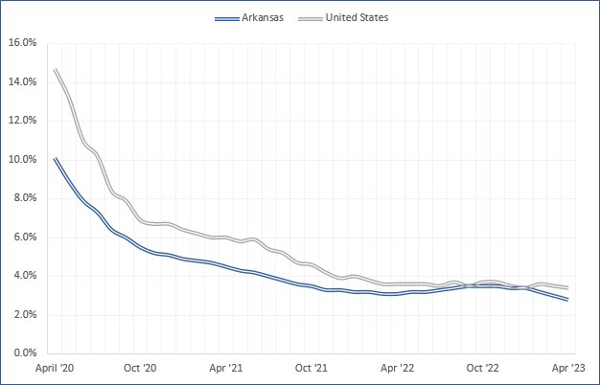

Job Gains/Losses by Major Industry Sectors April 2022 to April 2023 (Not Seasonally Adjusted)
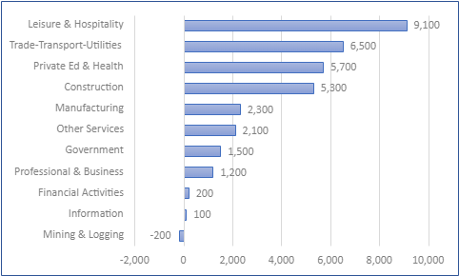

For more labor market data, visit www.discover.arkansas.gov.

About the Arkansas Department of Commerce
The Arkansas Department of Commerce is the umbrella department for workforce and economic development drivers. Its divisions and regulatory boards include Division of Aeronautics, Waterways Commission, Wine Producers Council, Division of Workforce Services, Office of Skills Development, State Bank Department, Insurance Department, Securities Department, Economic Development Commission and Development Finance Authority.
About the Arkansas Division of Workforce Services
The mission of the Arkansas Division of Workforce Services is to support and secure Arkansas' economic vitality through a highly skilled workforce by administering programs and providing services that empower employers and jobseekers. ADWS is a division of the Arkansas Department of Commerce.
www.dws.arkansas.gov | Facebook: facebook.com/arkdws | Twitter: @ArkansasDWS

About Bureau of Labor Statistics (BLS)
The Bureau of Labor Statistics measures labor market activity, working conditions, price changes, and productivity In the U.S. economy to support public and private decision making.

About Local Area Unemployment Statistics (LAUS)
The LAUS program produces monthly and annual employment, unemployment, and labor force data for Census regions and divisions, States, counties, metropolitan areas, and many cities, by place of residence.

About Current Employment Statistics (CES)
The CES program produces detailed industry estimates of employment, hours, and earnings of workers on nonfarm payrolls. CES State and Metro Area produces data for all 50 States, the District of Columbia, Puerto Rico, the Virgin Islands, and about 450 metropolitan areas and divisions.

