


Arkansas
L a b o r M a r k e t Re p o r t

20
18
March

www.discover.arkansas.gov

Table of Contents

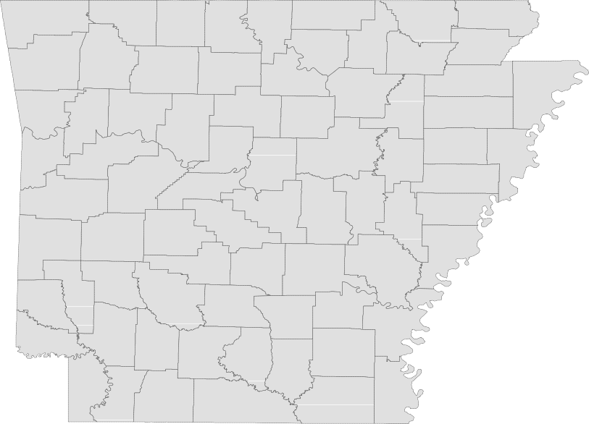

Technical Notes
Monthly Spotlight. 2
Arkansas Labor Force Summary 3
Arkansas Nonfarm Payroll Jobs. 4
Arkansas Production Workers. 6
Metropolitan Statistical Areas. 7
Micropolitan Statistical Areas/Cities. 14
County Labor Force Statistics. 15
Local Workforce Development Areas. 18

The Arkansas Labor Market is prepared monthly in conjunction with the U.S. Depart- ment of Labor, Bureau of Labor Statistics (BLS). The current month’s estimates are preliminary, while previous month’s data is subject to revision.

Estimates of nonfarm payroll jobs show the number of jobs by industry and reflect employment by place of work. Hours and earnings estimates are based on payroll and worker-hour data collected for production workers in manufacturing industries.

Industries are classifi according to the North American Industry Classification System (NAICS). All estimates are based on a first quarter 2017 benchmark.
Explanation of Terms and Concepts Monthly Business Survey of Employers
A monthly sample survey designed to provide industry information on nonfarm payroll jobs. Data are compiled each month from mail surveys and telephone interviews conducted by the Bureau of Labor Statistics in cooperation with Department of Work- force Services. The data are based on es- tablishment records and include all workers, full-or part-time, who received pay during the payroll period which includes the 12th of

the month. Approximately 5,000 Arkansas business establishments are surveyed.
Metropolitan Statistical Area (MSA)

A term applied by the U.S. Office of Man- agement and Budget to counties that have one or more central cities and that meet specifi criteria of population density, com- muting patterns and social and economic integration.
Current Population Survey (CPS)

A monthly sample survey of the popula- tion 16 years of age and over, designed to provide data on the labor force, the employed and the unemployed. The survey is conducted each month by the Bureau of the Census for BLS. The information is collected by trained interviewers from a sample of about 60,000 households. The data collected are based on the activity reported for the calendar week including the 12th of the month. Approximately 800 Arkansas households are represented in the sample survey.
Civilian Labor Force

The sum of all employed and unemployed persons 16 years of age or older. Members of the Armed Forces are excluded.

Employment

An estimate of the number of persons who worked any time for pay or profit or worked 15 hours or more as unpaid workers in a family business during the calendar week which includes the 12th of the month. Also included are those who, although not work- ing, had some job attachment and were not looking for work, and persons involved in labor management disputes.
Unemployment

An estimate of the number of persons who did not have a job, but were available for work and actively seeking work during the calendar week which includes the 12th of the month.
Unemployment Rate

The number of unemployed as a percentage of the civilian labor force. Unemployment rates are calculated from unrounded data.
Seasonal Adjustment

A statistical technique applied to monthly data to eliminate changes that normally oc- cur during the year due to seasonal events such as weather, major holidays, schedule shifts, harvest times, and the opening/clos- ing of schools.

www.discover.arkansas.gov

March Spotlight
Wages in Arkansas
The Quarterly Census of Employment and Wages (QCEW) is the most comprehensive data collection program utilized by the Bureau of Labor Statistics (BLS). The program is based on each state’s Unemploy- ment Insurance (UI) program, which enables BLS to produce data using every business that is covered under UI tax law. In addition to calculating UI covered employment, the program also tracks the wages paid to employees. Due to the extensive nature of the information, data can be produced at any level-- national, statewide, counties, and cities.

The information below comes from the QCEW program and provides annual average wage data for each county in Arkansas. Annual average wages are calculated using the total wages earned during the calendar year, divided by annual average employment. The wages below are compiled using all indus- tries in the private sector, for all workers included under UI tax law. It is important to note that QCEW data is based on county of employment, not county of residency. So if an individual works in a different county than where they live, their wages are counted in the county where they work.

In 2017, average annual wages in the private sector ranged from a high of $58,832, for those employed in Benton County, to a low of $21,988 in Newton County.

Wages in Arkansas by County
2017 Annual Average (Private Sector)

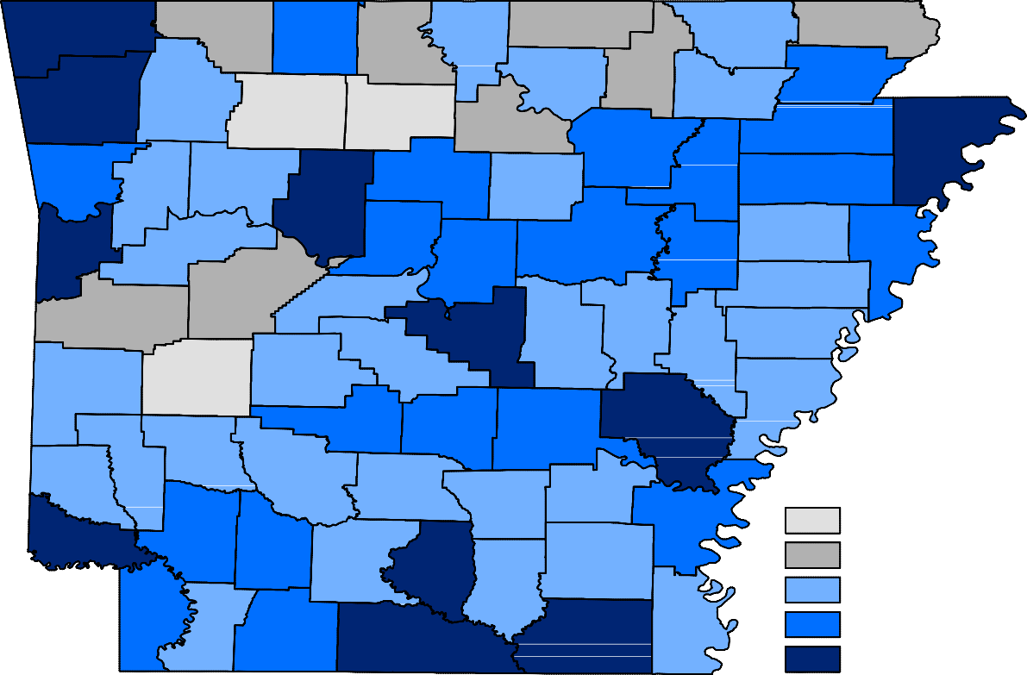
Benton
Carroll
Fulton
Clay
Boone
Randolph
Marion
Baxter
Sharp
Izard
Greene
Madison
Washington
Lawrence
Newton
Searcy
Stone
Craighead
Mississippi
Independence
Crawford
Johnson
Van Buren
Jackson
Franklin
Cleburne
Poinsett
Pope
Conway
Cross
Sebastian
Logan
White
Crittenden
Faulkner
Woodruff
Yell
St. Francis
Perry
Scott
Prairie
PulaskiLonoke
Lee
Saline
Monroe
Montgomery
Garland
Polk
Phillips
Hot Spring
Howard
Grant
Jefferson
Arkansas
Pike
Clark
Sevier
Dallas
Lincoln
Cleveland
Desha
Little RiverHempstead
Nevada
Ouachita
Calhoun
Drew
Bradley
Miller
Columbia
Chicot
Union
Ashley
Lafayette
Annual Average Wages
< $25,000
$25,000 - $30,000
$30,000 - $35,000
$35,000 - $40,000
> $40,000

State of Arkansas
Civilian Labor Force Summary

Labor force data, produced by the U.S. Department of Labor, Bureau of Labor Statistics and released by the Arkansas Department of Workforce Services, show Arkansas’ seasonally adjusted unemployment rate remained unchanged at 3.8 percent between February and March. Arkansas’ civilian labor force de- clined 742, a result of 1,291 fewer employed and 549 more unemployed Arkansans. The United States’ jobless rate remained stable at 4.1 percent in March.

BLS Program Operations Manager Susan Price said, “Arkansas’ unemployment rate remained at 3.8 per- cent in March, mirroring the trend seen at the national level. The State’s jobless rate is currently three- tenths of a percentage point lower than that of the U.S.”

Civilian Labor Force Estimates
Seasonally Adjusted
Not Seasonally Adjusted

Civilian Labor Force | Mar 18  1,353,025 | Feb 18  1,353,767 | Mar 17  1,350,593 | Civilian Labor Force | Mar 18  1,349,290 | Feb 18  1,342,068 | Mar 17  1,347,624
Employment | 1,301,673 | 1,302,964 | 1,301,684 | Employment | 1,296,850 | 1,285,294 | 1,300,205
Unemployment | 51,352 | 50,803 | 48,909 | Unemployment | 52,440 | 56,774 | 47,419
Unemployment Rate | 3.8 | 3.8 | 3.6 | Unemployment Rate | 3.9 | 4.2 | 3.5
U.S. Unemployment | 4.1 | 4.1 | 4.5 | U.S. Unemployment | 4.1 | 4.4 | 4.6

1,350,000
Number of Employed (Seasonally Adjusted)
March: 1998 - 2018

1,300,000

1,250,000

1,200,000

1,150,000

1,100,000

'98 '99 '00 '01 '02 '03 '04 '05 '06 '07 '08 '09 '10 '11 '12 '13 '14 '15 '16 '17 '18

State of Arkansas
Nonfarm Payroll Jobs

Not Seasonally Adjusted
(In Thousands)
(NAICS)
Mar 18
Feb 18
Mar 17
OTM
OT Y

Total Nonfarm | 1243.3 | 1233.6 | 1238.4 | 9.7 | 4.9
Goods Producing | 213.5 | 213.0 | 213.0 | 0.5 | 0.5
Mining, Logging, and Construction | 55.1 | 55.1 | 56.6 | 0.0 | -1.5
Mining & Logging | 5.5 | 5.5 | 5.8 | 0.0 | -0.3
Construction | 49.6 | 49.6 | 50.8 | 0.0 | -1.2
Specialty Trade Contractors | 30.0 | 30.2 | 31.8 | -0.2 | -1.8
Manufacturing | 158.4 | 157.9 | 156.4 | 0.5 | 2.0
Durable Goods | 75.5 | 74.9 | 74.7 | 0.6 | 0.8
Nondurable Goods | 82.9 | 83.0 | 81.7 | -0.1 | 1.2
Service Providing | 1029.8 | 1020.6 | 1025.4 | 9.2 | 4.4
Trade, Transportation & Utilities | 249.7 | 246.8 | 248.7 | 2.9 | 1.0
Wholesale Trade | 46.1 | 45.5 | 46.8 | 0.6 | -0.7
Retail Trade | 139.9 | 138.2 | 139.3 | 1.7 | 0.6
Transport, Warehousing & Utilities | 63.7 | 63.1 | 62.6 | 0.6 | 1.1
Information | 12.2 | 12.3 | 13.4 | -0.1 | -1.2
Financial Activities | 53.4 | 53.1 | 52.8 | 0.3 | 0.6
Finance & Insurance | 40.2 | 39.9 | 39.7 | 0.3 | 0.5
Real Estate & Rental & Leasing | 13.2 | 13.2 | 13.1 | 0.0 | 0.1
Professional & Business Services | 145.7 | 143.8 | 144.8 | 1.9 | 0.9
Professional, Scientific & Technical | 42.9 | 43.1 | 43.6 | -0.2 | -0.7
Management of Companies | 34.8 | 34.7 | 36.0 | 0.1 | -1.2
Administrative & Support Services | 68.0 | 66.0 | 65.2 | 2.0 | 2.8
Educational & Health Services | 189.0 | 188.4 | 187.1 | 0.6 | 1.9
Educational Services | 15.4 | 15.6 | 15.8 | -0.2 | -0.4
Health Care & Social Assistance | 173.6 | 172.8 | 171.3 | 0.8 | 2.3
Ambulatory Health Care | 57.0 | 56.5 | 55.8 | 0.5 | 1.2
Social Assistance | 40.2 | 40.2 | 39.3 | 0.0 | 0.9
Leisure & Hospitality | 116.5 | 113.1 | 115.3 | 3.4 | 1.2
Arts, Entertainment & Recreation | 10.8 | 10.3 | 10.4 | 0.5 | 0.4
Accommodation & Food Services | 105.7 | 102.8 | 104.9 | 2.9 | 0.8
Accommodation Services | 11.2 | 10.8 | 11.3 | 0.4 | -0.1
Food Services | 94.5 | 92.0 | 93.6 | 2.5 | 0.9
Other Services | 47.9 | 48.8 | 48.5 | -0.9 | -0.6
Government | 215.4 | 214.3 | 214.8 | 1.1 | 0.6
Federal Government | 19.5 | 19.5 | 20.0 | 0.0 | -0.5
State Government | 80.1 | 79.5 | 80.2 | 0.6 | -0.1
Local Government | 115.8 | 115.3 | 114.6 | 0.5 | 1.2

State of Arkansas
Nonfarm Payroll Job Summary

Februar y 2018 - March 2018
Nonfarm payroll jobs in Arkansas increased 9,700 in March to total 1,243,300. Seven major industry sec- tors posted gains, with four adding 1,100 or more jobs, each. Employment in leisure and hospitality rose 3,400, a typical seasonal expansion. Trade, transportation, and utilities increased 2,900. Growth occurred in all three subsectors, signaling the start of the spring shopping season. Professional and business services added 1,900 jobs, almost all in administrative and support services (+2,000). Employ- ment in government increased 1,100. Typical spring hiring began in both state (+600) and local (+500) government.

March 2017 - March 2018
Compared to March 2017, Arkansas’ nonfarm payroll employment is up 4,900. Growth was reported in seven major industry sectors, while jobs in four sectors declined. Manufacturing added 2,000 jobs. Hiring occurred in both nondurable (+1,200) and durable (+800) goods manufacturing. Employment in educational and health services rose 1,900. Additions in health care and social assistance (+2,300) more than offset the minor loss in educational services (-400). Notable gains were also posted in lei- sure and hospitality (+1,200) and trade, transportation, and utilities (+1,000). Jobs in construction declined 1,200 over the year, due in part to recent weather events. Employment in information is down 1,200.

84,000

Jobs in Manufacturing (Durable Goods vs. Nondurable Goods)
March 2016 - March 2018

82,000

80,000

78,000

76,000

74,000

72,000
 | Mar '16 | Sep '16 | Mar '17 | Sep '17 | Mar '18
Durable Goods Nondurable Goods

State of Arkansas
Production Workers- Hours and Earnings

Manufacturing

 | Mar 18 | Feb 18 | Mar 17
Average Weekly Hours | 42.1 | 41.3 | 38.7
Average Hourly Earnings | 16.76 | 16.71 | 15.87
Average Weekly Earnings | 705.60 | 690.12 | 614.17

Durable Goods and Nondurable Goods Manufacturing
Durable Goods Manufacturing
Nondurable Goods Manufacturing
Mar 18Feb 18Mar 17
Average Weekly Hours42.340.5
Average Hourly Earnings15.0615.13
Average Weekly Earnings637.04612.77
36.7
14.28
524.08

 | Mar 18 | Feb 18 | Mar 17
Average Weekly Hours | 41.8 | 42.2 | 40.9
Average Hourly Earnings | 18.79 | 18.55 | 17.47
Average Weekly Earnings | 785.42 | 782.81 | 714.52

$16.00
Average Hourly Earnings- Nondurable Goods Manufacturing
March: 2008 - 2018

$15.00

$14.00

$13.00

$12.00

$11.00

$10.00

2008 2009 2010 2011 2012 2013 2014 2015 2016 2017 2018

Metropolitan Statistical Areas
Little Rock-North Little Rock-Conway MSA

The Little Rock-North Little Rock-Conway MSA = Faulkner, Grant, Lonoke, Perry, Pulaski, & Saline counties.

Civilian Labor Force Estimates (Not Seasonally Adjusted)

 | Mar 18 | Feb 18 | Mar 17 | OTM | OT Y
Civilian Labor Force | 355,184 | 352,740 | 352,209 | 2,444 | 2,975
Employment | 342,512 | 339,230 | 341,016 | 3,282 | 1,496
Unemployment | 12,672 | 13,510 | 11,193 | -838 | 1,479
Unemployment Rate | 3.6 | 3.8 | 3.2 | -0.2 | 0.4

Nonfarm Payroll Jobs (Not Seasonally Adjusted)
(In Thousands)

321.3
NAICS  Total Nonfarm | Mar 18  361.1 | Feb 18  358.8 | Mar 17  356.6 | OTM  2.3 | OT Y  4.5
Goods Producing | 37.0 | 37.5 | 37.4 | -0.5 | -0.4
Mining, Logging & Construction | 16.8 | 17.4 | 17.1 | -0.6 | -0.3
Manufacturing  Service Providing | 20.2  324.1 | 20.1 | 20.3 | 0.1 | -0.1
Trade, Transportation & Utilities | 69.5 | 69.2 | 69.3 | 2.8  0.3 | 4.9  0.2
Wholesale Trade | 15.1 | 15.0 | 15.1 | 0.1 | 0.0
Retail Trade | 38.4 | 38.3 | 38.6 | 0.1 | -0.2
Trans., Warehousing & Utilities | 16.0 | 15.9 | 15.6 | 0.1 | 0.4
Information | 5.7 | 5.7 | 6.2 | 0.0 | -0.5
Financial Activities | 21.0 | 21.0 | 21.0 | 0.0 | 0.0
Professional & Business Services | 48.9 | 48.2 | 47.2 | 0.7 | 1.7
Educational & Health Services | 58.0 | 57.4 | 55.8 | 0.6 | 2.2
Leisure & Hospitality | 34.1 | 33.2 | 33.5 | 0.9 | 0.6
Other Services | 15.4 | 15.4 | 15.3 | 0.0 | 0.1
Government | 71.5 | 71.2 | 70.9 | 0.3 | 0.6
Federal Government | 9.4 | 9.4 | 9.5 | 0.0 | -0.1
State Government | 35.6 | 35.5 | 35.3 | 0.1 | 0.3
Local Government | 26.5 | 26.3 | 26.1 | 0.2 | 0.4

319.2

Over-the-Year Job Growth by Industry (Ranked)
March 2017 - March 2018

Educational & Health Services

Professional & Business Services

Leisure & Hospitality

Government

Trade-Transportation-Utilities

Other Services

Financial Activities

Manufacturing

Mining-Logging-Construction

Information

-1,000 -500 0 500 1,000 1,500 2,000 2,500

Metropolitan Statistical Areas
Fayetteville-Springdale-Rogers MSA

The Fayetteville-Springdale-Rogers MSA = Benton, Madison, & Washington counties in Arkansas
and McDonald county in Missouri.

Civilian Labor Force Estimates (Not Seasonally Adjusted)

 | Mar 18 | Feb 18 | Mar 17 | OTM | OT Y
Civilian Labor Force | 274,062 | 273,047 | 270,707 | 1,015 | 3,355
Employment | 266,319 | 264,740 | 263,835 | 1,579 | 2,484
Unemployment | 7,743 | 8,307 | 6,872 | -564 | 871
Unemployment Rate | 2.8 | 3.0 | 2.5 | -0.2 | 0.3

Nonfarm Payroll Jobs (Not Seasonally Adjusted)
(In Thousands)

216.2
NAICS  Total Nonfarm | Mar 18  257.9 | Feb 18  257.1 | Mar 17  252.7 | OTM  0.8 | OT Y  5.2
Goods Producing | 40.9 | 40.9 | 39.0 | 0.0 | 1.9
Mining, Logging & Construction | 11.6 | 11.5 | 10.9 | 0.1 | 0.7
Manufacturing  Service Providing | 29.3  217.0 | 29.4 | 28.1 | -0.1 | 1.2
Trade, Transportation & Utilities | 55.9 | 55.9 | 56.1 | 0.8  0.0 | 3.3  -0.2
Wholesale Trade | 13.4 | 13.3 | 13.0 | 0.1 | 0.4
Retail Trade | 25.9 | 26.1 | 26.3 | -0.2 | -0.4
Trans., Warehousing & Utilities | 16.6 | 16.5 | 16.8 | 0.1 | -0.2
Information | 1.8 | 1.8 | 2.0 | 0.0 | -0.2
Financial Activities | 7.9 | 7.8 | 7.7 | 0.1 | 0.2
Professional & Business Services | 50.4 | 50.2 | 50.4 | 0.2 | 0.0
Educational & Health Services | 29.1 | 29.0 | 28.2 | 0.1 | 0.9
Leisure & Hospitality | 26.1 | 25.7 | 24.7 | 0.4 | 1.4
Other Services | 8.8 | 9.0 | 8.9 | -0.2 | -0.1
Government | 37.0 | 36.8 | 35.7 | 0.2 | 1.3
Federal Government | 2.5 | 2.5 | 2.5 | 0.0 | 0.0
State Government | 15.2 | 15.1 | 14.3 | 0.1 | 0.9
Local Government | 19.3 | 19.2 | 18.9 | 0.1 | 0.4

213.7

Number of Employed
March 2016 - March 2018
275,000
Jobs in Manufacturing
March: 2008 - 2018
32,000

270,000
31,000

30,000

265,000
29,000

28,000

260,000

27,000

255,000
26,000

25,000

250,000

24,000

245,000
23,000

Mar '16
Sep '16
Mar '17
Sep '17
Mar '18
22,000

'08 '09 '10 '11 '12 '13 '14 '15 '16 '17 '18

Metropolitan Statistical Areas
Fort Smith MSA

The Fort Smith MSA = Crawford & Sebastian counties in Arkansas & LeFlore & Sequoyah counties in Oklahoma.

Civilian Labor Force Estimates (Not Seasonally Adjusted)

 | Mar 18 | Feb 18 | Mar 17 | OTM | OT Y
Civilian Labor Force | 118,577 | 118,187 | 120,007 | 390 | -1,430
Employment | 113,603 | 112,756 | 115,116 | 847 | -1,513
Unemployment | 4,974 | 5,431 | 4,891 | -457 | 83
Unemployment Rate | 4.2 | 4.6 | 4.1 | -0.4 | 0.1

Nonfarm Payroll Jobs (Not Seasonally Adjusted)
(In Thousands)

88.7
NAICS  Total Nonfarm | Mar 18  112.0 | Feb 18  111.5 | Mar 17  113.1 | OTM  0.5 | OT Y  -1.1
Goods Producing | 22.7 | 22.8 | 23.2 | -0.1 | -0.5
Mining, Logging & Construction | 5.3 | 5.3 | 5.3 | 0.0 | 0.0
Manufacturing  Service Providing | 17.4  89.3 | 17.5 | 17.9 | -0.1 | -0.5
Trade, Transportation & Utilities | 22.6 | 22.3 | 22.8 | 0.6  0.3 | -0.6  -0.2
Wholesale Trade | 3.9 | 3.9 | 3.8 | 0.0 | 0.1
Retail Trade | 12.5 | 12.2 | 12.8 | 0.3 | -0.3
Trans., Warehousing & Utilities | 6.2 | 6.2 | 6.2 | 0.0 | 0.0
Information | 1.2 | 1.2 | 1.2 | 0.0 | 0.0
Financial Activities | 3.8 | 3.8 | 3.8 | 0.0 | 0.0
Professional & Business Services | 12.4 | 12.4 | 12.6 | 0.0 | -0.2
Educational & Health Services | 16.7 | 16.7 | 16.9 | 0.0 | -0.2
Leisure & Hospitality | 9.2 | 9.0 | 9.4 | 0.2 | -0.2
Other Services | 4.4 | 4.4 | 4.4 | 0.0 | 0.0
Government | 19.0 | 18.9 | 18.8 | 0.1 | 0.2
Federal Government | 1.3 | 1.3 | 1.3 | 0.0 | 0.0
State Government | 3.2 | 3.1 | 3.2 | 0.1 | 0.0
Local Government | 14.5 | 14.5 | 14.3 | 0.0 | 0.2

89.9

Unemployment Rates
March: 1998 - 2018
10.0
Nonfarm Payroll Jobs
January 2016 - March 2018
116,000

9.0

115,000

8.0

114,000

7.0

113,000

6.0

112,000

5.0

111,000

4.0

110,000

3.0

109,000

2.0

108,000

1.0

0.0

'98 '99 '00 '01 '02 '03 '04 '05 '06 '07 '08 '09 '10 '11 '12 '13 '14 '15 '16 '17 '18

107,000 J F M A M J J A S O N D
2016 2017 2018

Metropolitan Statistical Areas
Hot Springs MSA

The Hot Springs MSA = Garland County.

Civilian Labor Force Estimates (Not Seasonally Adjusted)

 | Mar 18 | Feb 18 | Mar 17 | OTM | OT Y
Civilian Labor Force | 40,488 | 40,039 | 40,579 | 449 | -91
Employment | 38,751 | 38,176 | 39,063 | 575 | -312
Unemployment | 1,737 | 1,863 | 1,516 | -126 | 221
Unemployment Rate | 4.3 | 4.7 | 3.7 | -0.4 | 0.6

Nonfarm Payroll Jobs (Not Seasonally Adjusted)
(In Thousands)

NAICS
Total Nonfarm Goods Producing Service Providing Government
Mar 18
38.2
4.5
33.7
4.6
Feb 18
37.9
4.5
33.4
4.6
Mar 17
38.3
4.4
33.9
4.5
OTM
0.3
0.0
0.3
0.0
OT Y
-0.1
0.1
-0.2
0.1

46,000
Employment and Unemployment
March: 2008 - 2018

Employment + Unemployment = Civilian Labor Force

44,000

42,000

40,000

38,000

36,000

34,000

32,000

30,000

2008 2009 2010 2011 2012 2013 2014 2015 2016 2017 2018
Employment Unemployment

Metropolitan Statistical Areas
Jonesboro MSA

The Jonesboro MSA = Craighead & Poinsett counties.

Civilian Labor Force Estimates (Not Seasonally Adjusted)

 | Mar 18 | Feb 18 | Mar 17 | OTM | OT Y
Civilian Labor Force | 64,104 | 64,015 | 63,501 | 89 | 603
Employment | 61,979 | 61,692 | 61,613 | 287 | 366
Unemployment | 2,125 | 2,323 | 1,888 | -198 | 237
Unemployment Rate | 3.3 | 3.6 | 3.0 | -0.3 | 0.3

Nonfarm Payroll Jobs (Not Seasonally Adjusted)
(In Thousands)

NAICS
Total Nonfarm Goods Producing Service Providing Government

Mar 18 | Feb 18 | Mar 17 | OTM | OT Y
58.3 | 58.1 | 57.1 | 0.2 | 1.2
9.7 | 9.7 | 9.5 | 0.0 | 0.2
48.6 | 48.4 | 47.6 | 0.2 | 1.0
9.3 | 9.3 | 9.0 | 0.0 | 0.3

50,000
Jobs in Service Providing Industries
January 2016 - March 2018

49,000

48,000

47,000

46,000

45,000

44,000

43,000

J F M A M J J A S O N D
2016 2017 2018

Metropolitan Statistical Areas
Pine Bluff MSA

The Pine Bluff MSA = Cleveland, Jefferson, & Lincoln counties.

Civilian Labor Force Estimates (Not Seasonally Adjusted)

 | Mar 18 | Feb 18 | Mar 17 | OTM | OT Y
Civilian Labor Force | 35,099 | 34,991 | 35,318 | 108 | -219
Employment | 33,225 | 33,017 | 33,585 | 208 | -360
Unemployment | 1,874 | 1,974 | 1,733 | -100 | 141
Unemployment Rate | 5.3 | 5.6 | 4.9 | -0.3 | 0.4

Nonfarm Payroll Jobs (Not Seasonally Adjusted)
(In Thousands)

NAICS
Total Nonfarm Goods Producing Service Providing Government

Mar 18 | Feb 18 | Mar 17 | OTM | OT Y
32.9 | 32.9 | 32.9 | 0.0 | 0.0
6.1 | 6.1 | 6.1 | 0.0 | 0.0
26.8 | 26.8 | 26.8 | 0.0 | 0.0
9.6 | 9.6 | 9.5 | 0.0 | 0.1

5,000
Number of Unemployed
March: 1998 - 2018

4,500

4,000

3,500

3,000

2,500

2,000

1,500

1,000

500

0
'98 '99 '00 '01 '02 '03 '04 '05 '06 '07 '08 '09 '10 '11 '12 '13 '14 '15 '16 '17 '18

Metropolitan Statistical Areas
Out-of-State MSA

Civilian Labor Force Estimates (Not Seasonally Adjusted)

Memphis, TN-MS-AR MSA

The Memphis, TN-MS-AR MSA = Fayette, Shelby, & Tipton counties in Tennessee; Benton, Desoto, Marshall, Tate, & Tunica counties in Mississippi; & Crittenden County in Arkansas.

 | Mar 18 | Feb 18 | Mar 17 | OTM | OT Y
Civilian Labor Force | 638,845 | 635,936 | 626,796 | 2,909 | 12,049
Employment | 613,681 | 609,921 | 598,006 | 3,760 | 15,675
Unemployment | 25,164 | 26,015 | 28,790 | -851 | -3,626
Unemployment Rate | 3.9 | 4.1 | 4.6 | -0.2 | -0.7

Texarkana MSA
The Texarkana MSA= Bowie County in Texas & Little River & Miller counties in Arkansas.

 | Mar 18 | Feb 18 | Mar 17 | OTM | OT Y
Civilian Labor Force | 65,434 | 65,004 | 65,063 | 430 | 371
Employment | 62,345 | 61,858 | 62,130 | 487 | 215
Unemployment | 3,089 | 3,146 | 2,933 | -57 | 156
Unemployment Rate | 4.7 | 4.8 | 4.5 | -0.1 | 0.2

620,000
Memphis MSA - Number of Employed
March 2015 - March 2018

72,000
Texarkana MSA - Civilian Labor Force
March: 2008 - 2018

610,000
70,000

600,000
68,000

590,000
66,000

580,000
64,000

570,000
62,000

560,000
60,000

550,000
58,000

540,000
Mar '15 Sep '15 Mar '16 Sep '16 Mar '17 Sep '17 Mar '18
56,000

'08 '09 '10 '11 '12 '13 '14 '15 '16 '17 '18

Micropolitan Statistical Areas and Cities
Civilian Labor Force Estimates

Micropolitan Labor Force Estimates
Not Seasonally Adjusted
Micro Area
March 2018
CLFEmp Unemp Rate
February 2018
CLFEmp Unemp Rate
March 2017
CLFEmp Unemp Rate

Arkadelphia Micro | 9,551 | 9,176 | 375 | 3.9 | 9,498 | 9,096 | 402 | 4.2 | 9,492 | 9,151 | 341 | 3.6
Batesville Micro | 16,189 | 15,542 | 647 | 4.0 | 16,134 | 15,418 | 716 | 4.4 | 16,244 | 15,595 | 649 | 4.0
Blytheville Micro | 17,612 | 16,594 | 1,018 | 5.8 | 17,470 | 16,408 | 1,062 | 6.1 | 17,874 | 16,839 | 1,035 | 5.8
Camden Micro | 12,191 | 11,596 | 595 | 4.9 | 12,125 | 11,519 | 606 | 5.0 | 12,075 | 11,562 | 513 | 4.2
El Dorado Micro | 16,140 | 15,130 | 1,010 | 6.3 | 16,107 | 15,035 | 1,072 | 6.7 | 16,128 | 15,269 | 859 | 5.3
Forrest City Micro | 8,175 | 7,717 | 458 | 5.6 | 8,158 | 7,649 | 509 | 6.2 | 8,409 | 7,987 | 422 | 5.0
Harrison Micro | 19,174 | 18,421 | 753 | 3.9 | 19,059 | 18,221 | 838 | 4.4 | 19,241 | 18,609 | 632 | 3.3
Helena-West Helena Micro | 6,414 | 5,954 | 460 | 7.2 | 6,396 | 5,890 | 506 | 7.9 | 6,559 | 6,196 | 363 | 5.5
Hope Micro | 13,361 | 12,899 | 462 | 3.5 | 13,323 | 12,820 | 503 | 3.8 | 13,424 | 12,987 | 437 | 3.3
Magnolia Micro | 9,078 | 8,628 | 450 | 5.0 | 9,038 | 8,558 | 480 | 5.3 | 9,176 | 8,724 | 452 | 4.9
Malvern Micro | 14,127 | 13,601 | 526 | 3.7 | 14,028 | 13,450 | 578 | 4.1 | 14,197 | 13,722 | 475 | 3.3
Mountain Home Micro | 16,466 | 15,757 | 709 | 4.3 | 16,287 | 15,532 | 755 | 4.6 | 16,403 | 15,754 | 649 | 4.0
Paragould Micro | 19,593 | 18,848 | 745 | 3.8 | 19,550 | 18,741 | 809 | 4.1 | 19,939 | 19,229 | 710 | 3.6
Russellville Micro | 37,403 | 35,818 | 1,585 | 4.2 | 37,234 | 35,381 | 1,853 | 5.0 | 37,980 | 36,509 | 1,471 | 3.9
Searcy Micro | 33,888 | 32,198 | 1,690 | 5.0 | 33,699 | 31,938 | 1,761 | 5.2 | 33,841 | 32,285 | 1,556 | 4.6

Arkadelphia Micro = Clark County
Batesville Micro = Independence County Blytheville Micro = Mississippi County
Camden Micro = Calhoun & Ouachita counties
El Dorado Micro = Union County
Forrest City Micro = St. Francis County
Harrison Micro = Boone & Newton counties Helena-West Helena Micro = Phillips County Hope Micro = Hempstead & Nevada counties Magnolia Micro = Columbia County

City Labor Force Statistics
City
CLF
March 2018
Emp Unemp
Not Seasonally Adjusted
February 2018
Rate
CLF
Emp Unemp Rate
March 2017
CLFEmp Unemp Rate
Malvern Micro = Hot Spring County
Mountain Home Micro = Baxter County Paragould Micro = Greene County Russellville Micro = Pope & Yell counties Searcy Micro = White County

Bella Vista | 12,428 | 11,947 | 481 | 3.9 | 12,414 | 11,872 | 542 | 4.4 | 12,231 | 11,830 | 401 | 3.3
Benton | 17,288 | 16,710 | 578 | 3.3 | 17,172 | 16,548 | 624 | 3.6 | 17,099 | 16,619 | 480 | 2.8
Bentonville | 25,471 | 24,769 | 702 | 2.8 | 25,345 | 24,614 | 731 | 2.9 | 25,179 | 24,527 | 652 | 2.6
Blytheville | 6,007 | 5,650 | 357 | 5.9 | 5,956 | 5,587 | 369 | 6.2 | 6,093 | 5,734 | 359 | 5.9
Cabot | 11,845 | 11,437 | 408 | 3.4 | 11,740 | 11,333 | 407 | 3.5 | 11,800 | 11,450 | 350 | 3.0
Conway | 33,440 | 32,345 | 1,095 | 3.3 | 33,279 | 32,037 | 1,242 | 3.7 | 33,247 | 32,221 | 1,026 | 3.1
El Dorado | 7,059 | 6,575 | 484 | 6.9 | 7,040 | 6,534 | 506 | 7.2 | 7,076 | 6,636 | 440 | 6.2
Fayetteville | 47,436 | 46,194 | 1,242 | 2.6 | 47,278 | 45,904 | 1,374 | 2.9 | 46,925 | 45,742 | 1,183 | 2.5
Fort Smith | 39,347 | 37,818 | 1,529 | 3.9 | 39,176 | 37,487 | 1,689 | 4.3 | 39,824 | 38,473 | 1,351 | 3.4
Hot Springs | 14,607 | 13,899 | 708 | 4.8 | 14,421 | 13,692 | 729 | 5.1 | 14,607 | 14,011 | 596 | 4.1
Jacksonville | 11,782 | 11,275 | 507 | 4.3 | 11,716 | 11,166 | 550 | 4.7 | 11,695 | 11,213 | 482 | 4.1
Jonesboro | 37,828 | 36,637 | 1,191 | 3.1 | 37,773 | 36,461 | 1,312 | 3.5 | 37,377 | 36,346 | 1,031 | 2.8
Little Rock | 98,089 | 94,431 | 3,658 | 3.7 | 97,260 | 93,517 | 3,743 | 3.8 | 97,033 | 93,906 | 3,127 | 3.2
North Little Rock | 30,164 | 28,940 | 1,224 | 4.1 | 29,968 | 28,660 | 1,308 | 4.4 | 29,785 | 28,779 | 1,006 | 3.4
Paragould | 12,308 | 11,819 | 489 | 4.0 | 12,283 | 11,752 | 531 | 4.3 | 12,561 | 12,058 | 503 | 4.0
Pine Bluff | 16,681 | 15,700 | 981 | 5.9 | 16,649 | 15,598 | 1,051 | 6.3 | 16,730 | 15,821 | 909 | 5.4
Rogers | 35,155 | 34,229 | 926 | 2.6 | 35,011 | 34,016 | 995 | 2.8 | 34,759 | 33,895 | 864 | 2.5
Russellville | 13,570 | 13,041 | 529 | 3.9 | 13,479 | 12,878 | 601 | 4.5 | 13,724 | 13,254 | 470 | 3.4
Searcy | 10,401 | 9,975 | 426 | 4.1 | 10,332 | 9,895 | 437 | 4.2 | 10,419 | 10,002 | 417 | 4.0
Sherwood | 15,797 | 15,297 | 500 | 3.2 | 15,688 | 15,149 | 539 | 3.4 | 15,670 | 15,212 | 458 | 2.9
Springdale | 39,221 | 38,177 | 1,044 | 2.7 | 39,069 | 37,937 | 1,132 | 2.9 | 38,690 | 37,803 | 887 | 2.3
Texarkana, AR | 13,780 | 13,095 | 685 | 5.0 | 13,650 | 12,959 | 691 | 5.1 | 13,802 | 13,176 | 626 | 4.5
Van Buren | 10,268 | 9,880 | 388 | 3.8 | 10,228 | 9,796 | 432 | 4.2 | 10,413 | 10,077 | 336 | 3.2
West Memphis | 10,831 | 10,313 | 518 | 4.8 | 10,756 | 10,195 | 561 | 5.2 | 10,742 | 10,207 | 535 | 5.0

County Labor Force Statistics
Civilian Labor Force Estimates
Not Seasonally Adjusted

County CLF |  | March 2018  Emp Unemp |  | Rate | CLF | February 2018  Emp Unemp |  | Rate | CLF | March 2017 Emp Unemp |  | Rate
Arkansas | 8,740 | 8,399 | 341 | 3.9 | 8,710 | 8,329 | 381 | 4.4 | 8,912 | 8,630 | 282 | 3.2
Ashley | 7,750 | 7,295 | 455 | 5.9 | 7,706 | 7,201 | 505 | 6.6 | 7,789 | 7,344 | 445 | 5.7
Baxter | 16,466 | 15,757 | 709 | 4.3 | 16,287 | 15,532 | 755 | 4.6 | 16,403 | 15,754 | 649 | 4.0
Benton | 133,105 | 129,136 | 3,969 | 3.0 | 132,552 | 128,331 | 4,221 | 3.2 | 131,299 | 127,876 | 3,423 | 2.6
Boone | 15,841 | 15,199 | 642 | 4.1 | 15,721 | 15,032 | 689 | 4.4 | 15,846 | 15,331 | 515 | 3.3
Bradley | 4,446 | 4,215 | 231 | 5.2 | 4,423 | 4,187 | 236 | 5.3 | 4,331 | 4,110 | 221 | 5.1
Calhoun | 2,350 | 2,240 | 110 | 4.7 | 2,339 | 2,228 | 111 | 4.7 | 2,346 | 2,260 | 86 | 3.7
Carroll | 12,834 | 12,405 | 429 | 3.3 | 12,656 | 12,107 | 549 | 4.3 | 12,791 | 12,367 | 424 | 3.3
Chicot | 3,392 | 3,099 | 293 | 8.6 | 3,389 | 3,078 | 311 | 9.2 | 3,525 | 3,285 | 240 | 6.8
Clark | 9,551 | 9,176 | 375 | 3.9 | 9,498 | 9,096 | 402 | 4.2 | 9,492 | 9,151 | 341 | 3.6
Clay | 5,698 | 5,416 | 282 | 4.9 | 5,693 | 5,377 | 316 | 5.6 | 5,911 | 5,637 | 274 | 4.6
Cleburne | 9,157 | 8,715 | 442 | 4.8 | 9,114 | 8,617 | 497 | 5.5 | 9,332 | 8,877 | 455 | 4.9
Cleveland | 3,253 | 3,106 | 147 | 4.5 | 3,245 | 3,088 | 157 | 4.8 | 3,321 | 3,172 | 149 | 4.5
Columbia | 9,078 | 8,628 | 450 | 5.0 | 9,038 | 8,558 | 480 | 5.3 | 9,176 | 8,724 | 452 | 4.9
Conway | 8,128 | 7,756 | 372 | 4.6 | 8,115 | 7,690 | 425 | 5.2 | 8,270 | 7,869 | 401 | 4.8
Craighead | 53,872 | 52,161 | 1,711 | 3.2 | 53,769 | 51,911 | 1,858 | 3.5 | 53,223 | 51,747 | 1,476 | 2.8
Crawford | 26,294 | 25,302 | 992 | 3.8 | 26,200 | 25,086 | 1,114 | 4.3 | 26,684 | 25,807 | 877 | 3.3
Crittenden | 21,803 | 20,878 | 925 | 4.2 | 21,655 | 20,638 | 1,017 | 4.7 | 21,578 | 20,663 | 915 | 4.2
Cross | 7,447 | 7,115 | 332 | 4.5 | 7,382 | 7,016 | 366 | 5.0 | 7,770 | 7,466 | 304 | 3.9
Dallas | 2,871 | 2,733 | 138 | 4.8 | 2,861 | 2,718 | 143 | 5.0 | 2,833 | 2,717 | 116 | 4.1
Desha | 5,323 | 5,046 | 277 | 5.2 | 5,292 | 5,002 | 290 | 5.5 | 5,391 | 5,127 | 264 | 4.9
Drew | 7,913 | 7,481 | 432 | 5.5 | 7,907 | 7,441 | 466 | 5.9 | 7,822 | 7,410 | 412 | 5.3
Faulkner | 61,112 | 59,006 | 2,106 | 3.4 | 60,781 | 58,443 | 2,338 | 3.8 | 60,759 | 58,779 | 1,980 | 3.3
Franklin | 7,347 | 7,065 | 282 | 3.8 | 7,305 | 7,003 | 302 | 4.1 | 7,386 | 7,147 | 239 | 3.2
Fulton | 4,748 | 4,548 | 200 | 4.2 | 4,726 | 4,494 | 232 | 4.9 | 4,739 | 4,555 | 184 | 3.9
Garland | 40,488 | 38,751 | 1,737 | 4.3 | 40,039 | 38,176 | 1,863 | 4.7 | 40,579 | 39,063 | 1,516 | 3.7
Grant | 8,297 | 8,028 | 269 | 3.2 | 8,237 | 7,955 | 282 | 3.4 | 8,283 | 8,034 | 249 | 3.0
Greene | 19,593 | 18,848 | 745 | 3.8 | 19,550 | 18,741 | 809 | 4.1 | 19,939 | 19,229 | 710 | 3.6
Hempstead | 9,764 | 9,435 | 329 | 3.4 | 9,732 | 9,378 | 354 | 3.6 | 9,832 | 9,516 | 316 | 3.2
Hot Spring | 14,127 | 13,601 | 526 | 3.7 | 14,028 | 13,450 | 578 | 4.1 | 14,197 | 13,722 | 475 | 3.3
Howard | 5,981 | 5,775 | 206 | 3.4 | 5,915 | 5,709 | 206 | 3.5 | 5,977 | 5,807 | 170 | 2.8
Independence | 16,189 | 15,542 | 647 | 4.0 | 16,134 | 15,418 | 716 | 4.4 | 16,244 | 15,595 | 649 | 4.0
Izard | 4,829 | 4,567 | 262 | 5.4 | 4,790 | 4,499 | 291 | 6.1 | 4,976 | 4,737 | 239 | 4.8
Jackson | 5,775 | 5,410 | 365 | 6.3 | 5,736 | 5,337 | 399 | 7.0 | 5,980 | 5,622 | 358 | 6.0
Jefferson | 27,873 | 26,336 | 1,537 | 5.5 | 27,776 | 26,166 | 1,610 | 5.8 | 27,953 | 26,540 | 1,413 | 5.1
Johnson | 10,475 | 10,008 | 467 | 4.5 | 10,479 | 9,950 | 529 | 5.0 | 10,634 | 10,237 | 397 | 3.7
Lafayette | 2,505 | 2,361 | 144 | 5.7 | 2,514 | 2,357 | 157 | 6.2 | 2,532 | 2,411 | 121 | 4.8
Lawrence | 6,877 | 6,605 | 272 | 4.0 | 6,861 | 6,547 | 314 | 4.6 | 6,970 | 6,730 | 240 | 3.4
Lee | 2,878 | 2,724 | 154 | 5.4 | 2,868 | 2,699 | 169 | 5.9 | 2,992 | 2,850 | 142 | 4.7
Lincoln | 3,973 | 3,783 | 190 | 4.8 | 3,970 | 3,763 | 207 | 5.2 | 4,044 | 3,873 | 171 | 4.2
Little River | 5,579 | 5,301 | 278 | 5.0 | 5,532 | 5,245 | 287 | 5.2 | 5,578 | 5,331 | 247 | 4.4
Logan | 8,846 | 8,476 | 370 | 4.2 | 8,796 | 8,400 | 396 | 4.5 | 8,913 | 8,595 | 318 | 3.6
Lonoke | 33,667 | 32,500 | 1,167 | 3.5 | 33,459 | 32,204 | 1,255 | 3.8 | 33,549 | 32,536 | 1,013 | 3.0
Madison | 7,391 | 7,163 | 228 | 3.1 | 7,379 | 7,127 | 252 | 3.4 | 7,420 | 7,232 | 188 | 2.5
Marion | 6,443 | 6,178 | 265 | 4.1 | 6,405 | 6,094 | 311 | 4.9 | 6,496 | 6,258 | 238 | 3.7
Miller | 19,901 | 18,946 | 955 | 4.8 | 19,740 | 18,748 | 992 | 5.0 | 19,880 | 19,063 | 817 | 4.1
(continued on Page 16)

County Labor Force Statistics
Civilian Labor Force Estimates
(continued from Page 15)
Not Seasonally Adjusted

County CLF |  | March 2018  Emp Unemp |  | Rate | CLF | February 2018  Emp Unemp |  | Rate | CLF | March 2018  Emp Unemp |  | Rate
Mississippi | 17,612 | 16,594 | 1,018 | 5.8 | 17,470 | 16,408 | 1,062 | 6.1 | 17,874 | 16,839 | 1,035 | 5.8
Monroe | 2,728 | 2,608 | 120 | 4.4 | 2,722 | 2,588 | 134 | 4.9 | 2,825 | 2,704 | 121 | 4.3
Montgomery | 3,004 | 2,850 | 154 | 5.1 | 2,973 | 2,801 | 172 | 5.8 | 3,083 | 2,938 | 145 | 4.7
Nevada | 3,597 | 3,464 | 133 | 3.7 | 3,591 | 3,442 | 149 | 4.1 | 3,592 | 3,471 | 121 | 3.4
Newton | 3,333 | 3,222 | 111 | 3.3 | 3,338 | 3,189 | 149 | 4.5 | 3,395 | 3,278 | 117 | 3.4
Ouachita | 9,841 | 9,356 | 485 | 4.9 | 9,786 | 9,291 | 495 | 5.1 | 9,729 | 9,302 | 427 | 4.4
Perry | 4,181 | 3,994 | 187 | 4.5 | 4,173 | 3,957 | 216 | 5.2 | 4,184 | 4,004 | 180 | 4.3
Phillips | 6,414 | 5,954 | 460 | 7.2 | 6,396 | 5,890 | 506 | 7.9 | 6,559 | 6,196 | 363 | 5.5
Pike | 4,313 | 4,123 | 190 | 4.4 | 4,273 | 4,072 | 201 | 4.7 | 4,236 | 4,074 | 162 | 3.8
Poinsett | 10,232 | 9,818 | 414 | 4.0 | 10,246 | 9,781 | 465 | 4.5 | 10,278 | 9,866 | 412 | 4.0
Polk | 8,037 | 7,695 | 342 | 4.3 | 7,983 | 7,605 | 378 | 4.7 | 8,086 | 7,705 | 381 | 4.7
Pope | 28,934 | 27,708 | 1,226 | 4.2 | 28,806 | 27,362 | 1,444 | 5.0 | 29,310 | 28,160 | 1,150 | 3.9
Prairie | 3,584 | 3,425 | 159 | 4.4 | 3,566 | 3,404 | 162 | 4.5 | 3,710 | 3,568 | 142 | 3.8
Pulaski | 190,171 | 183,098 | 7,073 | 3.7 | 188,733 | 181,326 | 7,407 | 3.9 | 188,204 | 182,081 | 6,123 | 3.3
Randolph | 6,896 | 6,608 | 288 | 4.2 | 6,890 | 6,547 | 343 | 5.0 | 6,921 | 6,644 | 277 | 4.0
St. Francis | 8,175 | 7,717 | 458 | 5.6 | 8,158 | 7,649 | 509 | 6.2 | 8,409 | 7,987 | 422 | 5.0
Saline | 57,756 | 55,886 | 1,870 | 3.2 | 57,357 | 55,345 | 2,012 | 3.5 | 57,230 | 55,582 | 1,648 | 2.9
Scott | 4,354 | 4,182 | 172 | 4.0 | 4,344 | 4,158 | 186 | 4.3 | 4,417 | 4,285 | 132 | 3.0
Searcy | 2,945 | 2,816 | 129 | 4.4 | 2,918 | 2,759 | 159 | 5.4 | 2,901 | 2,784 | 117 | 4.0
Sebastian | 56,532 | 54,338 | 2,194 | 3.9 | 56,259 | 53,861 | 2,398 | 4.3 | 57,224 | 55,278 | 1,946 | 3.4
Sevier | 5,666 | 5,402 | 264 | 4.7 | 5,626 | 5,342 | 284 | 5.0 | 5,616 | 5,375 | 241 | 4.3
Sharp | 6,038 | 5,751 | 287 | 4.8 | 5,998 | 5,696 | 302 | 5.0 | 6,048 | 5,736 | 312 | 5.2
Stone | 4,679 | 4,443 | 236 | 5.0 | 4,648 | 4,387 | 261 | 5.6 | 4,788 | 4,550 | 238 | 5.0
Union | 16,140 | 15,130 | 1,010 | 6.3 | 16,107 | 15,035 | 1,072 | 6.7 | 16,128 | 15,269 | 859 | 5.3
Van Buren | 6,063 | 5,734 | 329 | 5.4 | 6,007 | 5,641 | 366 | 6.1 | 6,088 | 5,742 | 346 | 5.7
Washington | 122,913 | 119,727 | 3,186 | 2.6 | 122,454 | 118,975 | 3,479 | 2.8 | 121,427 | 118,557 | 2,870 | 2.4
White | 33,888 | 32,198 | 1,690 | 5.0 | 33,699 | 31,938 | 1,761 | 5.2 | 33,841 | 32,285 | 1,556 | 4.6
Woodruff | 2,828 | 2,686 | 142 | 5.0 | 2,818 | 2,663 | 155 | 5.5 | 2,966 | 2,817 | 149 | 5.0
Yell | 8,469 | 8,110 | 359 | 4.2 | 8,428 | 8,019 | 409 | 4.9 | 8,670 | 8,349 | 321 | 3.7

County Labor Force Summary
Between February and March, unemployment rates declined in 74 of Arkansas’ 75 counties. Cal- houn County remained stable over the month. Jobless rates ranged from a low of 2.6 percent in Washington County to a high of 8.6 percent in Chicot County.

In March, twenty-five counties posted unemployment rates at or below four percent. That is up significantly from the eleven counties above 4 percent last month. Only one county-- Chicot-- reported a jobless rate above eight percent.
Compared to March 2017, unemployment rates are up in sixty-one Arkansas counties. Eight
counties were unchanged and six declined over the year.

County Unemployment Rates

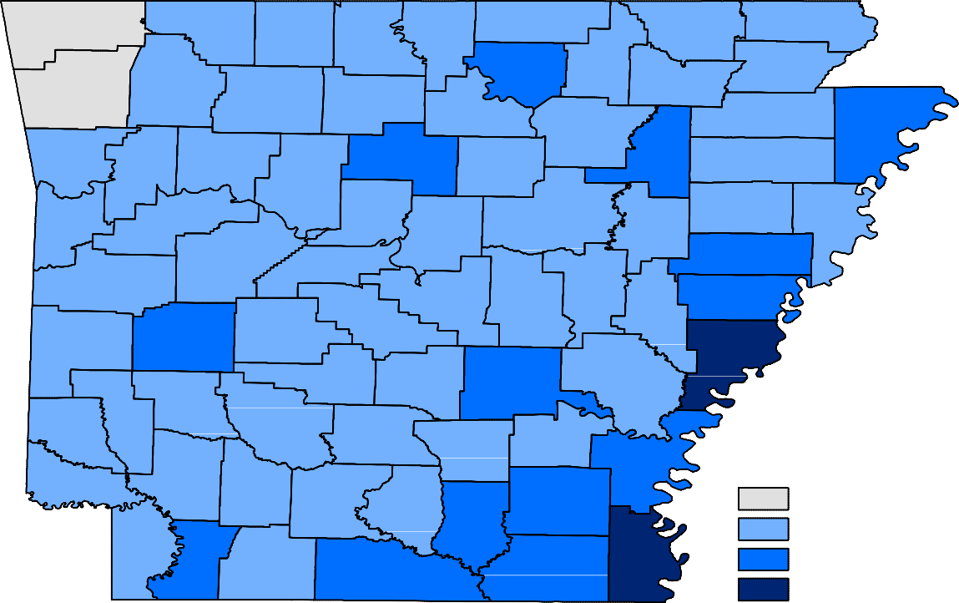
Benton
Carroll
Fulton
Clay
Boone
Randolph
Marion
Baxter
Sharp
Izard
Greene
Madison
Washington
Lawrence
Newton
Searcy
Stone
Craighead
Mississippi
Independence
Crawford
Johnson
Van Buren
Jackson
Poinsett
Franklin
Cleburne
Pope
Conway
Cross
Sebastian
Logan
White
Crittenden
Faulkner
Woodruff
Yell
St. Francis
Perry
Scott
Prairie
PulaskiLonoke
Lee
Saline
Monroe
Montgomery
Garland
Polk
Phillips
Hot Spring
Grant
Jefferson
Arkansas
Pike
Howard
Clark
Sevier
Dallas
Lincoln
Cleveland
Desha
Little RiverHempstead
Nevada
Ouachita
Calhoun
Drew
Bradley
Miller
Columbia
Chicot
Union
Ashley
Lafayette
Unemployment Rate
< or = 3.0% 3.1% - 5.0%
5.1% - 7.0%
> 7.0%

Ranked by Unemployment Rates
March 2018 (Not Seasonally Adjusted)

Rank  1 | County  Washington | Rate  2.6 | Rank  26 | County  Boone | Rate  4.1 | Rank  48 | County  Miller | Rate  4.8
2 | Benton | 3.0 | 26 | Marion | 4.1 | 48 | Sharp | 4.8
3 | Madison | 3.1 | 28 | Crittenden | 4.2 | 53 | Clay | 4.9
4 | Craighead | 3.2 | 28 | Fulton | 4.2 | 53 | Ouachita | 4.9
4 | Grant | 3.2 | 28 | Logan | 4.2 | 55 | Columbia | 5.0
4 | Saline | 3.2 | 28 | Pope | 4.2 | 55 | Little River | 5.0
7 | Carroll | 3.3 | 28 | Randolph | 4.2 | 55 | Stone | 5.0
7 | Newton | 3.3 | 28 | Yell | 4.2 | 55 | White | 5.0
9 | Faulkner | 3.4 | 34 | Baxter | 4.3 | 55 | Woodruff | 5.0
9 | Hempstead | 3.4 | 34 | Garland | 4.3 | 60 | Montgomery | 5.1
9 | Howard | 3.4 | 34 | Polk | 4.3 | 61 | Bradley | 5.2
12 | Lonoke | 3.5 | 37 | Monroe | 4.4 | 61 | Desha | 5.2
13 | Hot Spring | 3.7 | 37 | Pike | 4.4 | 63 | Izard | 5.4
13 | Nevada | 3.7 | 37 | Prairie | 4.4 | 63 | Lee | 5.4
13 | Pulaski | 3.7 | 37 | Searcy | 4.4 | 63 | Van Buren | 5.4
16 | Crawford | 3.8 | 41 | Cleveland | 4.5 | 66 | Drew | 5.5
16 | Franklin | 3.8 | 41 | Cross | 4.5 | 66 | Jefferson | 5.5
16 | Greene | 3.8 | 41 | Johnson | 4.5 | 68 | St. Francis | 5.6
19 | Arkansas | 3.9 | 41 | Perry | 4.5 | 69 | Lafayette | 5.7
19 | Clark | 3.9 | 45 | Conway | 4.6 | 70 | Mississippi | 5.8
19 | Sebastian | 3.9 | 46 | Calhoun | 4.7 | 71 | Ashley | 5.9
22 | Independence | 4.0 | 46 | Sevier | 4.7 | 72 | Jackson | 6.3
22 | Lawrence | 4.0 | 48 | Cleburne | 4.8 | 72 | Union | 6.3
22 | Poinsett | 4.0 | 48 | Dallas | 4.8 | 74 | Phillips | 7.2
22 | Scott | 4.0 | 48 | Lincoln | 4.8 | 75 | Chicot | 8.6

Local Workforce Development Areas
Civilian Labor Force Estimates
Not Seasonally Adjusted

LWDA CLF |  | March 2018  Emp Unemp |  | Rate | CLF | February 2018  Emp Unemp |  | Rate | CLF | March 2017  Emp Unemp |  | Rate
Central (minus LR) | 250,929 | 242,092 | 8,837 | 3.5 | 249,358 | 239,793 | 9,565 | 3.8 | 249,244 | 241,344 | 7,900 | 3.2
City of Little Rock | 98,089 | 94,431 | 3,658 | 3.7 | 97,260 | 93,517 | 3,743 | 3.8 | 97,033 | 93,906 | 3,127 | 3.2
Eastern | 46,717 | 44,388 | 2,329 | 5.0 | 46,459 | 43,892 | 2,567 | 5.5 | 47,308 | 45,162 | 2,146 | 4.5
North Central | 94,194 | 89,594 | 4,600 | 4.9 | 93,670 | 88,690 | 4,980 | 5.3 | 95,002 | 90,516 | 4,486 | 4.7
Northeast | 120,780 | 116,050 | 4,730 | 3.9 | 120,479 | 115,312 | 5,167 | 4.3 | 121,116 | 116,692 | 4,424 | 3.7
Northwest | 321,271 | 311,603 | 9,668 | 3.0 | 319,710 | 309,146 | 10,564 | 3.3 | 317,978 | 309,437 | 8,541 | 2.7
Southeast | 80,960 | 76,788 | 4,172 | 5.2 | 80,655 | 76,210 | 4,445 | 5.5 | 81,371 | 77,525 | 3,846 | 4.7
Southwest | 93,273 | 88,771 | 4,502 | 4.8 | 92,781 | 88,051 | 4,730 | 5.1 | 93,219 | 89,246 | 3,973 | 4.3
West Central | 131,670 | 126,077 | 5,593 | 4.2 | 130,812 | 124,573 | 6,239 | 4.8 | 132,655 | 127,567 | 5,088 | 3.8
Western | 111,410 | 107,058 | 4,352 | 3.9 | 110,887 | 106,113 | 4,774 | 4.3 | 112,710 | 108,817 | 3,893 | 3.5

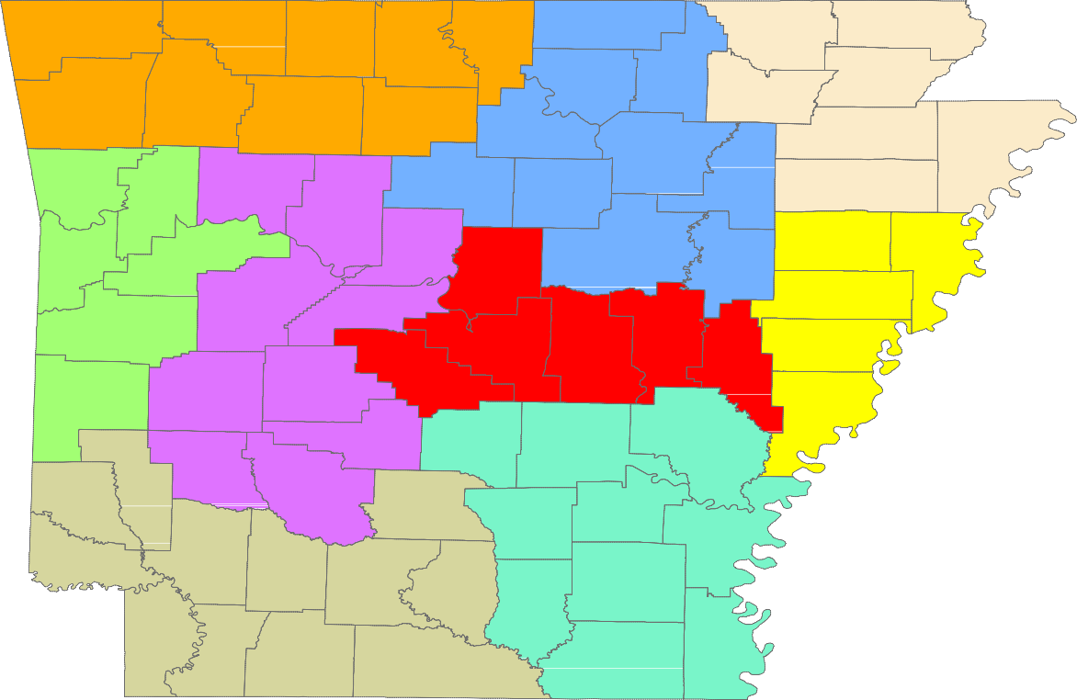
Benton
Carroll
Fulton
Clay
Boone
Randolph
Marion
Baxter
Sharp
Izard
Greene
Madison
Washington
Lawrence
Newton
Searcy
Stone
Craighead
Mississippi
Independence
Crawford
Johnson
Van Buren
Jackson
Franklin
Cleburne
Poinsett
Pope
Conway
Cross
Sebastian
Logan
White
Crittenden
Faulkner
Woodruff
Yell
St. Francis
Perry
Scott
Prairie
PulaskiLonoke
Lee
Saline
Monroe
Montgomery
Garland
Polk
Phillips
Hot Spring
Grant
Jefferson
Arkansas
Pike
Howard
Clark
Sevier
Dallas
Lincoln
Cleveland
Desha
Little RiverHempstead
Nevada
Ouachita
Calhoun
Drew
Bradley
Miller
Columbia
Chicot
Union
Ashley
Lafayette

Central (minus LR) Eastern
North Central
Northeast Northwest Southeast
Southwest West Central Western

