Labor Market Report
September

aArkadnsas Dwepartmsent
of Workforce Services

www.discover.arkansas.gov

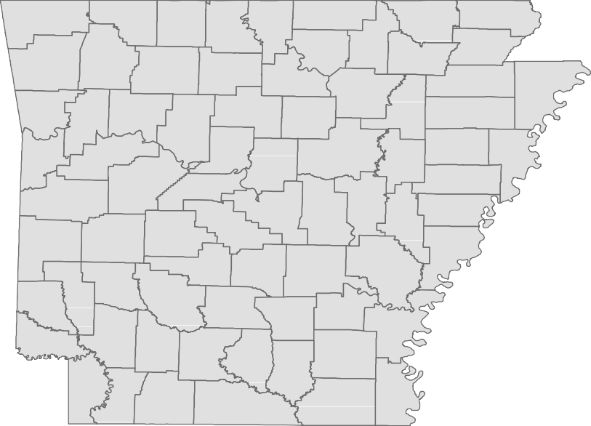
Table of Contents
Monthly Spotlight. 2
Arkansas Labor Force Summary. 3
Arkansas Nonfarm Payroll Jobs. 4
Arkansas Production Workers. 6
Metropolitan Statistical Areas. 7
Micropolitan Statistical Areas/Cities. 14
County Labor Force Statistics. 15
Local Workforce Development Areas. 18

The Arkansas Labor Market is prepared monthly in conjunction with the U.S. Depart- ment of Labor, Bureau of Labor Statistics (BLS). The current month’s estimates are preliminary, while previous month’s data is subject to revision.
Estimates of nonfarm payroll jobs show the number of jobs by industry and reflect employment by place of work. Hours and earnings estimates are based on payroll and worker-hour data collected for production workers in manufacturing industries.
Industries are classified according to the North American Industry Classification System (NAICS). All estimates are based on a first quarter 2018 benchmark.

Explanation of Terms and Concepts Monthly Business Survey of Employers
A monthly sample survey designed to provide industry information on nonfarm payroll jobs. Data are compiled each month from mail surveys and telephone interviews conducted by the Bureau of Labor Statistics in cooperation with Department of Work- force Services. The data are based on es- tablishment records and include all workers, full-or part-time, who received pay during the payroll period which includes the 12th of

Technical Notes
the month. Approximately 5,000 Arkansas
business establishments are surveyed.

Metropolitan Statistical Area (MSA)
A term applied by the U.S. Office of Man- agement and Budget to counties that have one or more central cities and that meet specified criteria of population density, com- muting patterns and social and economic integration.

Current Population Survey (CPS)
A monthly sample survey of the popula- tion 16 years of age and over, designed to provide data on the labor force, the employed and the unemployed. The survey is conducted each month by the Bureau of the Census for BLS. The information is collected by trained interviewers from a sample of about 60,000 households. The data collected are based on the activity reported for the calendar week including the 12th of the month. Approximately 800 Arkansas households are represented in the sample survey.

Civilian Labor Force
The sum of all employed and unemployed persons 16 years of age or older. Members of the Armed Forces are excluded.

Employment
An estimate of the number of persons who worked any time for pay or profit or worked 15 hours or more as unpaid workers in a family business during the calendar week which includes the 12th of the month. Also included are those who, although not work- ing, had some job attachment and were not looking for work, and persons involved in labor management disputes.

Unemployment
An estimate of the number of persons who did not have a job, but were available for work and actively seeking work during the calendar week which includes the 12th of the month.

Unemployment Rate
The number of unemployed as a percentage of the civilian labor force. Unemployment rates are calculated from unrounded data.

Seasonal Adjustment
A statistical technique applied to monthly data to eliminate changes that normally oc- cur during the year due to seasonal events such as weather, major holidays, schedule shifts, harvest times, and the opening/clos- ing of schools.

September Spotlight
Comparative Look at Unemployment Rates

Due to differing economies and labor force conditions in various parts of the country, unemployment rates vary greatly from state to state. In September 2019, seasonally adjusted jobless rates ranged from a low of 2.2 percent in Vermont to a high of 6.2 percent in Alaska. The unemployment rate in Arkansas increased to 3.5 percent in September, a ranking of 27 out of 51 states. By looking at the map below, it becomes apparent that trends exist among states that are located within the same region. While there are some exceptions, western states tend to have higher jobless rates than states located in the Midwest. Similarly, states located in the northeast generally experience lower unemployment rates than states located in the southeast. These regional trends occur because states often experience economic similarities based on shared industries, work forces, and climates.

Unemployment Rates, Ranked by State (Seasonally Adjusted)

September 2019

Rank | State | Rate | Rank | State | Rate | Rank | State | Rate
1 | Vermont | 2.2 | 18 | Florida | 3.2 | 34 | New York | 3.9
2 | Iowa | 2.5 | 18 | Indiana | 3.2 | 36 | California | 4.0
2  2 | New Hampshire  North Dakota | 2.5  2.5 | 18  18 | Kansas  Minnesota | 3.2  3.2 | 36  38 | Pennsylvania  Nevada | 4.0  4.1
5 | Colorado | 2.7 | 18 | Oklahoma | 3.2 | 38 | North Carolina | 4.1
5 | Hawaii | 2.7 | 18 | Wisconsin | 3.2 | 38 | Oregon | 4.1
5  5 | Utah  Virginia | 2.7  2.7 | 24  25 | Montana  Tennessee | 3.3  3.4 | 41  41 | Michigan  Ohio | 4.2  4.2
9  9 | Idaho  Maine | 2.9  2.9 | 25  27 | Texas  Arkansas | 3.4  3.5 | 43  44 | Louisiana  Kentucky | 4.3  4.4
9 | Massachusetts | 2.9 | 27 | Delaware | 3.5 | 45 | Washington | 4.6
9 | South Carolina | 2.9 | 27 | Georgia | 3.5 | 46 | West Virginia | 4.7
13  13 | Alabama  South Dakota | 3.0  3.0 | 30  30 | Connecticut  Rhode Island | 3.6  3.6 | 47  47 | Arizona  New Mexico | 4.9  4.9
15  15 | Missouri  Nebraska | 3.1  3.1 | 32  33 | Maryland  Wyoming | 3.7  3.8 | 49  49 | District of Columbia  Mississippi | 5.4  5.4
15 | New Jersey | 3.1 | 34 | Illinois | 3.9 | 51 | Alaska | 6.2
U.S. Unemployment Rate = 3.5 Percent

es
Washington
Montana
North Dakota Minnesota
Oregon
Idaho
South Dakota
Wisconsin Michigan
Wyoming
Vermont Maine New YorkNew Hampshire
Nebraska
Iowa
Nevada Utah
Colorado
Illinois Indiana Ohio
Massachusetts
Pennsylvania
New Jersey
Kansas
Missouri
West VirginiaMaryland
California
Kentucky Virginia
Oklahoma
Arizona
New Mexico
Arkansas
Tennessee
North Carolina
South Carolina
Texas
MississippiAlabamaGeorgia Louisiana

Florida
Continental US Only
Unemployment Rat
< or = 3.0% 3.1% - 5.0%
5.1% - 7.0%
> 7.0% [NONE]

State of Arkansas
Civilian Labor Force Summary

Labor force data, produced by the U.S. Department of Labor, Bureau of Labor Statistics and released by the Arkansas Division of Workforce Services, show Arkansas’ seasonally adjusted unemployment rate rose one-tenth of a percentage point, from 3.4 percent in August to 3.5 percent in September. Arkan- sas’ civilian labor force declined 319, a result of 552 fewer employed and 233 additional unemployed Arkansans. The United States’ jobless rate declined to 3.5 percent in September, down from 3.7 percent in August.
BLS Program Operations Manager Susan Price said, “Although Arkansas’ unemployment rate rose one- tenth of a percentage point in September, the civilian labor force remained statistically stable. Com- pared to September 2018, Arkansas’ labor force has grown by 10,487.”

Civilian Labor Force Estimates
Seasonally Adjusted
Not Seasonally Adjusted
Employment 1,315,091 1,315,643 1,302,425 Employment 1,318,270 1,310,849 1,306,513
Unemployment 47,102 46,869 49,281 Unemployment 45,693 48,750 46,919
Unemployment Rate 3.5 3.4 3.6 Unemployment Rate 3.4 3.6 3.5
U.S. Unemployment 3.5 3.7 3.7 U.S. Unemployment 3.3 3.8 3.6

 | Sep 19 | Aug 19 | Sep 18 | Sep 19 | Aug 19 | Sep 18
Civilian Labor Force | 1,362,193 | 1,362,512 | 1,351,706 Civilian Labor Force | 1,363,963 | 1,359,599 | 1,353,432

120,000

Number of Unemployed (Seasonally Adjusted)

September: 1999 - 2019

100,000

80,000

60,000

40,000

20,000

0
'99 '01 '03 '05 '07 '09 '11 '13 '15 '17 '19

State of Arkansas
Nonfarm Payroll Jobs

Not Seasonally Adjusted
(In Thousands)

(NAICS) Sep 19 Aug 19 Sep 18 OTM OTY
Total Nonfarm | 1286.2 | 1269.6 | 1270.3 | 16.6 | 15.9
Goods Producing | 223.6 | 223.8 | 219.0 | -0.2 | 4.6
Mining, Logging, and Construction | 61.2 | 60.0 | 57.9 | 1.2 | 3.3
Mining & Logging | 5.8 | 5.8 | 6.0 | 0.0 | -0.2
Construction | 55.4 | 54.2 | 51.9 | 1.2 | 3.5
Specialty Trade Contractors | 34.0 | 33.3 | 32.8 | 0.7 | 1.2
Manufacturing | 162.4 | 163.8 | 161.1 | -1.4 | 1.3
Durable Goods | 77.1 | 78.3 | 76.6 | -1.2 | 0.5
Nondurable Goods | 85.3 | 85.5 | 84.5 | -0.2 | 0.8
Service Providing | 1062.6 | 1045.8 | 1051.3 | 16.8 | 11.3
Trade, Transportation & Utilities | 252.3 | 253.1 | 251.1 | -0.8 | 1.2
Wholesale Trade | 48.4 | 49.2 | 47.3 | -0.8 | 1.1
Retail Trade | 138.3 | 138.8 | 137.9 | -0.5 | 0.4
Transport, Warehousing & Utilities | 65.6 | 65.1 | 65.9 | 0.5 | -0.3
Information | 11.0 | 11.0 | 11.0 | 0.0 | 0.0
Financial Activities | 63.3 | 63.6 | 60.8 | -0.3 | 2.5
Finance & Insurance | 49.3 | 49.1 | 47.2 | 0.2 | 2.1
Real Estate & Rental & Leasing | 14.0 | 14.5 | 13.6 | -0.5 | 0.4
Professional & Business Services | 146.9 | 144.7 | 147.7 | 2.2 | -0.8
Professional, Scientific & Technical | 43.2 | 43.3 | 43.5 | -0.1 | -0.3
Management of Companies | 36.2 | 36.3 | 34.7 | -0.1 | 1.5
Administrative & Support Services | 67.5 | 65.1 | 69.5 | 2.4 | -2.0
Educational & Health Services | 195.6 | 191.5 | 192.7 | 4.1 | 2.9
Educational Services | 15.9 | 13.1 | 15.8 | 2.8 | 0.1
Health Care & Social Assistance | 179.7 | 178.4 | 176.9 | 1.3 | 2.8
Ambulatory Health Care | 59.0 | 59.1 | 58.7 | -0.1 | 0.3
Social Assistance | 41.8 | 41.0 | 39.8 | 0.8 | 2.0
Leisure & Hospitality | 124.6 | 125.4 | 119.9 | -0.8 | 4.7
Arts, Entertainment & Recreation | 11.3 | 12.6 | 11.1 | -1.3 | 0.2
Accommodation & Food Services | 113.3 | 112.8 | 108.8 | 0.5 | 4.5
Accommodation Services | 11.6 | 11.8 | 11.6 | -0.2 | 0.0
Food Services | 101.7 | 101.0 | 97.2 | 0.7 | 4.5
Other Services | 53.1 | 53.7 | 53.9 | -0.6 | -0.8
Government | 215.8 | 202.8 | 214.2 | 13.0 | 1.6
Federal Government | 20.6 | 20.5 | 20.1 | 0.1 | 0.5
State Government | 79.3 | 74.7 | 79.1 | 4.6 | 0.2
Local Government | 115.9 | 107.6 | 115.0 | 8.3 | 0.9

State of Arkansas
Nonfarm Payroll Job Summary

August 2019 - September 2019
Arkansas’ nonfarm payroll jobs increased 16,600 in September to total 1,286,200. Four major industry sectors posted gains, more than offsetting declines in five sectors. Government added 13,000 jobs, mostly due to the return of teachers and staff at public schools and universities. Jobs in educational and health services rose 4,100. A majority of the expansion occurred in educational services (+2,800), related to staffing at private schools. Employment in professional and business services increased 2,200. All hiring was reported in administrative and support services (+2,400), a subsector which in- cludes employment agencies. Construction added 1,200 jobs, as work continues on several major projects. Manufacturing posted the largest decline, down 1,400 jobs. Most of the losses were re- ported in durable goods (-1,200), related to reductions in fabricated metal product manufacturing and in machinery manufacturing.
September 2018 - September 2019
Compared to September 2018, nonfarm payroll jobs in Arkansas are up 15,900. Growth occurred in seven major industry sectors, while three sectors posted minor declines. Employment in leisure and hospitality rose 4,700, mostly in food services (+4,500). Construction added 3,500, related to on- going projects. Jobs in educational and health services increased 2,900. A majority of the gains were in social assistance (+2,000), which includes activities such as day care services and vocational rehabilitation. Jobs in financial activities rose 2,500, largely in finance and insurance (+2,100). No- table expansions were also reported in government (+1,600), manufacturing (+1,300), and trade- transportation-utilities (+1,200).

Jobs in Leisure and Hospitality (Not Seasonally Adjusted)

January 2017 - September 2019
130,000

125,000

120,000

115,000

110,000

105,000

100,000

J F M A M J J A S O N D
2017 2018 2019

State of Arkansas
Production Workers- Hours and Earnings

Manufacturing
Sep 18
42.2
18.08
762.98
Aug 19
42.0
18.72
786.24
Sep 19
Average Weekly Hours 40.8
Average Hourly Earnings 18.53
Average Weekly Earnings 756.02

Durable Goods and Nondurable Goods Manufacturing
Sep 18
40.9
15.80
646.22
Aug 19
41.1
16.83
691.71
Sep 19
Average Weekly Hours 39.7
Average Hourly Earnings 16.17
Average Weekly Earnings 641.95
Sep 18
43.7
20.60
900.22
Aug 19
43.0
20.75
892.25
Sep 19
Average Weekly Hours 42.0
Average Hourly Earnings 21.09
Average Weekly Earnings 885.78
Nondurable Goods Manufacturing
Durable Goods Manufacturing

Average Weekly Earnings- Production Workers in Manufacturing

September: 2009 - 2019
$800.00

$750.00

$700.00

$650.00

$600.00

$550.00

$500.00

$450.00

$400.00

$350.00

$300.00
'09 '10 '11 '12 '13 '14 '15 '16 '17 '18 '19

Metropolitan Statistical Areas
Little Rock-North Little Rock-Conway MSA

The Little Rock-North Little Rock-Conway MSA = Faulkner, Grant, Lonoke, Perry, Pulaski, & Saline counties.

Civilian Labor Force Estimates (Not Seasonally Adjusted)

 | Sep 19 | Aug 19 | Sep 18 | OTM | OTY
Civilian Labor Force | 356,778 | 358,362 | 355,268 | -1,584 | 1,510
Employment | 345,493 | 346,616 | 343,927 | -1,123 | 1,566
Unemployment | 11,285 | 11,746 | 11,341 | -461 | -56
Unemployment Rate | 3.2 | 3.3 | 3.2 | -0.1 | 0.0

Nonfarm Payroll Jobs (Not Seasonally Adjusted)
(In Thousands)

NAICS Sep 19 | Aug 19 | Sep 18 | OTM | OTY
Total Nonfarm 366.4 | 363.8 | 363.8 | 2.6 | 2.6
Goods Producing 38.5 | 38.4 | 38.6 | 0.1 | -0.1
Mining, Logging & Construction 17.5 | 17.3 | 17.5 | 0.2 | 0.0
Manufacturing 21.0 | 21.1 | 21.1 | -0.1 | -0.1
Service Providing 327.9 | 325.4 | 325.2 | 2.5 | 2.7
Trade, Transportation & Utilities 70.5 | 70.6 | 70.3 | -0.1 | 0.2
Wholesale Trade 16.3 | 16.4 | 15.9 | -0.1 | 0.4
Retail Trade 38.0 | 38.1 | 38.5 | -0.1 | -0.5
Trans., Warehousing & Utilities 16.2 | 16.1 | 15.9 | 0.1 | 0.3
Information 4.1 | 4.2 | 4.3 | -0.1 | -0.2
Financial Activities 21.6 | 21.7 | 21.3 | -0.1 | 0.3
Professional & Business Services 48.0 | 48.2 | 49.8 | -0.2 | -1.8
Educational & Health Services 59.9 | 58.7 | 57.9 | 1.2 | 2.0
Leisure & Hospitality 36.1 | 36.2 | 34.4 | -0.1 | 1.7
Other Services 16.0 | 16.2 | 15.9 | -0.2 | 0.1
Government 71.7 | 69.6 | 71.3 | 2.1 | 0.4
Federal Government 9.8 | 9.8 | 9.6 | 0.0 | 0.2
State Government 35.9 | 34.9 | 35.6 | 1.0 | 0.3
Local Government 26.0 | 24.9 | 26.1 | 1.1 | -0.1

Number of Employed

September 2016 - September 2019
360,000

Jobs in Educational and Health Services

September: 2009 - 2019
65,000

355,000

60,000

350,000
55,000

345,000
50,000

340,000

45,000
335,000

40,000
330,000

325,000

35,000

320,000
Sep '16 Mar '17 Sep '17 Mar '18 Sep '18 Mar '19 Sep '19

30,000

'09 '10 '11 '12 '13 '14 '15 '16 '17 '18 '19

Metropolitan Statistical Areas
Fayetteville-Springdale-Rogers MSA

The Fayetteville-Springdale-Rogers MSA = Benton, Madison, & Washington counties in Arkansas and McDonald county in Missouri.
Civilian Labor Force Estimates (Not Seasonally Adjusted)

 | Sep 19 | Aug 19 | Sep 18 | OTM | OTY
Civilian Labor Force | 283,708 | 281,814 | 275,697 | 1,894 | 8,011
Employment | 276,979 | 274,459 | 268,436 | 2,520 | 8,543
Unemployment | 6,729 | 7,355 | 7,261 | -626 | -532
Unemployment Rate | 2.4 | 2.6 | 2.6 | -0.2 | -0.2

Nonfarm Payroll Jobs (Not Seasonally Adjusted)
(In Thousands)

NAICS Sep 19 | Aug 19 | Sep 18 | OTM | OTY
Total Nonfarm 269.7 | 264.5 | 260.5 | 5.2 | 9.2
Goods Producing 42.6 | 42.8 | 41.5 | -0.2 | 1.1
Mining, Logging & Construction 12.3 | 12.3 | 11.8 | 0.0 | 0.5
Manufacturing 30.3 | 30.5 | 29.7 | -0.2 | 0.6
Service Providing 227.1 | 221.7 | 219.0 | 5.4 | 8.1
Trade, Transportation & Utilities 57.6 | 57.2 | 56.1 | 0.4 | 1.5
Wholesale Trade 12.5 | 12.6 | 12.2 | -0.1 | 0.3
Retail Trade 27.2 | 26.8 | 26.2 | 0.4 | 1.0
Trans., Warehousing & Utilities 17.9 | 17.8 | 17.7 | 0.1 | 0.2
Information 2.2 | 2.2 | 2.0 | 0.0 | 0.2
Financial Activities 8.5 | 8.7 | 8.2 | -0.2 | 0.3
Professional & Business Services 53.2 | 53.4 | 49.9 | -0.2 | 3.3
Educational & Health Services 30.4 | 29.7 | 29.4 | 0.7 | 1.0
Leisure & Hospitality 27.3 | 26.3 | 27.0 | 1.0 | 0.3
Other Services 9.5 | 9.5 | 9.3 | 0.0 | 0.2
Government 38.4 | 34.7 | 37.1 | 3.7 | 1.3
Federal Government 2.7 | 2.7 | 2.7 | 0.0 | 0.0
State Government 16.9 | 14.4 | 15.8 | 2.5 | 1.1
Local Government 18.8 | 17.6 | 18.6 | 1.2 | 0.2

Civilian Labor Force | Jobs in Professional & Business Services
September: 1999 - 2019 | January 2017 - September 2019
300,000 | 54,000
 | 53,000
260,000
 | 52,000
220,000 | 51,000
 | 50,000
180,000
 | 49,000
140,000 | 48,000

100,000

'99

'01

'03

'05

'07

'09

'11

'13

'15

'17

'19

47,000 J F M A M J J A S O N D
2017 2018 2019

Metropolitan Statistical Areas
Fort Smith MSA

The Fort Smith MSA = Crawford & Sebastian counties in Arkansas & LeFlore & Sequoyah counties in Oklahoma.

Civilian Labor Force Estimates (Not Seasonally Adjusted)

 | Sep 19 | Aug 19 | Sep 18 | OTM | OTY
Civilian Labor Force | 118,128 | 118,744 | 118,788 | -616 | -660
Employment | 114,009 | 114,304 | 114,569 | -295 | -560
Unemployment | 4,119 | 4,440 | 4,219 | -321 | -100
Unemployment Rate | 3.5 | 3.7 | 3.6 | -0.2 | -0.1

Nonfarm Payroll Jobs (Not Seasonally Adjusted)
(In Thousands)

NAICS Sep 19 | Aug 19 | Sep 18 | OTM | OTY
Total Nonfarm 113.0 | 112.2 | 113.6 | 0.8 | -0.6
Goods Producing 22.9 | 22.9 | 22.9 | 0.0 | 0.0
Mining, Logging & Construction 5.1 | 5.2 | 5.3 | -0.1 | -0.2
Manufacturing 17.8 | 17.7 | 17.6 | 0.1 | 0.2
Service Providing 90.1 | 89.3 | 90.7 | 0.8 | -0.6
Trade, Transportation & Utilities 22.6 | 22.8 | 22.9 | -0.2 | -0.3
Wholesale Trade 4.2 | 4.2 | 4.1 | 0.0 | 0.1
Retail Trade 12.0 | 12.2 | 12.3 | -0.2 | -0.3
Trans., Warehousing & Utilities 6.4 | 6.4 | 6.5 | 0.0 | -0.1
Information 1.1 | 1.1 | 1.2 | 0.0 | -0.1
Financial Activities 4.0 | 4.0 | 4.0 | 0.0 | 0.0
Professional & Business Services 12.9 | 12.9 | 13.1 | 0.0 | -0.2
Educational & Health Services 17.2 | 17.3 | 17.1 | -0.1 | 0.1
Leisure & Hospitality 9.5 | 9.7 | 9.5 | -0.2 | 0.0
Other Services 4.5 | 4.5 | 4.5 | 0.0 | 0.0
Government 18.3 | 17.0 | 18.4 | 1.3 | -0.1
Federal Government 1.3 | 1.3 | 1.3 | 0.0 | 0.0
State Government 3.1 | 2.9 | 3.1 | 0.2 | 0.0
Local Government 13.9 | 12.8 | 14.0 | 1.1 | -0.1

Percent of Jobs by Industry Sector

September 2019
25.0%
16.2%
15.8%
15.2%
11.4%
8.4%
4.5%
4.0%
3.5%
1.0%

20.0%

20.0%

15.0%

10.0%

5.0%

0.0%

Metropolitan Statistical Areas
Hot Springs MSA
The Hot Springs MSA = Garland County.

Civilian Labor Force Estimates (Not Seasonally Adjusted)

 | Sep 19 | Aug 19 | Sep 18 | OTM | OTY
Civilian Labor Force | 40,914 | 41,612 | 40,425 | -698 | 489
Employment | 39,457 | 40,047 | 38,856 | -590 | 601
Unemployment | 1,457 | 1,565 | 1,569 | -108 | -112
Unemployment Rate | 3.6 | 3.8 | 3.9 | -0.2 | -0.3

Nonfarm Payroll Jobs (Not Seasonally Adjusted)
(In Thousands)
NAICS
Total Nonfarm Goods Producing Service Providing Government

Sep 19 | Aug 19 | Sep 18 | OTM | OTY
39.3 | 39.6 | 38.7 | -0.3 | 0.6
4.5 | 4.5 | 4.5 | 0.0 | 0.0
34.8 | 35.1 | 34.2 | -0.3 | 0.6
4.5 | 4.3 | 4.6 | 0.2 | -0.1

40,500

Nonfarm Payroll Jobs

September 2016 - September 2019

40,000

39,500

39,000

38,500

38,000

37,500

37,000

36,500

36,000
Sep '16 Mar '17 Sep '17 Mar '18 Sep '18 Mar '19 Sep '19

Metropolitan Statistical Areas
Jonesboro MSA

The Jonesboro MSA = Craighead & Poinsett counties.

Civilian Labor Force Estimates (Not Seasonally Adjusted)

 | Sep 19 | Aug 19 | Sep 18 | OTM | OTY
Civilian Labor Force | 65,393 | 65,333 | 64,771 | 60 | 622
Employment | 63,611 | 63,409 | 62,873 | 202 | 738
Unemployment | 1,782 | 1,924 | 1,898 | -142 | -116
Unemployment Rate | 2.7 | 2.9 | 2.9 | -0.2 | -0.2

Nonfarm Payroll Jobs (Not Seasonally Adjusted)
(In Thousands)
NAICS
Total Nonfarm Goods Producing Service Providing Government

Sep 19 | Aug 19 | Sep 18 | OTM | OTY
60.2 | 59.3 | 59.3 | 0.9 | 0.9
10.2 | 10.2 | 10.2 | 0.0 | 0.0
50.0 | 49.1 | 49.1 | 0.9 | 0.9
9.2 | 8.7 | 9.1 | 0.5 | 0.1

70,000

Civilian Labor Force

September: 2009 - 2019

Civilian Labor Force = Employment + Unemployment

60,000

50,000

40,000

30,000

20,000

10,000

0
2009 2010 2011 2012 2013 2014 2015 2016 2017 2018 2019
Employment Unemployment

Metropolitan Statistical Areas
Pine Bluff MSA

The Pine Bluff MSA = Cleveland, Jefferson, & Lincoln counties.

Civilian Labor Force Estimates (Not Seasonally Adjusted)

 | Sep 19 | Aug 19 | Sep 18 | OTM | OTY
Civilian Labor Force | 34,976 | 35,140 | 35,370 | -164 | -394
Employment | 33,252 | 33,293 | 33,686 | -41 | -434
Unemployment | 1,724 | 1,847 | 1,684 | -123 | 40
Unemployment Rate | 4.9 | 5.3 | 4.8 | -0.4 | 0.1

Nonfarm Payroll Jobs (Not Seasonally Adjusted)
(In Thousands)
NAICS
Total Nonfarm Goods Producing Service Providing Government

Sep 19 | Aug 19 | Sep 18 | OTM | OTY
33.1 | 32.8 | 33.5 | 0.3 | -0.4
6.0 | 6.0 | 6.1 | 0.0 | -0.1
27.1 | 26.8 | 27.4 | 0.3 | -0.3
9.1 | 8.8 | 9.2 | 0.3 | -0.1

33,800

Nonfarm Payroll Jobs

January 2017 - September 2019

33,600

33,400

33,200

33,000

32,800

32,600

32,400

32,200

32,000

31,800

31,600

J F M A M J J A S O N D
2017 2018 2019

Metropolitan Statistical Areas
Out-of-State MSA

Civilian Labor Force Estimates (Not Seasonally Adjusted)

Memphis, TN-MS-AR MSA

The Memphis, TN-MS-AR MSA = Fayette, Shelby, & Tipton counties in Tennessee; Benton, Desoto, Marshall, Tate, & Tunica counties in Mississippi; & Crittenden County in Arkansas.

 | Sep 19 | Aug 19 | Sep 18 | OTM | OTY
Civilian Labor Force | 648,472 | 651,867 | 630,566 | -3,395 | 17,906
Employment | 622,071 | 624,520 | 605,359 | -2,449 | 16,712
Unemployment | 26,401 | 27,347 | 25,207 | -946 | 1,194
Unemployment Rate | 4.1 | 4.2 | 4.0 | -0.1 | 0.1

Texarkana MSA
The Texarkana MSA= Bowie County in Texas & Little River & Miller counties in Arkansas.

 | Sep 19 | Aug 19 | Sep 18 | OTM | OTY
Civilian Labor Force | 64,668 | 64,108 | 65,016 | 560 | -348
Employment | 62,028 | 61,248 | 61,632 | 780 | 396
Unemployment | 2,640 | 2,860 | 3,384 | -220 | -744
Unemployment Rate | 4.1 | 4.5 | 5.2 | -0.4 | -1.1

Memphis MSA - Number of Employed

September 2017 - September 2019
640,000

Texarkana MSA - Unemployment Rates

September: 2009 - 2019
9.0

8.0
630,000

7.0

620,000

6.0

5.0
610,000

4.0

600,000

3.0

2.0
590,000

1.0

580,000

Sep '17
Mar '18
Sep '18
Mar '19
Sep '19
0.0

'09 '10 '11 '12 '13 '14 '15 '16 '17 '18 '19

Micropolitan Statistical Areas and Cities
Civilian Labor Force Estimates

Micropolitan Labor Force Estimates

3.8
3.8
4.8
4.2
4.9
4.8
3.1
5.8
3.5
4.3
3.5
3.8
3.2
4.0
3.9
370
625
835
512
782
400
603
377
476
391
495
629
625
1,504
1,300
9,313
15,868
16,547
11,773
15,141
7,898
18,708
6,175
13,117
8,790
13,450
15,864
19,193
36,021
32,421
September 2018
Emp Unemp Rate
CLF
9,683
16,493
17,382
12,285
15,923
8,298
19,311
6,552
13,593
9,181
13,945
16,493
19,818
37,525
33,721
4.2
4.2
5.3
4.8
5.3
5.0
3.4
6.1
4.0
4.8
3.9
4.0
3.5
4.5
4.1
406
682
923
578
838
414
639
390
533
430
535
643
699
1,638
1,373
9,230
15,386
16,434
11,491
14,954
7,863
18,416
6,050
12,775
8,476
13,299
15,507
19,235
34,946
32,112
Emp Unemp Rate
CLF
9,636
16,068
17,357
12,069
15,792
8,277
19,055
6,440
13,308
8,906
13,834
16,150
19,934
36,584
33,485
3.6
3.8
4.5
4.4
4.9
4.7
3.1
5.7
3.6
4.2
3.5
3.7
3.3
3.8
4.0
352
640
786
537
780
388
603
367
496
384
485
596
669
1,424
1,358
9,520
16,027
16,736
11,672
15,076
7,794
18,887
6,116
13,241
8,807
13,366
15,697
19,352
36,113
32,414
Not Seasonally Adjusted
August 2019
September 2019
Emp Unemp Rate
CLF
9,872
16,667
17,522
12,209
15,856
8,182
19,490
6,483
13,737
9,191
13,851
16,293
20,021
37,537
33,772
Micro Area
Arkadelphia Micro Batesville Micro Blytheville Micro Camden Micro
El Dorado Micro Forrest City Micro Harrison Micro
Helena-West Helena Micro Hope Micro
Magnolia Micro Malvern Micro Mountain Home Micro Paragould Micro Russellville Micro Searcy Micro

Arkadelphia Micro = Clark County Batesville Micro = Independence County Blytheville Micro = Mississippi County
Camden Micro = Calhoun & Ouachita counties El Dorado Micro = Union County
Forrest City Micro = St. Francis County Harrison Micro = Boone & Newton counties Helena-West Helena Micro = Phillips County Hope Micro = Hempstead & Nevada counties Magnolia Micro = Columbia County

City Labor Force Statistics
Malvern Micro = Hot Spring County Mountain Home Micro = Baxter County Paragould Micro = Greene County Russellville Micro = Pope & Yell counties Searcy Micro = White County

Not Seasonally Adjusted

September 2019 August 2019 September 2018

City CLF Emp Unemp
Rate
CLF Emp Unemp
Rate
CLF Emp Unemp
Rate

Bella Vista Benton Bentonville Blytheville Cabot Conway
El Dorado Fayetteville Fort Smith Hot Springs Jacksonville Jonesboro Little Rock
North Little Rock Paragould
Pine Bluff Rogers Russellville Searcy Sherwood Springdale Texarkana, AR Van Buren West Memphis
12,551
17,251
26,929
5,995
12,034
33,636
6,894
48,848
39,119
14,628
11,887
38,704
97,850
29,990
12,564
16,584
36,368
13,487
10,273
16,053
40,172
13,510
10,257
10,681
12,179
16,770
26,334
5,660
11,654
32,696
6,513
47,694
37,820
14,000
11,311
37,653
94,777
28,876
12,120
15,571
35,519
13,012
9,908
15,560
39,271
12,961
9,964
10,160
372
481
595
335
380
940
381
1,154
1,299
628
576
1,051
3,073
1,114
444
1,013
849
475
365
493
901
549
293
521
3.0
2.8
2.2
5.6
3.2
2.8
5.5
2.4
3.3
4.3
4.8
2.7
3.1
3.7
3.5
6.1
2.3
3.5
3.6
3.1
2.2
4.1
2.9
4.9
12,463
17,363
26,756
5,998
12,083
33,810
6,890
48,582
39,284
14,866
11,884
38,637
98,419
30,045
12,529
16,705
36,111
13,086
10,215
16,123
39,920
13,530
10,334
10,817
12,073
16,826
26,106
5,558
11,687
32,805
6,460
47,288
37,942
14,210
11,348
37,537
95,090
28,971
12,047
15,591
35,211
12,586
9,815
15,612
38,936
12,938
9,993
10,277
390
537
650
440
396
1,005
430
1,294
1,342
656
536
1,100
3,329
1,074
482
1,114
900
500
400
511
984
592
341
540
3.1
3.1
2.4
7.3
3.3
3.0
6.2
2.7
3.4
4.4
4.5
2.8
3.4
3.6
3.8
6.7
2.5
3.8
3.9
3.2
2.5
4.4
3.3
5.0
12,259
17,212
26,160
5,893
11,970
33,592
6,954
47,494
39,444
14,431
11,755
38,313
97,622
29,754
12,438
16,752
35,358
13,478
10,321
15,933
39,064
13,655
10,387
10,522
11,811
16,693
25,539
5,596
11,602
32,546
6,541
46,255
38,094
13,787
11,260
37,213
94,346
28,745
12,021
15,779
34,446
12,979
9,910
15,490
38,086
12,897
10,035
10,075
448
519
621
297
368
1,046
413
1,239
1,350
644
495
1,100
3,276
1,009
417
973
912
499
411
443
978
758
352
447
3.7
3.0
2.4
5.0
3.1
3.1
5.9
2.6
3.4
4.5
4.2
2.9
3.4
3.4
3.4
5.8
2.6
3.7
4.0
2.8
2.5
5.6
3.4
4.2

www.discover.arkansas.gov 14

County Labor Force Statistics
Civilian Labor Force Estimates
Not Seasonally Adjusted

September 2019 August 2019 September 2018

County CLF Emp Unemp
Rate
CLF Emp Unemp
Rate
CLF Emp Unemp
Rate

Arkansas Ashley Baxter Benton Boone Bradley Calhoun Carroll Chicot Clark Clay Cleburne Cleveland Columbia Conway
Craighead Crawford Crittenden Cross Dallas Desha Drew Faulkner Franklin Fulton Garland Grant Greene Hempstead Hot Spring Howard
Independence Izard
Jackson Jefferson Johnson Lafayette Lawrence Lee Lincoln Little River Logan Lonoke Madison Marion Miller
9,567
7,748
16,293
138,642
16,121
4,574
2,403
12,907
3,299
9,872
5,697
9,315
3,246
9,191
8,203
55,010
26,506
21,579
7,328
2,832
5,550
7,898
61,699
7,384
4,943
40,914
8,373
20,021
10,055
13,851
5,641
16,667
5,036
5,884
27,751
10,359
2,483
6,933
2,844
3,979
5,444
8,594
34,183
7,607
6,652
19,588
9,317
7,388
15,697
135,226
15,628
4,414
2,318
12,557
3,099
9,520
5,452
8,916
3,134
8,807
7,854
53,559
25,659
20,712
7,040
2,706
5,325
7,542
59,899
7,136
4,767
39,457
8,119
19,352
9,699
13,366
5,477
16,027
4,785
5,528
26,299
9,945
2,367
6,664
2,721
3,819
5,221
8,212
32,984
7,423
6,388
18,850
250
360
596
3,416
493
160
85
350
200
352
245
399
112
384
349
1,451
847
867
288
126
225
356
1,800
248
176
1,457
254
669
356
485
164
640
251
356
1,452
414
116
269
123
160
223
382
1,199
184
264
738
2.6
4.6
3.7
2.5
3.1
3.5
3.5
2.7
6.1
3.6
4.3
4.3
3.5
4.2
4.3
2.6
3.2
4.0
3.9
4.4
4.1
4.5
2.9
3.4
3.6
3.6
3.0
3.3
3.5
3.5
2.9
3.8
5.0
6.1
5.2
4.0
4.7
3.9
4.3
4.0
4.1
4.4
3.5
2.4
4.0
3.8
9,576
7,619
16,150
137,690
15,765
4,415
2,381
12,991
3,333
9,636
5,728
9,212
3,265
8,906
8,183
54,959
26,677
21,884
7,361
2,832
5,541
7,613
62,008
7,382
4,789
41,612
8,416
19,934
9,749
13,834
5,598
16,068
4,930
5,886
27,876
10,003
2,444
6,648
2,859
3,999
5,448
8,610
34,162
7,559
6,586
19,618
9,317
7,218
15,507
134,052
15,234
4,240
2,283
12,628
3,116
9,230
5,476
8,811
3,138
8,476
7,827
53,393
25,735
20,951
7,052
2,693
5,305
7,225
60,099
7,105
4,595
40,047
8,140
19,235
9,359
13,299
5,416
15,386
4,671
5,524
26,332
9,523
2,320
6,349
2,725
3,823
5,208
8,214
33,078
7,360
6,329
18,817
259
401
643
3,638
531
175
98
363
217
406
252
401
127
430
356
1,566
942
933
309
139
236
388
1,909
277
194
1,565
276
699
390
535
182
682
259
362
1,544
480
124
299
134
176
240
396
1,084
199
257
801
2.7
5.3
4.0
2.6
3.4
4.0
4.1
2.8
6.5
4.2
4.4
4.4
3.9
4.8
4.4
2.8
3.5
4.3
4.2
4.9
4.3
5.1
3.1
3.8
4.1
3.8
3.3
3.5
4.0
3.9
3.3
4.2
5.3
6.2
5.5
4.8
5.1
4.5
4.7
4.4
4.4
4.6
3.2
2.6
3.9
4.1
9,180
7,768
16,493
134,851
15,977
4,339
2,413
12,845
3,317
9,683
5,707
9,173
3,290
9,181
8,129
54,476
26,772
21,408
7,320
2,736
5,434
7,732
61,512
7,386
4,931
40,425
8,333
19,818
9,962
13,945
5,856
16,493
5,058
5,789
28,056
10,365
2,468
7,001
2,891
4,024
5,503
8,711
33,866
7,427
6,496
19,736
8,898
7,401
15,864
131,141
15,480
4,165
2,336
12,486
3,124
9,313
5,482
8,786
3,173
8,790
7,808
52,933
25,843
20,539
7,037
2,623
5,211
7,386
59,625
7,133
4,763
38,856
8,085
19,193
9,609
13,450
5,646
15,868
4,813
5,448
26,650
9,965
2,349
6,759
2,755
3,863
5,196
8,374
32,837
7,219
6,230
18,757
282
367
629
3,710
497
174
77
359
193
370
225
387
117
391
321
1,543
929
869
283
113
223
346
1,887
253
168
1,569
248
625
353
495
210
625
245
341
1,406
400
119
242
136
161
307
337
1,029
208
266
979
3.1
4.7
3.8
2.8
3.1
4.0
3.2
2.8
5.8
3.8
3.9
4.2
3.6
4.3
3.9
2.8
3.5
4.1
3.9
4.1
4.1
4.5
3.1
3.4
3.4
3.9
3.0
3.2
3.5
3.5
3.6
3.8
4.8
5.9
5.0
3.9
4.8
3.5
4.7
4.0
5.6
3.9
3.0
2.8
4.1
5.0

(continued on Page 16)

County Labor Force Statistics
Civilian Labor Force Estimates
(continued from Page 15)

Not Seasonally Adjusted

September 2019 August 2019 September 2018

County CLF Emp Unemp
Rate
CLF Emp Unemp
Rate
CLF Emp Unemp
Rate

Mississippi Monroe Montgomery Nevada Newton Ouachita Perry
Phillips Pike Poinsett Polk Pope Prairie Pulaski Randolph
St. Francis Saline Scott Searcy Sebastian Sevier Sharp Stone Union Van Buren
Washington White Woodruff Yell
17,522
2,789
3,016
3,682
3,369
9,806
4,244
6,483
4,288
10,383
8,126
29,045
3,624
190,329
7,414
8,182
57,950
4,337
2,902
56,339
5,475
5,880
4,913
15,856
5,742
126,523
33,772
2,810
8,492
16,736
2,672
2,885
3,542
3,259
9,354
4,095
6,116
4,139
10,052
7,772
27,921
3,458
184,041
7,171
7,794
56,355
4,192
2,771
54,533
5,214
5,611
4,730
15,076
5,483
123,646
32,414
2,670
8,192
786
117
131
140
110
452
149
367
149
331
354
1,124
166
6,288
243
388
1,595
145
131
1,806
261
269
183
780
259
2,877
1,358
140
300
4.5
4.2
4.3
3.8
3.3
4.6
3.5
5.7
3.5
3.2
4.4
3.9
4.6
3.3
3.3
4.7
2.8
3.3
4.5
3.2
4.8
4.6
3.7
4.9
4.5
2.3
4.0
5.0
3.5
17,357
2,792
3,006
3,559
3,290
9,688
4,283
6,440
4,336
10,374
8,094
28,303
3,563
191,251
7,304
8,277
58,242
4,284
2,953
56,636
5,450
5,686
4,933
15,792
5,643
125,748
33,485
2,812
8,281
16,434
2,680
2,868
3,416
3,182
9,208
4,107
6,050
4,167
10,016
7,742
27,007
3,426
184,648
7,036
7,863
56,544
4,138
2,804
54,710
5,163
5,407
4,746
14,954
5,365
122,592
32,112
2,664
7,939
923
112
138
143
108
480
176
390
169
358
352
1,296
137
6,603
268
414
1,698
146
149
1,926
287
279
187
838
278
3,156
1,373
148
342
5.3
4.0
4.6
4.0
3.3
5.0
4.1
6.1
3.9
3.5
4.3
4.6
3.8
3.5
3.7
5.0
2.9
3.4
5.0
3.4
5.3
4.9
3.8
5.3
4.9
2.5
4.1
5.3
4.1
17,382
2,752
3,032
3,631
3,334
9,872
4,236
6,552
4,259
10,295
7,980
29,027
3,569
189,492
7,227
8,298
57,829
4,400
2,984
56,860
5,581
5,818
4,841
15,923
5,924
123,003
33,721
2,837
8,498
16,547
2,648
2,897
3,508
3,228
9,437
4,076
6,175
4,100
9,940
7,673
27,849
3,439
183,205
6,975
7,898
56,099
4,252
2,862
54,928
5,320
5,560
4,638
15,141
5,638
119,915
32,421
2,709
8,172
835
104
135
123
106
435
160
377
159
355
307
1,178
130
6,287
252
400
1,730
148
122
1,932
261
258
203
782
286
3,088
1,300
128
326
4.8
3.8
4.5
3.4
3.2
4.4
3.8
5.8
3.7
3.4
3.8
4.1
3.6
3.3
3.5
4.8
3.0
3.4
4.1
3.4
4.7
4.4
4.2
4.9
4.8
2.5
3.9
4.5
3.8

County Labor Force Summary

Between August and September, unemployment rates declined in 69 of Arkansas’ 75 counties. Rates increased in five counties, while one county was unchanged. Jobless rates ranged from a low of 2.3 percent in Washington County to a high of 6.1 percent in Chicot and Jackson counties.
In September, forty-five counties posted unemployment rates at or below four percent. That is up from 33 counties at or below four percent last month. For the second month, no county re- ported an unemployment rate above seven percent.
Compared to September 2018, jobless rates are down in 37 Arkansas counties. Unemployment rates increased in 26 counties, while twelve counties were stable compared to last year.

County Unemployment Rates
www.discover.arkansas.gov
17
Rate
4.3
4.3
4.3
4.3
4.4
4.4
4.4
4.5
4.5
4.5
4.5
4.6
4.6
4.6
4.6
4.7
4.7
4.8
4.9
5.0
5.0
5.2
5.7
6.1
6.1
Rank County
50 Cleburne
50 Conway
50 Lee
50 Montgomery
55 Dallas
55 Logan
55 Polk
58 Drew
58 Mississippi
58 Searcy
58 Van Buren
62 Ashley
62 Ouachita
62 Prairie
62 Sharp
66 Lafayette
66 St. Francis
- Sevier
- Union
- Izard
70 Woodruff
- Jefferson
- Phillips
- Chicot
74 Jackson
Rank County Rate
21 Lonoke 3.5
21 Perry 3.5
21 Pike 3.5
21 Yell 3.5
30 Clark 3.6
30 Fulton 3.6
30 Garland 3.6
33 Baxter 3.7
33 Stone 3.7
35 Independence 3.8
35 Miller 3.8
35 Nevada 3.8
38 Cross 3.9
38 Lawrence 3.9
38 Pope 3.9
41 Crittenden 4.0
41 Johnson 4.0
41 Lincoln 4.0
41 Marion 4.0
41 White 4.0
46 Desha 4.1
46 Little River 4.1
48 Columbia 4.2
48 Monroe 4.2
50 Clay 4.3
Rate
2.3
2.4
2.5
2.6
2.6
2.7
2.8
2.9
2.9
3.0
3.1
3.2
3.2
3.2
3.3
3.3
3.3
3.3
3.3
3.4
3.5
3.5
3.5
3.5
3.5
Rank County
- Washington
- Madison
- Benton
- Arkansas
4 Craighead
- Carroll
- Saline
- Faulkner
8 Howard
- Grant
- Boone
- Crawford
12 Poinsett
12 Sebastian
15 Greene
15 Newton
15 Pulaski
15 Randolph
15 Scott
- Franklin
- Bradley
21 Calhoun
21 Cleveland
21 Hempstead
21 Hot Spring
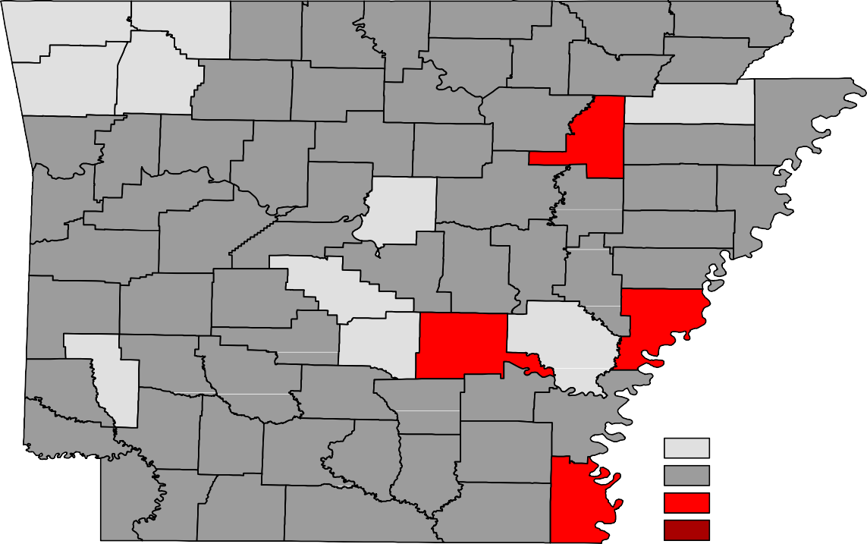
Benton
Carroll
Boone
Fulton
Clay
Marion
Baxter
Randolph
Sharp
Washington
Madison
Izard
Greene
Lawrence
Newton
Searcy
Stone
Independence
Craighead Mississippi
Crawford
Franklin
Johnson
Van Buren
Cleburne
Jackson
Poinsett
Pope
Sebastian
Logan
Conway
White
Cross
Faulkner
Woodruff
Crittenden
Yell
Perry
St. Francis
Scott
Pulaski
Lonoke
Prairie
Lee
Saline
Monroe
Polk
Montgomery
Garland
Phillips
Howard
Hot Spring Grant Jefferson Arkansas
Pike
Sevier
Clark
Dallas
Cleveland
Lincoln
Desha
Little River Hempstead Nevada Ouachita
Calhoun
Drew
Bradley
Miller Lafayette Columbia
Union
Ashley
Chicot
Unemployment Rates
< or = 3.0% 3.1% - 5.0%
5.1% - 7.0%
> 7.0% [NONE]

Ranked by Unemployment Rates
September 2019 (Not Seasonally Adjusted)

Local Workforce Development Areas
Civilian Labor Force Estimates
251,398 243,507 7,891 3.1
97,622 94,346 3,276 3.4
46,469 44,404 2,065 4.4
94,585 90,644 3,941 4.2
121,906 117,829 4,077 3.3
323,410 314,425 8,985 2.8
81,473 77,956 3,517 4.3
92,862 88,712 4,150 4.5
131,599 126,486 5,113 3.9
112,109 108,203 3,906 3.5
253,599 245,385 8,214 3.2
98,419 95,090 3,329 3.4
46,821 44,641 2,180 4.7
93,444 89,281 4,163 4.5
122,304 117,939 4,365 3.6
328,732 319,688 9,044 2.8
81,653 77,854 3,799 4.7
91,465 87,313 4,152 4.5
131,477 126,014 5,463 4.2
111,683 107,644 4,039 3.6
8,092 3.2
3,073 3.1
2,033 4.4
4,031 4.2
3,994 3.2
8,421 2.5
3,529 4.3
3,825 4.1
4,910 3.7
3,782 3.4
Eastern 46,416 44,383
North Central 94,962 90,931
Northeast 122,980 118,986
Northwest 331,016 322,595
Southeast 81,985 78,456
Southwest 92,456 88,631
West Central 132,284 127,374
Western 111,286 107,504
Central (minus LR) 252,724 244,632
City of Little Rock 97,850 94,777
September 2018
CLF Emp Unemp Rate
Emp Unemp Rate
CLF
Not Seasonally Adjusted
August 2019
September 2019
Emp Unemp Rate
CLF
LWDA

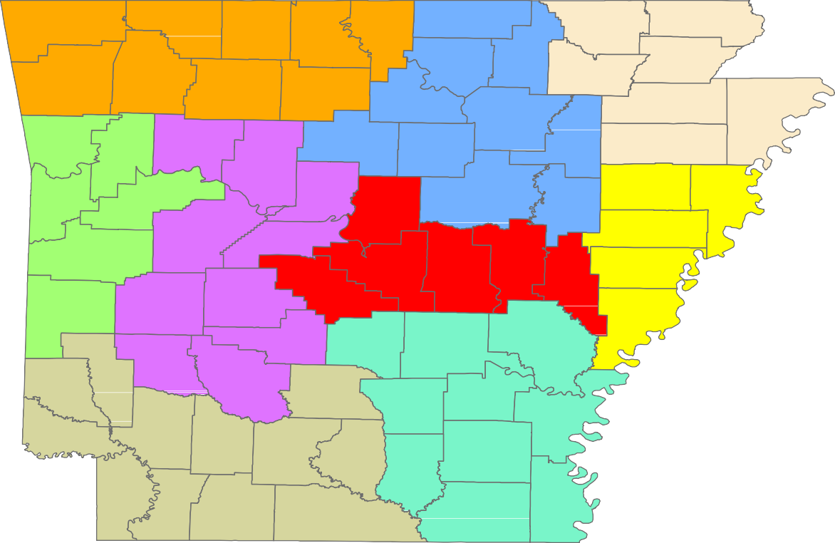
Benton
Carroll
Boone
Fulton
Clay
Marion
Baxter
Randolph
Sharp
Greene
Washington
Madison
Izard
Lawrence
Newton
Searcy
Stone
Craighead
Independence
Mississippi
Crawford
Franklin
Johnson
Van Buren
Cleburne
Jackson
Poinsett
Pope
Sebastian
Logan
Conway
White
Cross
Faulkner
Woodruff
Crittenden
Yell
Perry
St. Francis
Scott
Prairie
Pulaski Lonoke
Lee
Saline
Monroe
Polk
Montgomery
Garland
Phillips
Hot Spring
Grant
Jefferson
Arkansas
Howard
Pike
Sevier
Clark
Dallas
Cleveland
Lincoln
Desha
Little River Hempstead
Nevada
Ouachita
Calhoun
Drew
Bradley
Miller
Columbia
Chicot
Union
Ashley
Lafayette

Central (minus LR) Eastern
www.discover.arkansas.gov
18
North Central
Northeast Northwest Southeast
Southwest West Central Western

