Labor Market Report
October

www.discover.arkansas.gov

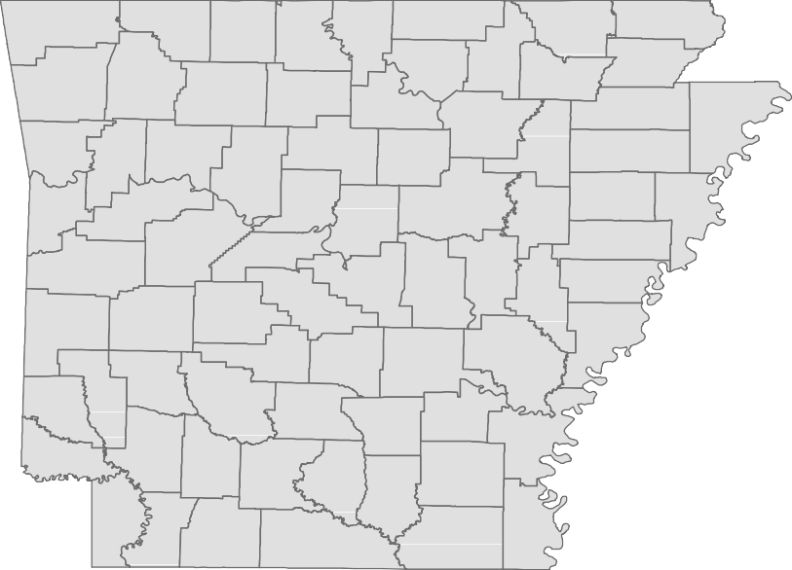
Table of Contents
Monthly Spotlight. 2
Arkansas Labor Force Summary. 3
Arkansas Nonfarm Payroll Jobs. 4
Arkansas Production Workers. 6
Metropolitan Statistical Areas. 7
Micropolitan Statistical Areas/Cities. 14
County Labor Force Statistics. 15
Local Workforce Development Areas. 18

The Arkansas Labor Market is prepared monthly in conjunction with the U.S. Depart- ment of Labor, Bureau of Labor Statistics (BLS). The current month’s estimates are preliminary, while previous month’s data is subject to revision.
Estimates of nonfarm payroll jobs show the number of jobs by industry and reflect employment by place of work. Hours and earnings estimates are based on payroll and worker-hour data collected for production workers in manufacturing industries.
Industries are classified according to the North American Industry Classification System (NAICS). All estimates are based on a first quarter 2018 benchmark.

Explanation of Terms and Concepts Monthly Business Survey of Employers
A monthly sample survey designed to provide industry information on nonfarm payroll jobs. Data are compiled each month from mail surveys and telephone interviews conducted by the Bureau of Labor Statistics in cooperation with Department of Work- force Services. The data are based on es- tablishment records and include all workers, full-or part-time, who received pay during the payroll period which includes the 12th of

Technical Notes
the month. Approximately 5,000 Arkansas
business establishments are surveyed.

Metropolitan Statistical Area (MSA)
A term applied by the U.S. Office of Man- agement and Budget to counties that have one or more central cities and that meet specified criteria of population density, com- muting patterns and social and economic integration.

Current Population Survey (CPS)
A monthly sample survey of the popula- tion 16 years of age and over, designed to provide data on the labor force, the employed and the unemployed. The survey is conducted each month by the Bureau of the Census for BLS. The information is collected by trained interviewers from a sample of about 60,000 households. The data collected are based on the activity reported for the calendar week including the 12th of the month. Approximately 800 Arkansas households are represented in the sample survey.

Civilian Labor Force
The sum of all employed and unemployed persons 16 years of age or older. Members of the Armed Forces are excluded.

Employment
An estimate of the number of persons who worked any time for pay or profit or worked 15 hours or more as unpaid workers in a family business during the calendar week which includes the 12th of the month. Also included are those who, although not work- ing, had some job attachment and were not looking for work, and persons involved in labor management disputes.

Unemployment
An estimate of the number of persons who did not have a job, but were available for work and actively seeking work during the calendar week which includes the 12th of the month.

Unemployment Rate
The number of unemployed as a percentage of the civilian labor force. Unemployment rates are calculated from unrounded data.

Seasonal Adjustment
A statistical technique applied to monthly data to eliminate changes that normally oc- cur during the year due to seasonal events such as weather, major holidays, schedule shifts, harvest times, and the opening/clos- ing of schools.

October Spotlight
Alternative Measures of Labor Underutilization

In addition to the unemployment rate, the Bureau of Labor Statistics (BLS) also calculates five additional es- timates based on various definitions of ‘unemployment’. These are known as Alternative Measures of Labor Underutilization and are referred to as U1-U6, with U-3 as the official unemployment rate. These measures are calculated using data from the Current Population Survey (CPS), a monthly survey conducted by the U.S. Census Bureau. Approximately 800 Arkansas households are in the survey each month.
Alternative Measures of Labor Underutilization are available at the statewide level and are produced quarterly. Estimates are calculated using a four quar- ter moving average. The most recent data available
Alternative Measures of Labor Underutilization
State of Arkansas
4th Q 2018 - 3rd Q 2019
U-1 U-2 U-3 U-4 U-5 U-6
1.0% 1.6% 3.7% 3.9% 4.6% 7.2%
is for 4th Quarter 2018 through 3rd Quarter 2019.
The following definitions are used to calculate each
measure of Labor Underutilization:
  - Measure: Persons unemployed for 15 weeks or longer, as a percent of the civilian labor force.
  - Measure: Job losers and persons who completed temporary jobs, as a percent of the civilian labor force. U-3 Measure: Total number of unemployed persons, as a percent of the civilian labor force (this is the definition used for the official unemployment rate).
  - Measure: Total number of unemployed and discouraged workers, as a percent of the civilian labor force plus discouraged workers.
  - Measure: Total number of unemployed, discouraged workers, and all other marginally attached workers, as a percent of the civilian labor force plus marginally attached workers.
  - Measure: Total number of unemployed, discouraged workers, marginally attached workers, and those em- ployed part-time for economic reasons (not by choice), as a percent of the civilian labor force plus marginally attached workers.

Alternative Measures of Labor Underutilization

State of Arkansas
Three-Year Comparison (Quarter Ending)
9.0

8.0

7.0

6.0

5.0

4.0

3.0

2.0

1.0

0.0

U-1

U-2

U-3 3rd Q 2017

3rd Q 2018

U-4
3rd Q 2019

U-5

U-6

State of Arkansas
Civilian Labor Force Summary

Labor force data, produced by the U.S. Department of Labor, Bureau of Labor Statistics and released by the Arkansas Division of Workforce Services, show Arkansas’ seasonally adjusted unemployment rate remained stable at 3.5 percent between September and October. Arkansas’ civilian labor force increased 1,626, a result of an additional 937 employed and 689 more unemployed Arkansans. The United States’ jobless rate increased one-tenth of a percentage point, from 3.5 percent in September to 3.6 percent in October.
BLS Program Operations Manager Susan Price said, “Arkansas’ unemployment rate was unchanged at
3.5 percent in October, as gains in employment and unemployment were small. Despite recent fluc- tuations in employment, there are currently 12,736 more employed Arkansans compared to October 2018.”
Civilian Labor Force Estimates
Seasonally Adjusted
Not Seasonally Adjusted
Employment 1,316,012 1,315,075 1,303,276 Employment 1,327,963 1,318,183 1,310,995
Unemployment 47,794 47,105 49,532 Unemployment 43,543 45,710 44,065
Unemployment Rate 3.5 3.5 3.7 Unemployment Rate 3.2 3.4 3.3
U.S. Unemployment 3.6 3.5 3.8 U.S. Unemployment 3.3 3.3 3.5

 | Oct 19 | Sep 19 | Oct 18 | Oct 19 | Sep 19 | Oct 18
Civilian Labor Force | 1,363,806 | 1,362,180 | 1,352,808 Civilian Labor Force | 1,371,506 | 1,363,893 | 1,355,060

Unemployment Rates - United States vs Arkansas (Seasonally Adjusted)

October 2016 - October 2019
5.0

4.8

4.6

4.4

4.2

4.0

3.8

3.6

3.4

3.2

3.0
Oct '16 Apr '17 Oct '17 Apr '18 Oct '18 Apr '19 Oct '19
United States Arkansas

State of Arkansas
Nonfarm Payroll Jobs

Not Seasonally Adjusted
(In Thousands)

(NAICS) Oct 19 Sep 19 Oct 18 OTM OTY
Total Nonfarm | 1291.7 | 1285.9 | 1273.2 | 5.8 | 18.5
Goods Producing | 225.4 | 223.2 | 218.3 | 2.2 | 7.1
Mining, Logging, and Construction | 61.2 | 61.1 | 57.8 | 0.1 | 3.4
Mining & Logging | 5.7 | 5.8 | 6.1 | -0.1 | -0.4
Construction | 55.5 | 55.3 | 51.7 | 0.2 | 3.8
Specialty Trade Contractors | 34.8 | 33.9 | 32.9 | 0.9 | 1.9
Manufacturing | 164.2 | 162.1 | 160.5 | 2.1 | 3.7
Durable Goods | 77.7 | 76.7 | 76.5 | 1.0 | 1.2
Nondurable Goods | 86.5 | 85.4 | 84.0 | 1.1 | 2.5
Service Providing | 1066.3 | 1062.7 | 1054.9 | 3.6 | 11.4
Trade, Transportation & Utilities | 253.9 | 252.5 | 252.0 | 1.4 | 1.9
Wholesale Trade | 48.9 | 48.6 | 47.8 | 0.3 | 1.1
Retail Trade | 139.0 | 138.2 | 138.5 | 0.8 | 0.5
Transport, Warehousing & Utilities | 66.0 | 65.7 | 65.7 | 0.3 | 0.3
Information | 10.9 | 10.8 | 11.1 | 0.1 | -0.2
Financial Activities | 62.8 | 63.3 | 60.8 | -0.5 | 2.0
Finance & Insurance | 48.9 | 49.3 | 47.2 | -0.4 | 1.7
Real Estate & Rental & Leasing | 13.9 | 14.0 | 13.6 | -0.1 | 0.3
Professional & Business Services | 148.8 | 147.0 | 148.0 | 1.8 | 0.8
Professional, Scientific & Technical | 44.2 | 43.2 | 44.0 | 1.0 | 0.2
Management of Companies | 36.6 | 36.2 | 34.9 | 0.4 | 1.7
Administrative & Support Services | 68.0 | 67.6 | 69.1 | 0.4 | -1.1
Educational & Health Services | 196.3 | 195.6 | 194.3 | 0.7 | 2.0
Educational Services | 16.3 | 15.9 | 16.2 | 0.4 | 0.1
Health Care & Social Assistance | 180.0 | 179.7 | 178.1 | 0.3 | 1.9
Ambulatory Health Care | 59.5 | 59.3 | 59.0 | 0.2 | 0.5
Social Assistance | 41.7 | 41.6 | 40.4 | 0.1 | 1.3
Leisure & Hospitality | 123.8 | 124.7 | 119.2 | -0.9 | 4.6
Arts, Entertainment & Recreation | 10.9 | 11.3 | 10.7 | -0.4 | 0.2
Accommodation & Food Services | 112.9 | 113.4 | 108.5 | -0.5 | 4.4
Accommodation Services | 11.5 | 11.6 | 11.4 | -0.1 | 0.1
Food Services | 101.4 | 101.8 | 97.1 | -0.4 | 4.3
Other Services | 53.2 | 53.0 | 53.4 | 0.2 | -0.2
Government | 216.6 | 215.8 | 216.1 | 0.8 | 0.5
Federal Government | 20.5 | 20.6 | 20.1 | -0.1 | 0.4
State Government | 80.0 | 79.3 | 79.7 | 0.7 | 0.3
Local Government | 116.1 | 115.9 | 116.3 | 0.2 | -0.2

State of Arkansas
Nonfarm Payroll Job Summary

September 2019 - October 2019
Nonfarm payroll jobs in Arkansas rose 5,800 in October to total 1,291,700. Gains were posted in eight major industry sectors, while three sectors slightly declined. Manufacturing added 2,100 jobs. Ex- pansions occurred in both nondurable (+1,100) and durable (+1,000) goods manufacturing, due to seasonal hiring at food manufacturing facilities and recalled workers. Employment in professional and business services rose 1,800. Most of the gains were in professional-scientific-technical services (+1,000), related in part to hiring for the upcoming tax season. Jobs in trade, transportation, and utilities increased 1,400. Hiring was reported in all three subsectors, due to preparation for the holiday shopping season.

October 2018 - October 2019
Since October 2018, Arkansas’ nonfarm payroll jobs are up 18,500. Eight major industry sectors posted growth, with five adding 2,000 or more jobs, each. Employment in leisure and hospitality increased 4,600. A majority of the gains occurred in food services (+4,300). Jobs in construction rose 3,800, re- lated to continuing projects. Manufacturing added 3,700 jobs, largely in nondurable goods manufac- turing (+2,500). Jobs in financial activities are up 2,000. Most of the growth was reported in finance and insurance (+1,700). Educational and health services increased 2,000, related to expansions in health care and social assistance (+1,900).

Nonfarm Payroll Jobs (Not Seasonally Adjusted)

October: 1999 - 2019
1,350,000

1,300,000

1,250,000

1,200,000

1,150,000

1,100,000

1,050,000
'99 '01 '03 '05 '07 '09 '11 '13 '15 '17 '19

State of Arkansas
Production Workers- Hours and Earnings

Manufacturing
Oct 18
43.3
18.17
786.76
Sep 19
41.3
18.70
772.31
Oct 19
Average Weekly Hours 40.8
Average Hourly Earnings 18.79
Average Weekly Earnings 766.63

Durable Goods and Nondurable Goods Manufacturing
Oct 18
42.6
16.04
683.30
Sep 19
40.6
16.57
672.74
Oct 19
Average Weekly Hours 39.2
Average Hourly Earnings 16.37
Average Weekly Earnings 641.70
Oct 18
44.2
20.59
910.08
Sep 19
42.1
21.07
887.05
Oct 19
Average Weekly Hours 42.6
Average Hourly Earnings 21.39
Average Weekly Earnings 911.21
Nondurable Goods Manufacturing
Durable Goods Manufacturing

Average Weekly Hours Worked - Production Workers in Manufacturing

October 2017 - October 2019
45.0

44.0

43.0

42.0

41.0

40.0

39.0

38.0

37.0

Oct '17
Apr '18
Oct '18
Apr '19
Oct '19

Metropolitan Statistical Areas
Little Rock-North Little Rock-Conway MSA

The Little Rock-North Little Rock-Conway MSA = Faulkner, Grant, Lonoke, Perry, Pulaski, & Saline counties.

Civilian Labor Force Estimates (Not Seasonally Adjusted)

 | Oct 19 | Sep 19 | Oct 18 | OTM | OTY
Civilian Labor Force | 360,147 | 357,382 | 355,560 | 2,765 | 4,587
Employment | 349,423 | 346,094 | 344,888 | 3,329 | 4,535
Unemployment | 10,724 | 11,288 | 10,672 | -564 | 52
Unemployment Rate | 3.0 | 3.2 | 3.0 | -0.2 | 0.0

Nonfarm Payroll Jobs (Not Seasonally Adjusted)
(In Thousands)

NAICS Oct 19 | Sep 19 | Oct 18 | OTM | OTY
Total Nonfarm 368.3 | 366.7 | 364.7 | 1.6 | 3.6
Goods Producing 38.3 | 38.2 | 38.5 | 0.1 | -0.2
Mining, Logging & Construction 17.6 | 17.5 | 17.5 | 0.1 | 0.1
Manufacturing 20.7 | 20.7 | 21.0 | 0.0 | -0.3
Service Providing 330.0 | 328.5 | 326.2 | 1.5 | 3.8
Trade, Transportation & Utilities 71.1 | 70.6 | 70.7 | 0.5 | 0.4
Wholesale Trade 16.4 | 16.3 | 16.0 | 0.1 | 0.4
Retail Trade 38.5 | 38.0 | 38.8 | 0.5 | -0.3
Trans., Warehousing & Utilities 16.2 | 16.3 | 15.9 | -0.1 | 0.3
Information 4.1 | 4.1 | 4.2 | 0.0 | -0.1
Financial Activities 21.6 | 21.6 | 21.4 | 0.0 | 0.2
Professional & Business Services 49.5 | 48.2 | 50.0 | 1.3 | -0.5
Educational & Health Services 59.8 | 60.2 | 58.0 | -0.4 | 1.8
Leisure & Hospitality 36.1 | 36.1 | 34.8 | 0.0 | 1.3
Other Services 15.9 | 16.0 | 15.7 | -0.1 | 0.2
Government 71.9 | 71.7 | 71.4 | 0.2 | 0.5
Federal Government 9.8 | 9.8 | 9.6 | 0.0 | 0.2
State Government 36.1 | 35.9 | 35.7 | 0.2 | 0.4
Local Government 26.0 | 26.0 | 26.1 | 0.0 | -0.1

Employment

October: 2009 - 2019
360,000

Jobs in Leisure and Hospitality

January 2017 - October 2019
38,000

37,000
350,000

36,000

340,000
35,000

330,000

34,000

33,000

320,000
32,000

310,000 31,000

300,000

'09

'10

'11

'12

'13

'14

'15

'16

'17

'18

'19

30,000
J F M A M J J A S O N D

2017 2018 2019

Metropolitan Statistical Areas
Fayetteville-Springdale-Rogers MSA

The Fayetteville-Springdale-Rogers MSA = Benton, Madison, & Washington counties in Arkansas
and McDonald county in Missouri.
Civilian Labor Force Estimates (Not Seasonally Adjusted)

 | Oct 19 | Sep 19 | Oct 18 | OTM | OTY
Civilian Labor Force | 286,952 | 284,020 | 276,369 | 2,932 | 10,583
Employment | 280,464 | 277,288 | 269,480 | 3,176 | 10,984
Unemployment | 6,488 | 6,732 | 6,889 | -244 | -401
Unemployment Rate | 2.3 | 2.4 | 2.5 | -0.1 | -0.2

Nonfarm Payroll Jobs (Not Seasonally Adjusted)
(In Thousands)

NAICS Oct 19 | Sep 19 | Oct 18 | OTM | OTY
Total Nonfarm 271.5 | 269.5 | 261.1 | 2.0 | 10.4
Goods Producing 43.1 | 42.7 | 41.4 | 0.4 | 1.7
Mining, Logging & Construction 12.4 | 12.3 | 11.7 | 0.1 | 0.7
Manufacturing 30.7 | 30.4 | 29.7 | 0.3 | 1.0
Service Providing 228.4 | 226.8 | 219.7 | 1.6 | 8.7
Trade, Transportation & Utilities 57.9 | 57.6 | 56.6 | 0.3 | 1.3
Wholesale Trade 12.6 | 12.5 | 12.2 | 0.1 | 0.4
Retail Trade 27.2 | 27.2 | 26.7 | 0.0 | 0.5
Trans., Warehousing & Utilities 18.1 | 17.9 | 17.7 | 0.2 | 0.4
Information 2.1 | 2.1 | 2.0 | 0.0 | 0.1
Financial Activities 8.5 | 8.5 | 8.2 | 0.0 | 0.3
Professional & Business Services 53.5 | 53.2 | 50.2 | 0.3 | 3.3
Educational & Health Services 30.6 | 30.4 | 29.6 | 0.2 | 1.0
Leisure & Hospitality 27.0 | 27.1 | 25.7 | -0.1 | 1.3
Other Services 9.5 | 9.5 | 9.3 | 0.0 | 0.2
Government 39.3 | 38.4 | 38.1 | 0.9 | 1.2
Federal Government 2.7 | 2.7 | 2.6 | 0.0 | 0.1
State Government 17.2 | 16.9 | 16.3 | 0.3 | 0.9
Local Government 19.4 | 18.8 | 19.2 | 0.6 | 0.2
Over-the-Year Employment Change by Industry Sector

October 2018 vs October 2019

Professional & Business

Leisure & Hospitality

Trade-Transportation-Utilities

Government

Manufacturing

Educational & Health

Mining-Logging-Construction

Financial Activities

Other Services

Information

- 500 1,000 1,500 2,000 2,500 3,000 3,500

Metropolitan Statistical Areas
Fort Smith MSA

The Fort Smith MSA = Crawford & Sebastian counties in Arkansas & LeFlore & Sequoyah counties in Oklahoma.

Civilian Labor Force Estimates (Not Seasonally Adjusted)

 | Oct 19 | Sep 19 | Oct 18 | OTM | OTY
Civilian Labor Force | 118,840 | 118,302 | 118,933 | 538 | -93
Employment | 114,723 | 114,175 | 114,840 | 548 | -117
Unemployment | 4,117 | 4,127 | 4,093 | -10 | 24
Unemployment Rate | 3.5 | 3.5 | 3.4 | 0.0 | 0.1

Nonfarm Payroll Jobs (Not Seasonally Adjusted)
(In Thousands)

NAICS Oct 19  Total Nonfarm 113.5 | Sep 19  113.2 | Oct 18  113.8 | OTM  0.3 | OTY  -0.3
Goods Producing 22.8 | 22.9 | 22.8 | -0.1 | 0.0
Mining, Logging & Construction 5.0 | 5.1 | 5.2 | -0.1 | -0.2
Manufacturing 17.8 | 17.8 | 17.6 | 0.0 | 0.2
Service Providing 90.7 | 90.3 | 91.0 | 0.4 | -0.3
Trade, Transportation & Utilities 23.1 | 22.7 | 23.1 | 0.4 | 0.0
Wholesale Trade 4.3 | 4.2 | 4.2 | 0.1 | 0.1
Retail Trade 12.3 | 12.0 | 12.3 | 0.3 | 0.0
Trans., Warehousing & Utilities 6.5 | 6.5 | 6.6 | 0.0 | -0.1
Information 1.1 | 1.1 | 1.2 | 0.0 | -0.1
Financial Activities 4.0 | 4.0 | 4.0 | 0.0 | 0.0
Professional & Business Services 12.9 | 12.9 | 13.1 | 0.0 | -0.2
Educational & Health Services 17.4 | 17.3 | 17.2 | 0.1 | 0.2
Leisure & Hospitality 9.4 | 9.5 | 9.4 | -0.1 | 0.0
Other Services 4.5 | 4.5 | 4.5 | 0.0 | 0.0
Government 18.3 | 18.3 | 18.5 | 0.0 | -0.2
Federal Government 1.3 | 1.3 | 1.3 | 0.0 | 0.0
State Government 3.2 | 3.1 | 3.2 | 0.1 | 0.0
Local Government 13.8 | 13.9 | 14.0 | -0.1 | -0.2
Number of Employed Nonfarm Payroll Jobs
October 2017 - October 2019 October: 2009 - 2019
116,000

Oct '17
119,000
117,000
 |  | 112,000
115,000
113,000 |  | 108,000
111,000
109,000 |  | 104,000
107,000

Apr '18

Oct '18

Apr '19

Oct '19

100,000

'09 '10 '11 '12 '13 '14 '15 '16 '17 '18 '19

Metropolitan Statistical Areas
Hot Springs MSA
The Hot Springs MSA = Garland County.

Civilian Labor Force Estimates (Not Seasonally Adjusted)

 | Oct 19 | Sep 19 | Oct 18 | OTM | OTY
Civilian Labor Force | 41,014 | 41,006 | 40,404 | 8 | 610
Employment | 39,596 | 39,548 | 38,890 | 48 | 706
Unemployment | 1,418 | 1,458 | 1,514 | -40 | -96
Unemployment Rate | 3.5 | 3.6 | 3.7 | -0.1 | -0.2

Nonfarm Payroll Jobs (Not Seasonally Adjusted)
(In Thousands)
NAICS
Total Nonfarm Goods Producing Service Providing Government

Oct 19 | Sep 19 | Oct 18 | OTM | OTY
39.5 | 39.4 | 38.8 | 0.1 | 0.7
4.5 | 4.5 | 4.5 | 0.0 | 0.0
35.0 | 34.9 | 34.3 | 0.1 | 0.7
4.5 | 4.5 | 4.5 | 0.0 | 0.0

36,000

Jobs in Service Providing Industries

January 2017 - October 2019

35,500

35,000

34,500

34,000

33,500

33,000

32,500

32,000

J F M A M J J A S O N D
2017 2018 2019

Metropolitan Statistical Areas
Jonesboro MSA

The Jonesboro MSA = Craighead & Poinsett counties.

Civilian Labor Force Estimates (Not Seasonally Adjusted)

 | Oct 19 | Sep 19 | Oct 18 | OTM | OTY
Civilian Labor Force | 66,208 | 65,524 | 64,667 | 684 | 1,541
Employment | 64,513 | 63,743 | 62,873 | 770 | 1,640
Unemployment | 1,695 | 1,781 | 1,794 | -86 | -99
Unemployment Rate | 2.6 | 2.7 | 2.8 | -0.1 | -0.2

Nonfarm Payroll Jobs (Not Seasonally Adjusted)
(In Thousands)
NAICS
Total Nonfarm Goods Producing Service Providing Government

Oct 19 | Sep 19 | Oct 18 | OTM | OTY
60.6 | 60.2 | 59.1 | 0.4 | 1.5
10.2 | 10.2 | 10.2 | 0.0 | 0.0
50.4 | 50.0 | 48.9 | 0.4 | 1.5
9.2 | 9.2 | 9.1 | 0.0 | 0.1

65,000

Nonfarm Payroll Jobs

October: 1999 - 2019

60,000

55,000

50,000

45,000

40,000

35,000

30,000
'99 '01 '03 '05 '07 '09 '11 '13 '15 '17 '19

Metropolitan Statistical Areas
Pine Bluff MSA

The Pine Bluff MSA = Cleveland, Jefferson, & Lincoln counties.

Civilian Labor Force Estimates (Not Seasonally Adjusted)

 | Oct 19 | Sep 19 | Oct 18 | OTM | OTY
Civilian Labor Force | 35,245 | 35,124 | 35,546 | 121 | -301
Employment | 33,604 | 33,396 | 33,944 | 208 | -340
Unemployment | 1,641 | 1,728 | 1,602 | -87 | 39
Unemployment Rate | 4.7 | 4.9 | 4.5 | -0.2 | 0.2

Nonfarm Payroll Jobs (Not Seasonally Adjusted)
(In Thousands)
NAICS
Total Nonfarm Goods Producing Service Providing Government

Oct 19 | Sep 19 | Oct 18 | OTM | OTY
33.2 | 33.2 | 33.6 | 0.0 | -0.4
6.0 | 6.0 | 6.0 | 0.0 | 0.0
27.2 | 27.2 | 27.6 | 0.0 | -0.4
9.1 | 9.1 | 9.3 | 0.0 | -0.2

40,000

Nonfarm Payroll Jobs

October: 2009 - 2019

38,000

36,000

34,000

32,000

30,000

28,000

26,000

24,000

22,000

20,000
2009 2010 2011 2012 2013 2014 2015 2016 2017 2018 2019

Metropolitan Statistical Areas
Out-of-State MSA

Civilian Labor Force Estimates (Not Seasonally Adjusted)

Memphis, TN-MS-AR MSA

The Memphis, TN-MS-AR MSA = Fayette, Shelby, & Tipton counties in Tennessee; Benton, Desoto, Marshall, Tate, & Tunica counties in Mississippi; & Crittenden County in Arkansas.

 | Oct 19 | Sep 19 | Oct 18 | OTM | OTY
Civilian Labor Force | 646,985 | 648,021 | 636,392 | -1,036 | 10,593
Employment | 622,117 | 621,699 | 611,449 | 418 | 10,668
Unemployment | 24,868 | 26,322 | 24,943 | -1,454 | -75
Unemployment Rate | 3.8 | 4.1 | 3.9 | -0.3 | -0.1

Texarkana MSA
The Texarkana MSA= Bowie County in Texas & Little River & Miller counties in Arkansas.

 | Oct 19 | Sep 19 | Oct 18 | OTM | OTY
Civilian Labor Force | 64,988 | 64,761 | 65,123 | 227 | -135
Employment | 62,405 | 62,118 | 61,974 | 287 | 431
Unemployment | 2,583 | 2,643 | 3,149 | -60 | -566
Unemployment Rate | 4.0 | 4.1 | 4.8 | -0.1 | -0.8

Memphis MSA - Number of Employed

October: 2009 - 2019
650,000

Texarkana MSA - Civilian Labor Force

October 2017 - October 2019
66,000

630,000

65,500
610,000

590,000

65,000

570,000

550,000
64,500

530,000
64,000
510,000

490,000

63,500

470,000

63,000

450,000

'09 '10 '11 '12 '13 '14 '15 '16 '17 '18 '19
Oct '17
Apr '18
Oct '18
Apr '19
Oct '19

Micropolitan Statistical Areas and Cities
Civilian Labor Force Estimates

Micropolitan Labor Force Estimates

3.2
3.6
4.3
4.0
4.6
4.5
3.1
5.0
3.3
4.0
3.3
3.6
3.0
3.6
3.7
319
591
758
491
726
370
590
330
453
357
462
593
589
1,348
1,248
9,623
15,635
16,999
11,731
15,143
7,913
18,471
6,222
13,217
8,623
13,526
15,955
19,015
36,365
32,569
October 2018
Emp Unemp Rate
CLF
9,942
16,226
17,757
12,222
15,869
8,283
19,061
6,552
13,670
8,980
13,988
16,548
19,604
37,713
33,817
3.6
3.9
4.5
4.4
5.0
4.8
3.1
5.8
3.7
4.2
3.5
3.6
3.4
3.8
4.0
353
642
786
536
780
388
604
368
498
384
486
595
670
1,424
1,364
9,402
15,838
16,823
11,779
14,950
7,767
18,776
5,999
13,089
8,766
13,464
15,831
19,238
35,613
32,451
Emp Unemp Rate
CLF
9,755
16,480
17,609
12,315
15,730
8,155
19,380
6,367
13,587
9,150
13,950
16,426
19,908
37,037
33,815
3.5
3.7
4.1
4.3
4.8
4.5
3.0
5.5
3.5
4.0
3.4
3.4
3.1
3.5
3.8
342
611
720
533
763
365
577
351
481
371
476
560
622
1,288
1,292
9,443
15,856
16,937
11,836
15,013
7,801
18,875
6,058
13,091
8,817
13,531
15,790
19,363
35,948
32,565
Not Seasonally Adjusted
September 2019
October 2019
Emp Unemp Rate
CLF
9,785
16,467
17,657
12,369
15,776
8,166
19,452
6,409
13,572
9,188
14,007
16,350
19,985
37,236
33,857
Micro Area
Arkadelphia Micro Batesville Micro Blytheville Micro Camden Micro
El Dorado Micro Forrest City Micro Harrison Micro
Helena-West Helena Micro Hope Micro
Magnolia Micro Malvern Micro Mountain Home Micro Paragould Micro Russellville Micro Searcy Micro

Arkadelphia Micro = Clark County Batesville Micro = Independence County Blytheville Micro = Mississippi County
Camden Micro = Calhoun & Ouachita counties
El Dorado Micro = Union County
Forrest City Micro = St. Francis County Harrison Micro = Boone & Newton counties Helena-West Helena Micro = Phillips County Hope Micro = Hempstead & Nevada counties Magnolia Micro = Columbia County

City Labor Force Statistics
Malvern Micro = Hot Spring County Mountain Home Micro = Baxter County Paragould Micro = Greene County Russellville Micro = Pope & Yell counties Searcy Micro = White County

Not Seasonally Adjusted

October 2019 September 2019 October 2018

City CLF Emp Unemp
Rate
CLF Emp Unemp
Rate
CLF Emp Unemp
Rate

Bella Vista Benton Bentonville Blytheville Cabot Conway
El Dorado Fayetteville Fort Smith Hot Springs Jacksonville Jonesboro Little Rock
North Little Rock Paragould
Pine Bluff Rogers Russellville Searcy Sherwood Springdale Texarkana, AR Van Buren West Memphis
12,690
17,427
27,213
6,008
12,165
33,952
6,861
49,368
39,409
14,647
11,939
39,166
98,899
30,217
12,535
16,721
36,775
13,394
10,291
16,181
40,663
13,577
10,363
10,715
12,332
16,955
26,666
5,728
11,801
33,059
6,486
48,273
38,166
14,050
11,438
38,174
95,841
29,200
12,127
15,732
35,966
12,941
9,954
15,735
39,749
13,064
10,063
10,234
358
472
547
280
364
893
375
1,095
1,243
597
501
992
3,058
1,017
408
989
809
453
337
446
914
513
300
481
2.8
2.7
2.0
4.7
3.0
2.6
5.5
2.2
3.2
4.1
4.2
2.5
3.1
3.4
3.3
5.9
2.2
3.4
3.3
2.8
2.2
3.8
2.9
4.5
12,563
17,280
26,961
6,025
12,055
33,693
6,839
48,901
39,200
14,660
11,910
38,782
98,013
30,040
12,494
16,657
36,406
13,304
10,284
16,080
40,217
13,536
10,279
10,681
12,192
16,799
26,364
5,690
11,674
32,752
6,458
47,747
37,901
14,033
11,331
37,732
94,943
28,926
12,049
15,640
35,558
12,829
9,919
15,587
39,315
12,987
9,985
10,160
371
481
597
335
381
941
381
1,154
1,299
627
579
1,050
3,070
1,114
445
1,017
848
475
365
493
902
549
294
521
3.0
2.8
2.2
5.6
3.2
2.8
5.6
2.4
3.3
4.3
4.9
2.7
3.1
3.7
3.6
6.1
2.3
3.6
3.5
3.1
2.2
4.1
2.9
4.9
12,278
17,223
26,232
6,030
11,999
33,588
6,913
47,575
39,387
14,442
11,733
38,226
97,598
29,790
12,305
16,806
35,458
13,527
10,339
15,942
39,125
13,627
10,391
10,571
11,853
16,729
25,630
5,749
11,668
32,633
6,542
46,398
38,111
13,799
11,285
37,175
94,563
28,811
11,909
15,883
34,569
13,082
9,955
15,525
38,205
12,965
10,058
10,154
425
494
602
281
331
955
371
1,177
1,276
643
448
1,051
3,035
979
396
923
889
445
384
417
920
662
333
417
3.5
2.9
2.3
4.7
2.8
2.8
5.4
2.5
3.2
4.5
3.8
2.7
3.1
3.3
3.2
5.5
2.5
3.3
3.7
2.6
2.4
4.9
3.2
3.9

www.discover.arkansas.gov 14

County Labor Force Statistics
Civilian Labor Force Estimates
Not Seasonally Adjusted

 |  | October 2019 |  |  | September 2019 |  |  | October 2018
County | CLF | Emp Unemp | Rate | CLF | Emp Unemp | Rate | CLF | Emp Unemp | Rate

Arkansas Ashley Baxter Benton Boone Bradley Calhoun Carroll Chicot Clark Clay Cleburne Cleveland Columbia Conway
Craighead Crawford Crittenden Cross Dallas Desha Drew Faulkner Franklin Fulton Garland Grant Greene Hempstead Hot Spring Howard
Independence Izard
Jackson Jefferson Johnson Lafayette Lawrence Lee Lincoln Little River Logan Lonoke Madison Marion Miller
9,586
7,811
16,350
140,176
16,091
4,554
2,440
12,836
3,338
9,785
5,649
9,256
3,289
9,188
8,273
55,674
26,733
21,662
7,414
2,847
5,591
7,896
62,289
7,472
4,895
41,014
8,481
19,985
9,943
14,007
5,638
16,467
4,908
5,929
27,943
10,248
2,495
6,974
2,887
4,013
5,495
8,583
34,410
7,718
6,609
19,708
9,335
7,470
15,790
136,927
15,616
4,396
2,355
12,500
3,149
9,443
5,429
8,861
3,171
8,817
7,953
54,299
25,916
20,863
7,128
2,729
5,380
7,542
60,565
7,237
4,733
39,596
8,232
19,363
9,596
13,531
5,480
15,856
4,689
5,571
26,570
9,863
2,387
6,730
2,769
3,863
5,273
8,218
33,401
7,534
6,365
19,001
251
341
560
3,249
475
158
85
336
189
342
220
395
118
371
320
1,375
817
799
286
118
211
354
1,724
235
162
1,418
249
622
347
476
158
611
219
358
1,373
385
108
244
118
150
222
365
1,009
184
244
707
2.6
4.4
3.4
2.3
3.0
3.5
3.5
2.6
5.7
3.5
3.9
4.3
3.6
4.0
3.9
2.5
3.1
3.7
3.9
4.1
3.8
4.5
2.8
3.1
3.3
3.5
2.9
3.1
3.5
3.4
2.8
3.7
4.5
6.0
4.9
3.8
4.3
3.5
4.1
3.7
4.0
4.3
2.9
2.4
3.7
3.6
9,525
7,831
16,426
138,793
16,028
4,552
2,422
12,837
3,327
9,755
5,664
9,347
3,259
9,150
8,266
55,121
26,562
21,578
7,403
2,826
5,479
7,839
61,804
7,436
4,956
41,006
8,388
19,908
9,944
13,950
5,616
16,480
4,992
5,845
27,870
10,214
2,486
6,973
2,851
3,995
5,455
8,554
34,241
7,615
6,690
19,627
9,275
7,471
15,831
135,376
15,534
4,392
2,337
12,487
3,127
9,402
5,419
8,948
3,147
8,766
7,917
53,671
25,714
20,712
7,115
2,700
5,255
7,483
60,003
7,188
4,780
39,548
8,133
19,238
9,588
13,464
5,453
15,838
4,741
5,489
26,415
9,799
2,370
6,705
2,728
3,834
5,232
8,172
33,041
7,431
6,427
18,889
250
360
595
3,417
494
160
85
350
200
353
245
399
112
384
349
1,450
848
866
288
126
224
356
1,801
248
176
1,458
255
670
356
486
163
642
251
356
1,455
415
116
268
123
161
223
382
1,200
184
263
738
2.6
4.6
3.6
2.5
3.1
3.5
3.5
2.7
6.0
3.6
4.3
4.3
3.4
4.2
4.2
2.6
3.2
4.0
3.9
4.5
4.1
4.5
2.9
3.3
3.6
3.6
3.0
3.4
3.6
3.5
2.9
3.9
5.0
6.1
5.2
4.1
4.7
3.8
4.3
4.0
4.1
4.5
3.5
2.4
3.9
3.8
9,150
7,740
16,548
135,134
15,763
4,532
2,419
12,841
3,292
9,942
5,841
9,179
3,321
8,980
8,210
54,346
26,765
21,488
7,412
2,876
5,555
7,950
61,588
7,433
4,740
40,404
8,372
19,604
10,034
13,988
5,909
16,226
4,830
5,847
28,166
10,453
2,504
6,972
2,946
4,059
5,513
8,764
34,014
7,500
6,460
19,731
8,890
7,391
15,955
131,608
15,273
4,361
2,343
12,498
3,111
9,623
5,620
8,823
3,209
8,623
7,908
52,878
25,901
20,700
7,146
2,767
5,353
7,621
59,785
7,196
4,579
38,890
8,140
19,015
9,693
13,526
5,712
15,635
4,627
5,533
26,825
10,069
2,395
6,737
2,825
3,910
5,234
8,452
33,025
7,304
6,212
18,857
260
349
593
3,526
490
171
76
343
181
319
221
356
112
357
302
1,468
864
788
266
109
202
329
1,803
237
161
1,514
232
589
341
462
197
591
203
314
1,341
384
109
235
121
149
279
312
989
196
248
874
2.8
4.5
3.6
2.6
3.1
3.8
3.1
2.7
5.5
3.2
3.8
3.9
3.4
4.0
3.7
2.7
3.2
3.7
3.6
3.8
3.6
4.1
2.9
3.2
3.4
3.7
2.8
3.0
3.4
3.3
3.3
3.6
4.2
5.4
4.8
3.7
4.4
3.4
4.1
3.7
5.1
3.6
2.9
2.6
3.8
4.4

(continued on Page 16)

County Labor Force Statistics
Civilian Labor Force Estimates
(continued from Page 15)

Not Seasonally Adjusted

 |  | October 2019 |  |  | September 2019 |  |  | October 2018
County | CLF | Emp Unemp | Rate | CLF | Emp Unemp | Rate | CLF | Emp Unemp | Rate

Mississippi Monroe Montgomery Nevada Newton Ouachita Perry
Phillips Pike Poinsett Polk Pope Prairie Pulaski Randolph
St. Francis Saline Scott Searcy Sebastian Sevier Sharp Stone Union Van Buren
Washington White Woodruff Yell
17,657
2,768
2,968
3,629
3,361
9,929
4,280
6,409
4,291
10,534
8,016
28,778
3,600
192,144
7,385
8,166
58,543
4,337
2,897
56,772
5,463
5,704
4,753
15,776
5,709
127,935
33,857
2,831
8,458
16,937
2,657
2,842
3,495
3,259
9,481
4,138
6,058
4,139
10,214
7,683
27,768
3,467
186,108
7,149
7,801
56,979
4,198
2,772
55,033
5,215
5,443
4,570
15,013
5,456
125,147
32,565
2,701
8,180
720
111
126
134
102
448
142
351
152
320
333
1,010
133
6,036
236
365
1,564
139
125
1,739
248
261
183
763
253
2,788
1,292
130
278
4.1
4.0
4.2
3.7
3.0
4.5
3.3
5.5
3.5
3.0
4.2
3.5
3.7
3.1
3.2
4.5
2.7
3.2
4.3
3.1
4.5
4.6
3.9
4.8
4.4
2.2
3.8
4.6
3.3
17,609
2,764
3,012
3,643
3,352
9,893
4,250
6,367
4,295
10,403
8,042
28,652
3,619
190,650
7,353
8,155
58,049
4,325
3,002
56,458
5,465
5,727
4,763
15,730
5,762
126,661
33,815
2,810
8,385
16,823
2,647
2,881
3,501
3,242
9,442
4,101
5,999
4,146
10,072
7,686
27,528
3,453
184,363
7,110
7,767
56,453
4,180
2,871
54,651
5,205
5,459
4,580
14,950
5,502
123,782
32,451
2,670
8,085
786
117
131
142
110
451
149
368
149
331
356
1,124
166
6,287
243
388
1,596
145
131
1,807
260
268
183
780
260
2,879
1,364
140
300
4.5
4.2
4.3
3.9
3.3
4.6
3.5
5.8
3.5
3.2
4.4
3.9
4.6
3.3
3.3
4.8
2.7
3.4
4.4
3.2
4.8
4.7
3.8
5.0
4.5
2.3
4.0
5.0
3.6
17,757
2,726
3,042
3,636
3,298
9,803
4,241
6,552
4,258
10,321
7,947
29,112
3,598
189,493
7,260
8,283
57,852
4,412
2,929
56,763
5,581
5,796
4,820
15,869
5,863
123,227
33,817
2,859
8,601
16,999
2,621
2,912
3,524
3,198
9,388
4,093
6,222
4,104
9,995
7,663
28,070
3,467
183,626
7,023
7,913
56,219
4,271
2,819
54,953
5,332
5,540
4,632
15,143
5,600
120,286
32,569
2,740
8,295
758
105
130
112
100
415
148
330
154
326
284
1,042
131
5,867
237
370
1,633
141
110
1,810
249
256
188
726
263
2,941
1,248
119
306
4.3
3.9
4.3
3.1
3.0
4.2
3.5
5.0
3.6
3.2
3.6
3.6
3.6
3.1
3.3
4.5
2.8
3.2
3.8
3.2
4.5
4.4
3.9
4.6
4.5
2.4
3.7
4.2
3.6

County Labor Force Summary

Between September and October, unemployment rates declined in 64 of Arkansas’ 75 counties. Rates in nine counties were stable over-the-month, while two counties posted rate increases. Jobless rates ranged from a low of 2.2 percent in Washington County to a high of 6.0 percent in Jackson County.
In October, unemployment rates in 52 counties were at or below four percent. That is up from forty-four counties with rates at or below four percent last month. For the third consecutive month, no county posted an unemployment rate above seven percent.
Compared to October 2018, jobless rates have increased in 33 counties. Rates are down in thirty-
one counties, while eleven counties were the same compared to last year.

County Unemployment Rates
www.discover.arkansas.gov
17
Rate
4.0
4.0
4.1
4.1
4.1
4.2
4.2
4.3
4.3
4.3
4.3
4.4
4.4
4.5
4.5
4.5
4.5
4.5
4.6
4.6
4.8
4.9
5.5
5.7
6.0
Rank County
50 Little River
50 Monroe
53 Dallas
53 Lee
53 Mississippi
56 Montgomery
56 Polk
58 Cleburne
58 Lafayette
58 Logan
58 Searcy
62 Ashley
62 Van Buren
64 Drew
64 Izard
64 Ouachita
64 St. Francis
64 Sevier
69 Sharp
69 Woodruff
- Union
- Jefferson
- Phillips
- Chicot
- Jackson
Rank County Rate
25 Hot Spring 3.4
27 Bradley 3.5
27 Calhoun 3.5
27 Clark 3.5
27 Garland 3.5
27 Hempstead 3.5
27 Lawrence 3.5
27 Pike 3.5
27 Pope 3.5
35 Cleveland 3.6
35 Miller 3.6
37 Crittenden 3.7
37 Independence 3.7
37 Lincoln 3.7
37 Marion 3.7
37 Nevada 3.7
37 Prairie 3.7
43 Desha 3.8
43 Johnson 3.8
43 White 3.8
46 Clay 3.9
46 Conway 3.9
46 Cross 3.9
46 Stone 3.9
50 Columbia 4.0
Rate
2.2
2.3
2.4
2.5
2.6
2.6
2.7
2.8
2.8
2.9
2.9
3.0
3.0
3.0
3.1
3.1
3.1
3.1
3.1
3.2
3.2
3.3
3.3
3.3
3.4
Rank County
- Washington
- Benton
- Madison
- Craighead
- Arkansas
5 Carroll
- Saline
- Faulkner
8 Howard
10 Grant
10 Lonoke
12 Boone
12 Newton
12 Poinsett
15 Crawford
15 Franklin
15 Greene
15 Pulaski
15 Sebastian
20 Randolph
20 Scott
22 Fulton
22 Perry
22 Yell
25 Baxter
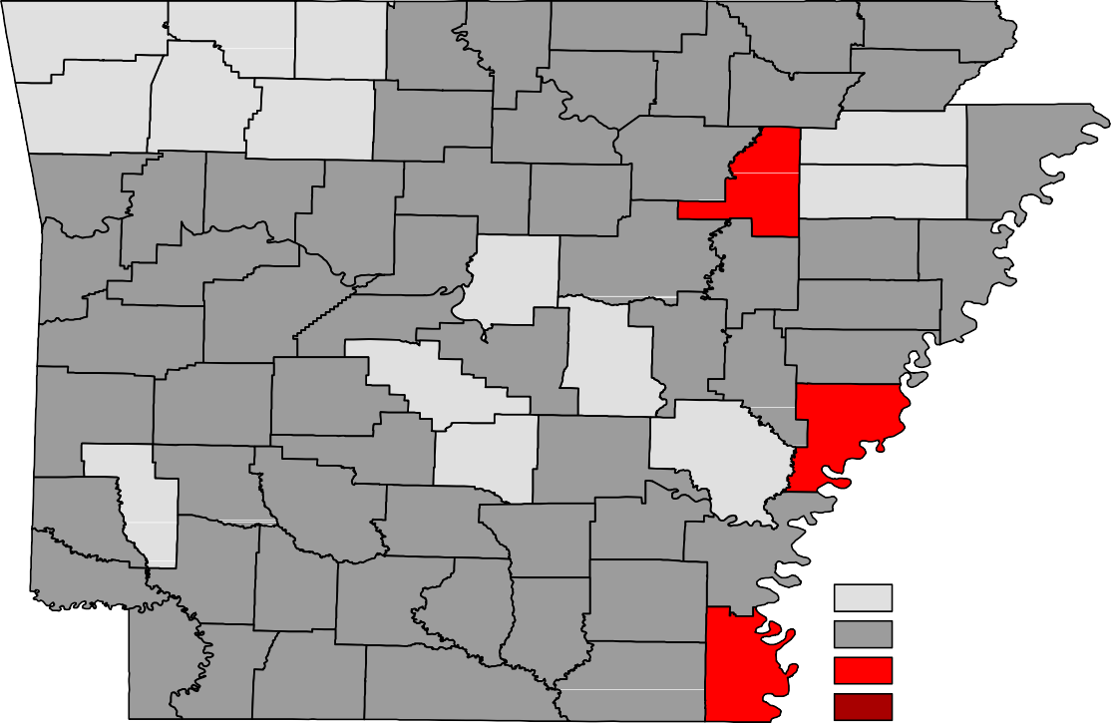
Benton
Carroll
Boone
Fulton
Clay
Marion
Baxter
Randolph
Sharp
Washington
Madison
Izard
Greene
Lawrence
Newton
Searcy
Stone
Independence
Craighead Mississippi
Crawford
Franklin
Johnson
Van Buren
Cleburne
Jackson Poinsett
Pope
Sebastian
Logan
Conway
White
Cross
Faulkner
Woodruff
Crittenden
Yell
Perry
St. Francis
Scott
Pulaski
Lonoke
Prairie
Lee
Saline
Monroe
Polk
Montgomery
Garland
Phillips
Howard
Hot Spring Grant Jefferson Arkansas
Pike
Sevier
Clark
Dallas
Cleveland
Lincoln
Desha
Little River Hempstead Nevada Ouachita
Calhoun
Drew
Bradley
Miller Lafayette Columbia
Union
Ashley
Chicot
Unemployment Rates
< or = 3.0% 3.1% - 5.0%
5.1% - 7.0%
> 7.0% [NONE]
Ranked by Unemployment Rates
October 2019 (Not Seasonally Adjusted)

Local Workforce Development Areas
Civilian Labor Force Estimates

 |  |  | Not Seasonally Adjusted
 | October 2019 |  | September 2019 |  | October 2018
LWDA CLF | Emp Unemp | Rate | CLF Emp Unemp Rate | CLF | Emp Unemp | Rate
Central (minus LR) 254,855 | 247,336 7,519 | 3.0 | 253,114 245,017 8,097 3.2 | 251,673 | 244,180 7,493 | 3.0
City of Little Rock 98,899 | 95,841 3,058 | 3.1 | 98,013 94,943 3,070 3.1 | 97,598 | 94,563 3,035 | 3.1
Eastern 46,538 | 44,619 1,919 | 4.1 | 46,354 44,321 2,033 4.4 | 46,681 | 44,806 1,875 | 4.0
North Central 94,309 | 90,445 3,864 | 4.1 | 94,497 90,458 4,039 4.3 | 93,977 | 90,278 3,699 | 3.9
Northeast 123,858 | 120,121 3,737 | 3.0 | 123,031 119,038 3,993 3.2 | 122,101 | 118,267 3,834 | 3.1
Northwest 333,973 | 325,910 8,063 | 2.4 | 331,404 322,981 8,423 2.5 | 323,700 | 315,153 8,547 | 2.6
Southeast 82,502 | 79,108 3,394 | 4.1 | 82,065 78,532 3,533 4.3 | 82,137 | 78,811 3,326 | 4.0
Southwest 92,551 | 88,842 3,709 | 4.0 | 92,257 88,433 3,824 4.1 | 92,855 | 89,011 3,844 | 4.1
West Central 132,102 | 127,453 4,649 | 3.5 | 131,785 126,871 4,914 3.7 | 132,251 | 127,490 4,761 | 3.6
Western 111,913 | 108,285 3,628 | 3.2 | 111,377 107,591 3,786 3.4 | 112,084 | 108,436 3,648 | 3.3

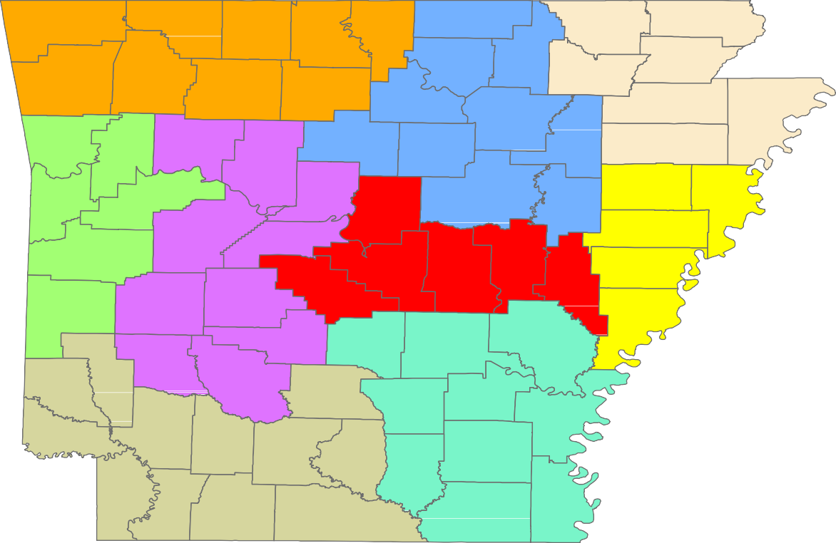
Benton
Carroll
Boone
Fulton
Clay
Marion
Baxter
Randolph
Sharp
Greene
Washington
Madison
Izard
Lawrence
Newton
Searcy
Stone
Craighead
Independence
Mississippi
Crawford
Franklin
Johnson
Van Buren
Cleburne
Jackson
Poinsett
Pope
Sebastian
Logan
Conway
White
Cross
Faulkner
Woodruff
Crittenden
Yell
Perry
St. Francis
Scott
Prairie
Pulaski Lonoke
Lee
Saline
Monroe
Polk
Montgomery
Garland
Phillips
Hot Spring
Grant
Jefferson
Arkansas
Howard
Pike
Sevier
Clark
Dallas
Cleveland
Lincoln
Desha
Little River Hempstead
Nevada
Ouachita
Calhoun
Drew
Bradley
Miller
Columbia
Chicot
Union
Ashley
Lafayette

Central (minus LR) Eastern
www.discover.arkansas.gov
18
North Central
Northeast Northwest Southeast
Southwest West Central Western

