Arkansas
Labor Market
Report

March 2017

Table of Contents

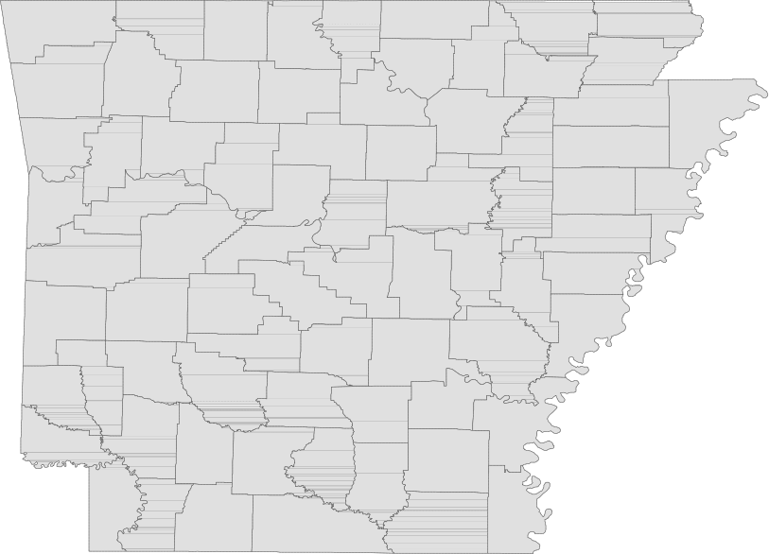Monthly Spotlight..................................................2

Arkansas Labor Force Summary.......................3

Arkansas Nonfarm Payroll Jobs........................4

Arkansas Production Workers...........................6

Metropolitan Statistical Areas...........................7

Micropolitan Statistical Areas/Cities.............14

County Labor Force Statistics..........................15

Local Workforce Development Areas..........18

Technical Notes

The Arkansas Labor Market is prepared monthly in conjunction with the U.S. Department of Labor, Bu- reau of Labor Statistics (BLS). The current month’s estimates are preliminary, while previous month’s data is subject to revision.

Estimates of nonfarm payroll jobs show the num- ber of jobs by industry and reflect employment by place of work. Hours and earnings estimates are based on payroll and worker-hour data col- lected for production workers in manufacturing industries.

Industries are classified according to the North American Industry Classification System (NAICS). All estimates are based on a first quarter 2016 benchmark.

Explanation of Terms and Concepts

Monthly Business Survey of Employers

A monthly sample survey designed to provide industry information on nonfarm payroll jobs. Data are compiled each month from mail surveys and telephone interviews conducted by the Bureau of Labor Statistics in cooperation with Department of Workforce Services. The data are based on establishment records and include all workers, full-or part-time, who received pay during the payroll period which includes the 12th of the
month. Approximately 5,000 Arkansas business
establishments are surveyed.

Metropolitan Statistical Area (MSA)

A term applied by the U.S. Office of Management and Budget to counties that have one or more central cities and that meet specified criteria of population density, commuting patterns and social and economic integration.

Current Population Survey (CPS)

A monthly sample survey of the population 16 years of age and over, designed to provide data on the labor force, the employed and the unem- ployed. The survey is conducted each month by the Bureau of the Census for BLS. The information is collected by trained interviewers from a sample of about 60,000 households. The data collected are based on the activity reported for the calendar week including the 12th of the month. Approxi- mately 800 Arkansas households are represented in the sample survey.

Civilian Labor Force

The sum of all employed and unemployed persons
16 years of age or older. Members of the Armed
Forces are excluded.
Employment

An estimate of the number of persons who worked any time for pay or profit or worked 15 hours or more as unpaid workers in a family business dur- ing the calendar week which includes the 12th of the month. Also included are those who, although not working, had some job attachment and were not looking for work, and persons involved in labor management disputes.

Unemployment

An estimate of the number of persons who did not have a job, but were available for work and actively seeking work during the calendar week which includes the 12th of the month.

Unemployment Rate

The number of unemployed as a percentage of the civilian labor force. Unemployment rates are calculated from unrounded data.

Seasonal Adjustment

A statistical technique applied to monthly data to eliminate changes that normally occur during the year due to seasonal events such as weather, major holidays, schedule shifts, harvest times, and the opening/closing of schools.

March Spotlight
A Comparative Look at Unemployment Rates

Due to differing economies and labor force conditions in various parts of the country, unemployment rates vary greatly from state to state. In March 2017, state jobless rates ranged from a low of 2.6 per- cent in Colorado to a high of 6.7 percent in New Mexico. The unemployment rate in Arkansas in March declined to 3.6 percent, a ranking of 13 out of 51 states. By looking at the map below, it becomes ap- parent that trends exist among states that are located within the same region. While there are some ex- ceptions, western states tend to have higher jobless rates than states located in the Midwest. Similarly, states located in the northeast generally experience lower unemployment rates than states located in the southeast. These regional trends occur because states often experience economic similarities based on shared industries, work forces, and climates.

Unemployment Rates, Ranked by State (Seasonally Adjusted)
March 2017

Rank
State
Rate Rank State Rate Rank State Rate

1 Colorado
2 Hawaii
3 New Hampshire
3 North Dakota
3 South Dakota
6 Maine
6 Vermont
8 Iowa
8 Nebraska
8 Utah
11 Wisconsin
12 Idaho
13 Arkansas
13 Massachusetts
15 Kansas
15 Minnesota
15 Montana
2.6
2.7
2.8
2.8
2.8
3.0
3.0
3.1
3.1
3.1
3.4
3.5
3.6
3.6
3.8
3.8
3.8
15 Oregon
15 Virginia
20 Indiana
20 Missouri
22 New Jersey
23 Maryland
23 New York
23 Oklahoma
23 Rhode Island
27 South Carolina
28 Delaware
28 Wyoming
30 Washington
31 Connecticut
31 Florida
31 Nevada
31 Pennsylvania
3.8
3.8
3.9
3.9
4.2
4.3
4.3
4.3
4.3
4.4
4.5
4.5
4.7
4.8
4.8
4.8
4.8
35 California
35 Illinois
35 North Carolina
35 West Virginia
39 Arizona
39 Kentucky
39 Mississippi
39 Texas
43 Georgia
43 Michigan
43 Ohio
43 Tennessee
47 Louisiana
48 Alabama
48 District of Columbia
50 Alaska
51 New Mexico
4.9
4.9
4.9
4.9
5.0
5.0
5.0
5.0
5.1
5.1
5.1
5.1
5.7
5.8
5.8
6.4
6.7

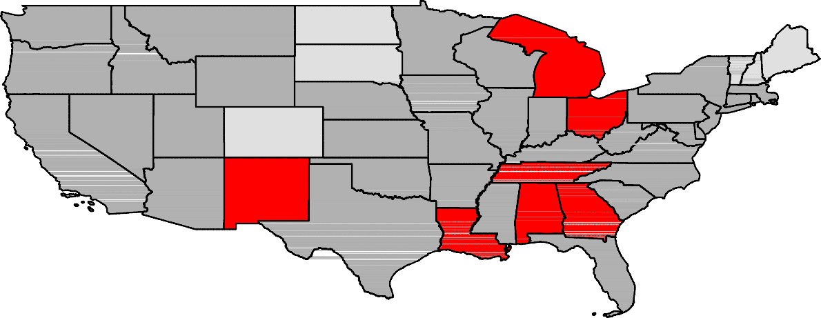U.S. Unemployment Rate = 4.5 Percent

Washington

Oregon

Idaho

Montana
North Dakota

South Dakota

Minnesota

Wisconsin

Michigan

Vermont

Maine

Wyoming

Nebraska

Iowa
New York

Pennsylvania
New Hampshire
Massachusetts
Connecticut
Rhode Island

Illinois
Indiana
Ohio
New Jersey

Nevada

California
Utah
Colorado
Kansas

Missouri

Kentucky
West Virginia Maryland
Delaware
Virginia

Arizona

New Mexico
Oklahoma

Arkansas
Tennessee North Carolina

South Carolina

Continental U.S. Only

Texas
MississippiAlabama

Louisiana
Georgia

Florida
Rate

< or = 3.0%

3.1% - 5.0%

5.1% - 7.0%

> 7.0% [NONE]

Civilian Labor Force Summar y

Labor force data, produced by the U.S. Department of Labor, Bureau of Labor Statistics and released by the Arkansas Department of Workforce Services, show Arkansas’ seasonally adjusted unemployment rate decreased one-tenth of a percentage point, from 3.7 percent in February to 3.6 percent in March. Arkansas’ civilian labor force gained 3,188, a result of 4,428 more employed and 1,240 fewer unem- ployed Arkansans. The United States’ jobless rate declined two-tenths of a percentage point, from 4.7 percent in February to 4.5 percent in March.

BLS Program Operations Manager Susan Price said, “The unemployment rate decline to 3.6 percent marks a new record low for Arkansas, breaking last month’s previous record low of 3.7 percent. Arkan- sas’ jobless rate has fallen each month since December, after remaining fairly stable throughout most
of 2016.”

Civilian Labor Force Estimates

Seasonally Adjusted Not Seasonally Adjusted

Civilian Labor Force | Mar 17  1,341,183 | Feb 17  1,337,995 | Mar 16  1,345,488 | Civilian Labor Force | Mar 17  1,343,083 | Feb 17  1,336,804 | Mar 16  1,343,609
Employment | 1,292,574 | 1,288,146 | 1,290,525 | Employment | 1,295,244 | 1,279,386 | 1,289,318
Unemployment | 48,609 | 49,849 | 54,963 | Unemployment | 47,839 | 57,418 | 54,291
Unemployment Rate | 3.6 | 3.7 | 4.1 | Unemployment Rate | 3.6 | 4.3 | 4.0
U.S. Unemployment | 4.5 | 4.7 | 5.0 | U.S. Unemployment | 4.6 | 4.9 | 5.1

9.0
Unemployment Rates (Seasonally Adjusted vs. Not Seasonally Adjusted)
March 2013 - March 2017

8.0

7.0

6.0

5.0

4.0

3.0

2.0

1.0

0.0
Mar '13 Sep '13 Mar '14 Sep '14 Mar '15 Sep '15 Mar '16 Sep '16 Mar '17
Seasonally Adjusted Not Seasonally Adjusted

Nonfarm Payroll Jobs

Not Seasonally Adjusted
(In Thousands)

(NAICS)
Mar 17 Feb 17 Mar 16
OTM OT Y

Total Nonfarm | 1240.9 | 1233.4 | 1224.3 | 7.5 | 16.6
Goods Producing | 211.7 | 211.7 | 209.8 | 0.0 | 1.9
Mining, Logging, and Construction | 55.1 | 55.2 | 55.8 | -0.1 | -0.7
Mining & Logging | 6.0 | 6.0 | 6.6 | 0.0 | -0.6
Construction | 49.1 | 49.2 | 49.2 | -0.1 | -0.1
Specialty Trade Contractors | 31.3 | 31.8 | 31.5 | -0.5 | -0.2
Manufacturing | 156.6 | 156.5 | 154.0 | 0.1 | 2.6
Durable Goods | 73.6 | 73.6 | 74.7 | 0.0 | -1.1
Nondurable Goods | 83.0 | 82.9 | 79.3 | 0.1 | 3.7
Service Providing | 1029.2 | 1021.7 | 1014.5 | 7.5 | 14.7
Trade, Transportation & Utilities | 252.0 | 249.7 | 250.4 | 2.3 | 1.6
Wholesale Trade | 46.6 | 45.7 | 46.3 | 0.9 | 0.3
Retail Trade | 140.9 | 139.7 | 140.7 | 1.2 | 0.2
Transport, Warehousing & Utilities | 64.5 | 64.3 | 63.4 | 0.2 | 1.1
Information | 13.1 | 13.1 | 13.6 | 0.0 | -0.5
Financial Activities | 50.9 | 50.7 | 50.8 | 0.2 | 0.1
Finance & Insurance | 37.9 | 37.8 | 37.8 | 0.1 | 0.1
Real Estate & Rental & Leasing | 13.0 | 12.9 | 13.0 | 0.1 | 0.0
Professional & Business Services | 148.1 | 146.1 | 142.3 | 2.0 | 5.8
Professional, Scientific & Technical | 44.3 | 44.7 | 43.0 | -0.4 | 1.3
Management of Companies | 34.7 | 34.5 | 34.4 | 0.2 | 0.3
Administrative & Support Services | 69.1 | 66.9 | 64.9 | 2.2 | 4.2
Educational & Health Services | 185.8 | 187.1 | 178.8 | -1.3 | 7.0
Educational Services | 17.1 | 17.0 | 15.0 | 0.1 | 2.1
Health Care & Social Assistance | 168.7 | 170.1 | 163.8 | -1.4 | 4.9
Ambulatory Health Care | 55.5 | 56.3 | 52.6 | -0.8 | 2.9
Social Assistance | 39.6 | 39.5 | 39.4 | 0.1 | 0.2
Leisure & Hospitality 115.3 112.5 113.8 2.8 1.5
Arts, Entertainment & Recreation | 10.2 | 9.7 | 10.4 | 0.5 | -0.2
Accommodation & Food Services | 105.1 | 102.8 | 103.4 | 2.3 | 1.7
Accommodation Services | 10.9 | 10.4 | 10.9 | 0.5 | 0.0
Food Services | 94.2 | 92.4 | 92.5 | 1.8 | 1.7
Other Services | 48.2 | 48.0 | 46.9 | 0.2 | 1.3
Government | 215.8 | 214.5 | 217.9 | 1.3 | -2.1
Federal Government | 20.3 | 20.3 | 20.3 | 0.0 | 0.0
State Government | 80.2 | 79.5 | 80.7 | 0.7 | -0.5
Local Government | 115.3 | 114.7 | 116.9 | 0.6 | -1.6

Nonfarm Payroll Job Summar y

Februar y 2017 - March 2017

Nonfarm payroll jobs in Arkansas increased 7,500 in March to total 1,240,900. Seven major industry sec- tors posted gains, while two sectors declined and two were unchanged. Leisure and hospitality added
2,800 jobs, mostly in accommodation and food services (+2,300). Jobs in trade, transportation, and utilities rose 2,300. A majority of the expansion occurred in retail trade (+1,200), typical hiring for the spring shopping season. Employment in professional and business services increased 2,000. Most of the gains were in administrative and support services (+2,200). Educational and health services de- creased 1,300. Losses were reported in health care and social assistance (-1,400), with reported declines at nursing care facilities, hospitals, and physicians’ offices.

March 2016 - March 2017

Compared to March 2016, Arkansas’ nonfarm payroll employment is up 16,600. Growth was posted in seven major industry sectors, as four sectors declined. Employment in educational and health servic- es rose 7,000, mostly in health care and social assistance (+4,900). Professional and business services added 5,800 jobs, with gains posted in all three subsectors. Jobs in manufacturing are up 2,600. Hiring in nondurable goods (+3,700) more than offset losses in durable goods (-1,100). Small increases were reported in trade, transportation, and utilities (+1,600), leisure and hospitality (+1,500), and other services (+1,300). Jobs in government fell 2,100. Decreases occurred in local (-1,600) and state (-500) government.

160,000
Jobs in Professional and Business Services
March: 1997 - 2017

150,000

140,000

130,000

120,000

110,000

100,000

90,000

80,000

70,000

60,000

'97 '98 '99 '00 '01 '02 '03 '04 '05 '06 '07 '08 '09 '10 '11 '12 '13 '14 '15 '16 '17

Production Workers- Hours and Earnings

Manufacturing

Mar 17 Feb 17
Mar 16

Average Weekly Hours Average Hourly Earnings Average Weekly Earnings

38.5
15.93
613.31

38.4
15.94
612.10

39.7
15.90
631.23

Durable Goods and Nondurable Goods Manufacturing

Durable Goods Manufacturing Nondurable Goods Manufacturing

Mar 17 Feb 17

Mar 16

Mar 17 Feb 17
Mar 16

Average Weekly Hours Average Hourly Earnings Average Weekly Earnings

40.8
17.57
716.86

40.3
17.28
696.38

41.0
17.52
718.32

Average Weekly Hours Average Hourly Earnings Average Weekly Earnings

36.5
14.35
523.78
36.8
14.66
539.49
38.5
14.26
549.01

17.00
Average Hourly Earnings in Manufacturing
March 2015 - March 2017

16.50

16.00

15.50

15.00

14.50

Mar
'15

Sep
'15

Mar
'16

Sep
'16

Mar
'17

Little Rock-Nor th Little Rock-Conway MSA

The Little Rock-North Little Rock-Conway MSA= Faulkner, Grant, Lonoke, Perry, Pulaski, & Saline counties.

Civilian Labor Force Estimates (Not Seasonally Adjusted)

 | Mar 17 | Feb 17 | Mar 16 | OTM | OT Y
Civilian Labor Force | 349,775 | 348,254 | 350,064 | 1,521 | -289
Employment | 338,502 | 334,842 | 337,518 | 3,660 | 984
Unemployment | 11,273 | 13,412 | 12,546 | -2,139 | -1,273
Unemployment Rate | 3.2 | 3.9 | 3.6 | -0.7 | -0.4

Nonfarm Payroll Jobs (Not Seasonally Adjusted)
(In Thousands)

NAICS  Total Nonfarm | Mar 17  356.5 | Feb 17  354.6 | Mar 16  353.5 | OTM  1.9 | OT Y  3.0
Goods Producing | 36.5 | 36.5 | 37.1 | 0.0 | -0.6
Mining, Logging & Construction | 16.5 | 16.5 | 17.0 | 0.0 | -0.5
Manufacturing | 20.0 | 20.0 | 20.1 | 0.0 | -0.1
Service Providing 320.0 318.1 316.4 1.9 3.6
Trade, Transportation & Utilities | 70.8 | 70.6 | 69.8 | 0.2 | 1.0
Wholesale Trade | 14.9 | 14.9 | 15.2 | 0.0 | -0.3
Retail Trade | 40.0 | 39.8 | 39.0 | 0.2 | 1.0
Trans., Warehousing & Utilities | 15.9 | 15.9 | 15.6 | 0.0 | 0.3
Information | 6.1 | 6.1 | 6.4 | 0.0 | -0.3
Financial Activities | 20.4 | 20.3 | 20.3 | 0.1 | 0.1
Professional & Business Services | 47.9 | 47.5 | 47.4 | 0.4 | 0.5
Educational & Health Services | 56.3 | 56.2 | 53.0 | 0.1 | 3.3
Leisure & Hospitality | 32.9 | 32.4 | 33.2 | 0.5 | -0.3
Other Services | 14.7 | 14.6 | 14.4 | 0.1 | 0.3
Government | 70.9 | 70.4 | 71.9 | 0.5 | -1.0
Federal Government | 9.8 | 9.7 | 9.6 | 0.1 | 0.2
State Government | 35.3 | 35.2 | 35.1 | 0.1 | 0.2
Local Government | 25.8 | 25.5 | 27.2 | 0.3 | -1.4

30,000
Number of Unemployed
March: 2007 - 2017

57,000
Jobs in Educational and Health Services
March 2014 - March 2017

56,000

25,000

55,000

20,000
54,000

53,000

15,000
52,000

51,000

10,000

50,000

5,000
49,000

48,000

0
'07 '08 '09 '10 '11 '12 '13 '14 '15 '16 '17
47,000
Mar '14 Sep '14 Mar '15 Sep '15 Mar '16 Sep '16 Mar '17

Fayetteville-Springdale-Rogers MSA

The Fayetteville-Springdale-Rogers MSA= Benton, Madison, & Washington counties in Arkansas & McDonald county in Missouri.

Civilian Labor Force Estimates (Not Seasonally Adjusted)

 | Mar 17 | Feb 17 | Mar 16 | OTM | OT Y
Civilian Labor Force | 269,347 | 267,189 | 262,252 | 2,158 | 7,095
Employment | 262,512 | 258,927 | 254,599 | 3,585 | 7,913
Unemployment | 6,835 | 8,262 | 7,653 | -1,427 | -818
Unemployment Rate | 2.5 | 3.1 | 2.9 | -0.6 | -0.4

Nonfarm Payroll Jobs (Not Seasonally Adjusted)
(In Thousands)

NAICS  Total Nonfarm | Mar 17  253.5 | Feb 17  251.0 | Mar 16  243.7 | OTM  2.5 | OT Y  9.8
Goods Producing | 38.1 | 37.9 | 37.4 | 0.2 | 0.7
Mining, Logging & Construction | 10.6 | 10.4 | 10.2 | 0.2 | 0.4
Manufacturing | 27.5 | 27.5 | 27.2 | 0.0 | 0.3
Service Providing 215.4 213.1 206.3 2.3 9.1
Trade, Transportation & Utilities | 55.9 | 55.5 | 55.2 | 0.4 | 0.7
Wholesale Trade | 12.6 | 12.5 | 12.2 | 0.1 | 0.4
Retail Trade | 25.9 | 25.6 | 26.3 | 0.3 | -0.4
Trans., Warehousing & Utilities | 17.4 | 17.4 | 16.7 | 0.0 | 0.7
Information | 1.9 | 1.9 | 2.0 | 0.0 | -0.1
Financial Activities | 7.8 | 7.7 | 7.6 | 0.1 | 0.2
Professional & Business Services | 53.3 | 52.4 | 47.9 | 0.9 | 5.4
Educational & Health Services | 28.0 | 27.9 | 27.0 | 0.1 | 1.0
Leisure & Hospitality | 25.0 | 24.5 | 24.2 | 0.5 | 0.8
Other Services | 7.7 | 7.6 | 7.5 | 0.1 | 0.2
Government | 35.8 | 35.6 | 34.9 | 0.2 | 0.9
Federal Government | 2.5 | 2.5 | 2.6 | 0.0 | -0.1
State Government | 14.3 | 14.2 | 13.5 | 0.1 | 0.8
Local Government | 19.0 | 18.9 | 18.8 | 0.1 | 0.2

300,000
Number of Employed
March: 1997 - 2017

250,000

200,000

150,000

100,000

50,000

'97 '98 '99 '00 '01 '02 '03 '04 '05 '06 '07 '08 '09 '10 '11 '12 '13 '14 '15 '16 '17

For t Smith MSA

The Fort Smith MSA= Crawford & Sebastian counties in Arkansas & LeFlore & Sequoyah counties in Oklahoma.

Civilian Labor Force Estimates (Not Seasonally Adjusted)

 | Mar 17 | Feb 17 | Mar 16 | OTM | OT Y
Civilian Labor Force | 119,652 | 120,140 | 121,288 | -488 | -1,636
Employment | 114,793 | 114,592 | 115,594 | 201 | -801
Unemployment | 4,859 | 5,548 | 5,694 | -689 | -835
Unemployment Rate | 4.1 | 4.6 | 4.7 | -0.5 | -0.6

Nonfarm Payroll Jobs (Not Seasonally Adjusted)
(In Thousands)

NAICS  Total Nonfarm | Mar 17  112.9 | Feb 17  113.4 | Mar 16  113.5 | OTM  -0.5 | OT Y  -0.6
Goods Producing | 22.6 | 22.9 | 23.4 | -0.3 | -0.8
Mining, Logging & Construction | 5.2 | 5.3 | 5.5 | -0.1 | -0.3
Manufacturing | 17.4 | 17.6 | 17.9 | -0.2 | -0.5
Service Providing 90.3 90.5 90.1 -0.2 0.2
Trade, Transportation & Utilities | 23.1 | 23.3 | 23.4 | -0.2 | -0.3
Wholesale Trade | 3.9 | 3.9 | 3.8 | 0.0 | 0.1
Retail Trade | 12.7 | 12.9 | 12.9 | -0.2 | -0.2
Trans., Warehousing & Utilities | 6.5 | 6.5 | 6.7 | 0.0 | -0.2
Information | 1.3 | 1.3 | 1.2 | 0.0 | 0.1
Financial Activities | 3.8 | 3.8 | 3.7 | 0.0 | 0.1
Professional & Business Services | 12.8 | 13.0 | 12.8 | -0.2 | 0.0
Educational & Health Services | 16.8 | 16.8 | 16.5 | 0.0 | 0.3
Leisure & Hospitality | 9.5 | 9.4 | 9.5 | 0.1 | 0.0
Other Services | 4.3 | 4.3 | 4.3 | 0.0 | 0.0
Government | 18.7 | 18.6 | 18.7 | 0.1 | 0.0
Federal Government | 1.3 | 1.3 | 1.3 | 0.0 | 0.0
State Government | 3.2 | 3.1 | 3.2 | 0.1 | 0.0
Local Government | 14.2 | 14.2 | 14.2 | 0.0 | 0.0

118,000
Number of Employed
January 2015 - March 2017

94,000
Jobs in Service Providing Sectors
March: 2007 - 2017

117,000

116,000

92,000

115,000

90,000

114,000

113,000

88,000

112,000

86,000

111,000

110,000

84,000

109,000

82,000

108,000

J F M A M J J A S O N D
2015 2016 2017

80,000

'07 '08 '09 '10 '11 '12 '13 '14 '15 '16 '17

Hot Springs MSA

The Hot Springs MSA= Garland County.

Civilian Labor Force Estimates (Not Seasonally Adjusted)

 | Mar 17 | Feb 17 | Mar 16 | OTM | OT Y
Civilian Labor Force | 40,583 | 40,252 | 40,249 | 331 | 334
Employment | 39,052 | 38,399 | 38,531 | 653 | 521
Unemployment | 1,531 | 1,853 | 1,718 | -322 | -187
Unemployment Rate | 3.8 | 4.6 | 4.3 | -0.8 | -0.5

Nonfarm Payroll Jobs (Not Seasonally Adjusted)
(In Thousands)

NAICS
Mar 17 | Feb 17 | Mar 16 | OTM | OT Y
38.6 | 38.1 | 37.8 | 0.5 | 0.8
4.5 | 4.4 | 4.3 | 0.1 | 0.2
34.1 | 33.7 | 33.5 | 0.4 | 0.6
4.5 | 4.5 | 4.7 | 0.0 | -0.2

Total Nonfarm Goods Producing Service Providing Government

50,000

45,000
Employment and Unemployment
March: 1997 - 2017

Employment + Unemployment = Civilian Labor Force

40,000

35,000

30,000

25,000

20,000

15,000

10,000

5,000

0
'97 '98 '99 '00 '01 '02 '03 '04 '05 '06 '07 '08 '09 '10 '11 '12 '13 '14 '15 '16 '17

Employment Unemployment

Jonesboro MSA

The Jonesboro MSA= Craighead & Poinsett counties.

Civilian Labor Force Estimates (Not Seasonally Adjusted)

 | Mar 17 | Feb 17 | Mar 16 | OTM | OT Y
Civilian Labor Force | 62,468 | 62,375 | 62,054 | 93 | 414
Employment | 60,571 | 60,084 | 59,887 | 487 | 684
Unemployment | 1,897 | 2,291 | 2,167 | -394 | -270
Unemployment Rate | 3.0 | 3.7 | 3.5 | -0.7 | -0.5

Nonfarm Payroll Jobs (Not Seasonally Adjusted)
(In Thousands)

NAICS
Mar 17 | Feb 17 | Mar 16 | OTM | OT Y
56.5 | 56.5 | 55.3 | 0.0 | 1.2
9.4 | 9.4 | 8.9 | 0.0 | 0.5
47.1 | 47.1 | 46.4 | 0.0 | 0.7
9.1 | 9.1 | 8.9 | 0.0 | 0.2

Total Nonfarm Goods Producing Service Providing Government

48,000
Jobs in Service Providing Industries
January 2015 - March 2017

47,000

46,000

45,000

44,000

43,000

42,000

J F M A M J J A S O N D

2015 2016 2017

Pine Bluff MSA

The Pine Bluff MSA= Cleveland, Jefferson, & Lincoln counties.

Civilian Labor Force Estimates (Not Seasonally Adjusted)

 | Mar 17 | Feb 17 | Mar 16 | OTM | OT Y
Civilian Labor Force | 35,689 | 35,640 | 36,248 | 49 | -559
Employment | 33,928 | 33,579 | 34,282 | 349 | -354
Unemployment | 1,761 | 2,061 | 1,966 | -300 | -205
Unemployment Rate | 4.9 | 5.8 | 5.4 | -0.9 | -0.5

Nonfarm Payroll Jobs (Not Seasonally Adjusted)
(In Thousands)

NAICS
Mar 17 | Feb 17 | Mar 16 | OTM | OT Y
33.4 | 33.2 | 33.5 | 0.2 | -0.1
6.0 | 6.0 | 6.1 | 0.0 | -0.1
27.4 | 27.2 | 27.4 | 0.2 | 0.0
9.6 | 9.6 | 9.7 | 0.0 | -0.1

Total Nonfarm Goods Producing Service Providing Government

35,000
Number of Employed
March 2014 - March 2017

34,500

34,000

33,500

33,000

32,500

32,000

Mar
'14

Sep
'14

Mar
'15

Sep
'15

Mar
'16

Sep
'16

Mar
'17

Out-of-State MSA

Civilian Labor Force Estimates (Not Seasonally Adjusted)

Memphis, TN-MS-AR MSA

The Memphis, TN-MS-AR MSA= Fayette, Shelby, & Tipton counties in Tennessee; Benton, Desoto, Marshall, Tate, & Tunica counties in Mississippi; & Crittenden County in Arkansas.

 | Mar 17 | Feb 17 | Mar 16 | OTM | OT Y
Civilian Labor Force | 629,130 | 626,302 | 617,757 | 2,828 | 11,373
Employment | 597,471 | 594,206 | 586,999 | 3,265 | 10,472
Unemployment | 31,659 | 32,096 | 30,758 | -437 | 901
Unemployment Rate | 5.0 | 5.1 | 5.0 | -0.1 | -0.0

Texarkana MSA

The Texarkana MSA= Bowie County in Texas & Little River & Miller counties in Arkansas.

 | Mar 17 | Feb 17 | Mar 16 | OTM | OT Y
Civilian Labor Force | 65,253 | 64,922 | 65,240 | 331 | 13
Employment | 62,093 | 61,481 | 62,425 | 612 | -332
Unemployment | 3,160 | 3,441 | 2,815 | -281 | 345
Unemployment Rate | 4.8 | 5.3 | 4.3 | -0.5 | 0.5

70,000
Number of Unemployed- Memphis MSA
March: 2007 - 2017

63,500
Number of Employed- Texarkana MSA
March 2015 - March 2017

60,000
63,000

62,500

50,000

62,000

40,000
61,500

30,000
61,000

60,500

20,000

60,000

10,000
59,500

0
'07 '08 '09 '10 '11 '12 '13 '14 '15 '16 '17
59,000

Mar
'15

Sep
'15

Mar
'16

Sep
'16

Mar
'17

Micropolitan Labor Force Estimates (Not Seasonally Adjusted)

Micro Area | CLF | Marc  Emp | h 2017  Unemp | Rate | CLF | Februa  Emp | ry 2017  Unemp | Rate | CLF | Marc  Emp | h 2016  Unemp | Rate
Arkadelphia Micro | 9,536 | 9,191 | 345 | 3.6 | 9,510 | 9,084 | 426 | 4.5 | 9,525 | 9,124 | 401 | 4.2
Batesville Micro | 16,124 | 15,468 | 656 | 4.1 | 16,100 | 15,281 | 819 | 5.1 | 16,099 | 15,298 | 801 | 5.0
Blytheville Micro | 17,981 | 16,929 | 1,052 | 5.9 | 17,937 | 16,679 | 1,258 | 7.0 | 18,046 | 16,826 | 1,220 | 6.8
Camden Micro | 12,157 | 11,636 | 521 | 4.3 | 12,133 | 11,522 | 611 | 5.0 | 12,205 | 11,614 | 591 | 4.8
El Dorado Micro | 16,279 | 15,407 | 872 | 5.4 | 16,223 | 15,274 | 949 | 5.8 | 16,708 | 15,813 | 895 | 5.4
Forrest City Micro | 8,891 | 8,462 | 429 | 4.8 | 8,860 | 8,354 | 506 | 5.7 | 8,923 | 8,433 | 490 | 5.5
Harrison Micro | 19,453 | 18,815 | 638 | 3.3 | 19,358 | 18,543 | 815 | 4.2 | 19,563 | 18,790 | 773 | 4.0
Helena-West Helena Micro | 6,566 | 6,192 | 374 | 5.7 | 6,511 | 6,075 | 436 | 6.7 | 6,902 | 6,475 | 427 | 6.2
Hope Micro | 13,625 | 13,180 | 445 | 3.3 | 13,553 | 13,020 | 533 | 3.9 | 13,673 | 13,145 | 528 | 3.9
Magnolia Micro | 9,092 | 8,638 | 454 | 5.0 | 9,069 | 8,525 | 544 | 6.0 | 9,498 | 8,980 | 518 | 5.5
Malvern Micro | 14,048 | 13,567 | 481 | 3.4 | 13,970 | 13,392 | 578 | 4.1 | 14,300 | 13,702 | 598 | 4.2
Mountain Home Micro | 16,233 | 15,579 | 654 | 4.0 | 16,131 | 15,332 | 799 | 5.0 | 16,124 | 15,422 | 702 | 4.4
Paragould Micro | 19,631 | 18,912 | 719 | 3.7 | 19,628 | 18,782 | 846 | 4.3 | 19,930 | 19,067 | 863 | 4.3
Russellville Micro | 38,193 | 36,704 | 1,489 | 3.9 | 37,985 | 36,164 | 1,821 | 4.8 | 38,311 | 36,589 | 1,722 | 4.5
Searcy Micro | 33,292 | 31,724 | 1,568 | 4.7 | 33,228 | 31,405 | 1,823 | 5.5 | 34,529 | 32,625 | 1,904 | 5.5

Arkadelphia Micro= Clark County Batesville Micro= Independence County Blytheville Micro= Mississippi County
Camden Micro= Calhoun & Ouachita counties
El Dorado Micro= Union County
Forrest City Micro= St. Francis County Harrison Micro= Boone & Newton counties Helena-West Helena Micro= Phillips County Hope Micro= Hempstead & Nevada counties Magnolia Micro= Columbia County
Malvern Micro= Hot Spring County Mountain Home Micro= Baxter County Paragould Micro= Greene County Russellville Micro= Pope & Yell counties Searcy Micro= White County

City Labor Force Statistics (Not Seasonally Adjusted)

City | CLF | Marc  Emp | h 2017  Unemp | Rate | CLF | Februa  Emp | ry 2017  Unemp | Rate | CLF | Marc  Emp | h 2016  Unemp | Rate
Bella Vista | 12,260 | 11,859 | 401 | 3.3 | 12,193 | 11,692 | 501 | 4.1 | 11,946 | 11,487 | 459 | 3.8
Benton | 16,299 | 15,825 | 474 | 2.9 | 16,246 | 15,658 | 588 | 3.6 | 16,281 | 15,768 | 513 | 3.2
Bentonville | 24,206 | 23,570 | 636 | 2.6 | 23,949 | 23,238 | 711 | 3.0 | 23,487 | 22,830 | 657 | 2.8
Blytheville | 6,136 | 5,771 | 365 | 5.9 | 6,146 | 5,686 | 460 | 7.5 | 6,225 | 5,736 | 489 | 7.9
Cabot | 11,673 | 11,318 | 355 | 3.0 | 11,594 | 11,183 | 411 | 3.5 | 11,694 | 11,325 | 369 | 3.2
Conway | 32,993 | 31,959 | 1,034 | 3.1 | 32,845 | 31,609 | 1,236 | 3.8 | 32,992 | 31,874 | 1,118 | 3.4
El Dorado | 7,115 | 6,669 | 446 | 6.3 | 7,089 | 6,611 | 478 | 6.7 | 7,275 | 6,845 | 430 | 5.9
Fayetteville | 47,149 | 45,965 | 1,184 | 2.5 | 46,707 | 45,317 | 1,390 | 3.0 | 45,764 | 44,523 | 1,241 | 2.7
Fort Smith | 39,694 | 38,328 | 1,366 | 3.4 | 39,832 | 38,234 | 1,598 | 4.0 | 40,270 | 38,741 | 1,529 | 3.8
Hot Springs | 14,169 | 13,580 | 589 | 4.2 | 14,044 | 13,353 | 691 | 4.9 | 14,037 | 13,399 | 638 | 4.5
Jacksonville | 11,711 | 11,225 | 486 | 4.1 | 11,692 | 11,107 | 585 | 5.0 | 11,741 | 11,184 | 557 | 4.7
Jonesboro | 36,718 | 35,679 | 1,039 | 2.8 | 36,654 | 35,409 | 1,245 | 3.4 | 36,443 | 35,226 | 1,217 | 3.3
Little Rock | 96,504 | 93,344 | 3,160 | 3.3 | 96,018 | 92,359 | 3,659 | 3.8 | 96,358 | 93,003 | 3,355 | 3.5
North Little Rock | 29,799 | 28,784 | 1,015 | 3.4 | 29,667 | 28,480 | 1,187 | 4.0 | 29,834 | 28,679 | 1,155 | 3.9
Paragould | 12,335 | 11,826 | 509 | 4.1 | 12,342 | 11,744 | 598 | 4.8 | 12,506 | 11,923 | 583 | 4.7
Pine Bluff | 16,935 | 16,014 | 921 | 5.4 | 16,915 | 15,860 | 1,055 | 6.2 | 17,204 | 16,152 | 1,052 | 6.1
Rogers | 34,342 | 33,485 | 857 | 2.5 | 34,052 | 33,013 | 1,039 | 3.1 | 33,385 | 32,434 | 951 | 2.8
Russellville | 13,651 | 13,180 | 471 | 3.5 | 13,569 | 12,995 | 574 | 4.2 | 13,656 | 13,110 | 546 | 4.0
Searcy | 10,212 | 9,792 | 420 | 4.1 | 10,175 | 9,693 | 482 | 4.7 | 10,536 | 10,070 | 466 | 4.4
Sherwood | 15,553 | 15,094 | 459 | 3.0 | 15,503 | 14,935 | 568 | 3.7 | 15,529 | 15,039 | 490 | 3.2
Springdale | 38,991 | 38,106 | 885 | 2.3 | 38,656 | 37,569 | 1,087 | 2.8 | 37,921 | 36,910 | 1,011 | 2.7
Texarkana, AR | 13,862 | 13,228 | 634 | 4.6 | 13,778 | 13,063 | 715 | 5.2 | 13,872 | 13,299 | 573 | 4.1
Van Buren | 10,249 | 9,909 | 340 | 3.3 | 10,270 | 9,877 | 393 | 3.8 | 10,430 | 10,033 | 397 | 3.8
West Memphis | 10,650 | 10,107 | 543 | 5.1 | 10,598 | 9,983 | 615 | 5.8 | 10,589 | 10,051 | 538 | 5.1

County | CLF | MarchEmp | 2017  Unemp | Rate | CLF | Februa  Emp | ry 2017  Unemp | Rate | CLF | Marc  Emp | h 2016  Unemp | Rate
Arkansas | 9,192 | 8,905 | 287 | 3.1 | 9,124 | 8,776 | 348 | 3.8 | 9,291 | 8,968 | 323 | 3.5
Ashley | 7,763 | 7,310 | 453 | 5.8 | 7,724 | 7,186 | 538 | 7.0 | 7,874 | 7,392 | 482 | 6.1
Baxter | 16,233 | 15,579 | 654 | 4.0 | 16,131 | 15,332 | 799 | 5.0 | 16,124 | 15,422 | 702 | 4.4
Benton | 129,091 | 125,711 | 3,380 | 2.6 | 128,048 | 123,938 | 4,110 | 3.2 | 125,485 | 121,766 | 3,719 | 3.0
Boone | 16,026 | 15,506 | 520 | 3.2 | 15,944 | 15,287 | 657 | 4.1 | 16,099 | 15,470 | 629 | 3.9
Bradley | 4,515 | 4,290 | 225 | 5.0 | 4,485 | 4,223 | 262 | 5.8 | 4,339 | 4,142 | 197 | 4.5
Calhoun | 2,376 | 2,286 | 90 | 3.8 | 2,363 | 2,257 | 106 | 4.5 | 2,408 | 2,299 | 109 | 4.5
Carroll | 13,082 | 12,654 | 428 | 3.3 | 12,913 | 12,331 | 582 | 4.5 | 12,777 | 12,292 | 485 | 3.8
Chicot | 3,501 | 3,251 | 250 | 7.1 | 3,483 | 3,194 | 289 | 8.3 | 3,620 | 3,372 | 248 | 6.9
Clark | 9,536 | 9,191 | 345 | 3.6 | 9,510 | 9,084 | 426 | 4.5 | 9,525 | 9,124 | 401 | 4.2
Clay | 5,893 | 5,617 | 276 | 4.7 | 5,877 | 5,523 | 354 | 6.0 | 6,141 | 5,752 | 389 | 6.3
Cleburne | 9,291 | 8,828 | 463 | 5.0 | 9,281 | 8,709 | 572 | 6.2 | 9,540 | 8,919 | 621 | 6.5
Cleveland | 3,322 | 3,171 | 151 | 4.5 | 3,301 | 3,131 | 170 | 5.1 | 3,381 | 3,223 | 158 | 4.7
Columbia | 9,092 | 8,638 | 454 | 5.0 | 9,069 | 8,525 | 544 | 6.0 | 9,498 | 8,980 | 518 | 5.5
Conway | 8,292 | 7,885 | 407 | 4.9 | 8,307 | 7,800 | 507 | 6.1 | 8,570 | 8,105 | 465 | 5.4
Craighead | 52,236 | 50,752 | 1,484 | 2.8 | 52,166 | 50,368 | 1,798 | 3.4 | 51,826 | 50,108 | 1,718 | 3.3
Crawford | 26,345 | 25,458 | 887 | 3.4 | 26,461 | 25,377 | 1,084 | 4.1 | 26,861 | 25,776 | 1,085 | 4.0
Crittenden | 21,466 | 20,537 | 929 | 4.3 | 21,377 | 20,284 | 1,093 | 5.1 | 21,403 | 20,423 | 980 | 4.6
Cross | 7,885 | 7,577 | 308 | 3.9 | 7,823 | 7,430 | 393 | 5.0 | 8,008 | 7,634 | 374 | 4.7
Dallas | 3,009 | 2,891 | 118 | 3.9 | 3,000 | 2,853 | 147 | 4.9 | 2,955 | 2,798 | 157 | 5.3
Desha | 5,358 | 5,091 | 267 | 5.0 | 5,334 | 5,000 | 334 | 6.3 | 5,535 | 5,210 | 325 | 5.9
Drew | 7,959 | 7,540 | 419 | 5.3 | 7,913 | 7,440 | 473 | 6.0 | 8,007 | 7,539 | 468 | 5.8
Faulkner | 60,255 | 58,264 | 1,991 | 3.3 | 59,985 | 57,627 | 2,358 | 3.9 | 60,473 | 58,109 | 2,364 | 3.9
Franklin | 7,348 | 7,104 | 244 | 3.3 | 7,321 | 7,025 | 296 | 4.0 | 7,456 | 7,126 | 330 | 4.4
Fulton | 4,640 | 4,453 | 187 | 4.0 | 4,638 | 4,384 | 254 | 5.5 | 4,765 | 4,542 | 223 | 4.7
Garland | 40,583 | 39,052 | 1,531 | 3.8 | 40,252 | 38,399 | 1,853 | 4.6 | 40,249 | 38,531 | 1,718 | 4.3
Grant | 8,266 | 8,015 | 251 | 3.0 | 8,245 | 7,920 | 325 | 3.9 | 8,350 | 8,021 | 329 | 3.9
Greene | 19,631 | 18,912 | 719 | 3.7 | 19,628 | 18,782 | 846 | 4.3 | 19,930 | 19,067 | 863 | 4.3
Hempstead | 9,944 | 9,621 | 323 | 3.2 | 9,898 | 9,500 | 398 | 4.0 | 9,993 | 9,607 | 386 | 3.9
Hot Spring | 14,048 | 13,567 | 481 | 3.4 | 13,970 | 13,392 | 578 | 4.1 | 14,300 | 13,702 | 598 | 4.2
Howard | 6,026 | 5,854 | 172 | 2.9 | 5,969 | 5,748 | 221 | 3.7 | 6,022 | 5,817 | 205 | 3.4
Independence | 16,124 | 15,468 | 656 | 4.1 | 16,100 | 15,281 | 819 | 5.1 | 16,099 | 15,298 | 801 | 5.0
Izard | 4,994 | 4,753 | 241 | 4.8 | 4,954 | 4,666 | 288 | 5.8 | 5,056 | 4,770 | 286 | 5.7
Jackson | 5,981 | 5,619 | 362 | 6.1 | 5,923 | 5,488 | 435 | 7.3 | 6,241 | 5,836 | 405 | 6.5
Jefferson | 28,321 | 26,886 | 1,435 | 5.1 | 28,299 | 26,627 | 1,672 | 5.9 | 28,713 | 27,117 | 1,596 | 5.6
Johnson | 10,544 | 10,144 | 400 | 3.8 | 10,552 | 10,045 | 507 | 4.8 | 10,510 | 10,013 | 497 | 4.7
Lafayette | 2,550 | 2,426 | 124 | 4.9 | 2,551 | 2,401 | 150 | 5.9 | 2,600 | 2,442 | 158 | 6.1
Lawrence | 6,958 | 6,712 | 246 | 3.5 | 6,924 | 6,618 | 306 | 4.4 | 7,114 | 6,818 | 296 | 4.2
Lee | 3,144 | 2,997 | 147 | 4.7 | 3,130 | 2,943 | 187 | 6.0 | 3,158 | 3,006 | 152 | 4.8
Lincoln | 4,046 | 3,871 | 175 | 4.3 | 4,040 | 3,821 | 219 | 5.4 | 4,154 | 3,942 | 212 | 5.1
Little River | 5,599 | 5,350 | 249 | 4.4 | 5,576 | 5,284 | 292 | 5.2 | 5,621 | 5,379 | 242 | 4.3
Logan | 9,048 | 8,724 | 324 | 3.6 | 9,021 | 8,620 | 401 | 4.4 | 9,183 | 8,748 | 435 | 4.7
Lonoke | 33,182 | 32,164 | 1,018 | 3.1 | 33,033 | 31,778 | 1,255 | 3.8 | 33,322 | 32,184 | 1,138 | 3.4
Madison | 7,384 | 7,196 | 188 | 2.5 | 7,317 | 7,070 | 247 | 3.4 | 7,314 | 7,077 | 237 | 3.2
Marion | 6,475 | 6,233 | 242 | 3.7 | 6,443 | 6,135 | 308 | 4.8 | 6,544 | 6,287 | 257 | 3.9
Miller | 19,974 | 19,146 | 828 | 4.1 | 19,873 | 18,907 | 966 | 4.9 | 20,086 | 19,250 | 836 | 4.2
(continued on Page 16)

(continued from Page 15)

County | CLF | MarchEmp | 2017  Unemp | Rate | CLF | Februa  Emp | ry 2017  Unemp | Rate | CLF | Marc  Emp | h 2016  Unemp | Rate
Mississippi | 17,981 | 16,929 | 1,052 | 5.9 | 17,937 | 16,679 | 1,258 | 7.0 | 18,046 | 16,826 | 1,220 | 6.8
Monroe | 2,858 | 2,734 | 124 | 4.3 | 2,825 | 2,678 | 147 | 5.2 | 2,987 | 2,853 | 134 | 4.5
Montgomery | 3,050 | 2,901 | 149 | 4.9 | 3,000 | 2,827 | 173 | 5.8 | 3,157 | 2,985 | 172 | 5.4
Nevada | 3,681 | 3,559 | 122 | 3.3 | 3,655 | 3,520 | 135 | 3.7 | 3,680 | 3,538 | 142 | 3.9
Newton | 3,427 | 3,309 | 118 | 3.4 | 3,414 | 3,256 | 158 | 4.6 | 3,464 | 3,320 | 144 | 4.2
Ouachita | 9,781 | 9,350 | 431 | 4.4 | 9,770 | 9,265 | 505 | 5.2 | 9,797 | 9,315 | 482 | 4.9
Perry | 4,195 | 4,013 | 182 | 4.3 | 4,188 | 3,963 | 225 | 5.4 | 4,235 | 4,018 | 217 | 5.1
Phillips | 6,566 | 6,192 | 374 | 5.7 | 6,511 | 6,075 | 436 | 6.7 | 6,902 | 6,475 | 427 | 6.2
Pike | 4,195 | 4,033 | 162 | 3.9 | 4,147 | 3,951 | 196 | 4.7 | 4,227 | 4,041 | 186 | 4.4
Poinsett | 10,232 | 9,819 | 413 | 4.0 | 10,209 | 9,716 | 493 | 4.8 | 10,228 | 9,779 | 449 | 4.4
Polk | 7,857 | 7,473 | 384 | 4.9 | 7,764 | 7,328 | 436 | 5.6 | 8,307 | 7,896 | 411 | 4.9
Pope | 29,391 | 28,230 | 1,161 | 4.0 | 29,248 | 27,833 | 1,415 | 4.8 | 29,408 | 28,081 | 1,327 | 4.5
Prairie | 3,634 | 3,489 | 145 | 4.0 | 3,612 | 3,433 | 179 | 5.0 | 3,678 | 3,528 | 150 | 4.1
Pulaski | 187,400 | 181,224 | 6,176 | 3.3 | 186,594 | 179,312 | 7,282 | 3.9 | 187,257 | 180,562 | 6,695 | 3.6
Randolph | 6,749 | 6,470 | 279 | 4.1 | 6,721 | 6,377 | 344 | 5.1 | 6,386 | 6,082 | 304 | 4.8
St. Francis | 8,891 | 8,462 | 429 | 4.8 | 8,860 | 8,354 | 506 | 5.7 | 8,923 | 8,433 | 490 | 5.5
Saline | 56,477 | 54,822 | 1,655 | 2.9 | 56,209 | 54,242 | 1,967 | 3.5 | 56,427 | 54,624 | 1,803 | 3.2
Scott | 4,485 | 4,353 | 132 | 2.9 | 4,448 | 4,294 | 154 | 3.5 | 4,497 | 4,325 | 172 | 3.8
Searcy | 2,953 | 2,833 | 120 | 4.1 | 2,924 | 2,775 | 149 | 5.1 | 2,971 | 2,832 | 139 | 4.7
Sebastian | 56,992 | 55,025 | 1,967 | 3.5 | 57,215 | 54,890 | 2,325 | 4.1 | 57,824 | 55,619 | 2,205 | 3.8
Sevier | 5,721 | 5,475 | 246 | 4.3 | 5,686 | 5,376 | 310 | 5.5 | 5,726 | 5,444 | 282 | 4.9
Sharp | 6,076 | 5,767 | 309 | 5.1 | 6,069 | 5,694 | 375 | 6.2 | 6,026 | 5,679 | 347 | 5.8
Stone | 4,659 | 4,419 | 240 | 5.2 | 4,602 | 4,319 | 283 | 6.1 | 4,714 | 4,464 | 250 | 5.3
Union | 16,279 | 15,407 | 872 | 5.4 | 16,223 | 15,274 | 949 | 5.8 | 16,708 | 15,813 | 895 | 5.4
Van Buren | 5,908 | 5,556 | 352 | 6.0 | 5,864 | 5,441 | 423 | 7.2 | 6,391 | 5,945 | 446 | 7.0
Washington | 122,075 | 119,206 | 2,869 | 2.4 | 120,959 | 117,526 | 3,433 | 2.8 | 118,682 | 115,466 | 3,216 | 2.7
White | 33,292 | 31,724 | 1,568 | 4.7 | 33,228 | 31,405 | 1,823 | 5.5 | 34,529 | 32,625 | 1,904 | 5.5
Woodruff | 2,948 | 2,797 | 151 | 5.1 | 2,912 | 2,742 | 170 | 5.8 | 3,014 | 2,843 | 171 | 5.7
Yell | 8,802 | 8,474 | 328 | 3.7 | 8,737 | 8,331 | 406 | 4.6 | 8,903 | 8,508 | 395 | 4.4

County Labor Force Summar y

Between February and March, unemployment rates declined in all 75 Arkansas counties. Jobless rates ranged from a low of 2.4 percent in Washington County to a high of 7.1 percent in Chicot County.

In March, thirty-eight counties posted unemployment rates at or below four percent. That is more than double the 15 counties at or below four percent last month. No county reported a jobless rate above eight percent.

Compared to March 2016, unemployment rates are down in 70 counties. Three counties posted
rate increases while two were unchanged.

Benton

Washington
Carroll

Madison

Boone

Newton

Marion

Searcy

Baxter

Stone
Fulton

Izard

Sharp

Randolph

Lawrence
Clay

Greene

Craighead

Mississippi

Crawford

Franklin

Johnson

Pope

Van Buren

Cleburne
Independence

Jackson

Poinsett

Cross

Sebastian

Scott
Logan

Yell
Conway

Perry

Saline

Faulkner

Pulaski
White

Lonoke

Prairie
Woodruff

Monroe

St. Francis

Lee
Crittenden

Polk

Sevier
Montgomery

Pike
Howard
Garland

Hot Spring

Clark
Dallas

Grant

Jefferson

Lincoln
Cleveland

Arkansas

Desha

Phillips

Unemployment Rate

Little River
Hempstead

Miller

Nevada

Ouachita

Calhoun

Bradley

Drew

Chicot
< or = 3.0%

3.1% - 5.0%

5.1% - 7.0%

Lafayette
Columbia
Union
Ashley
> 7.0%

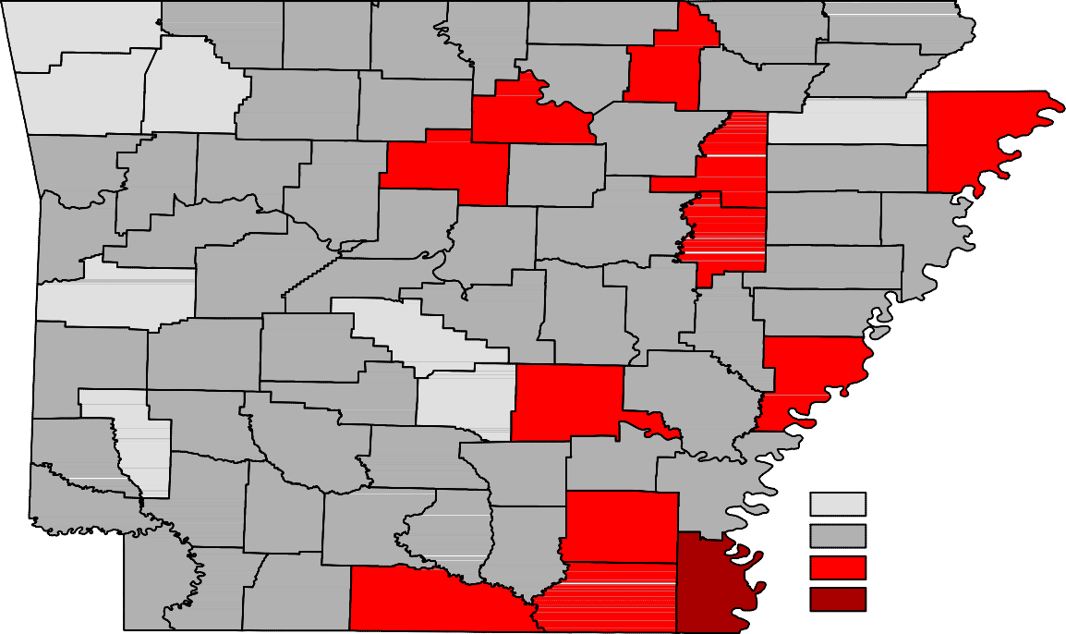Ranked by Unemployment Rates

March 2017- Not Seasonally Adjusted

Rank  1 | County  Washington | Rate  2.4 | Rank  25 | County  Marion | Rate  3.7 | Rank  51 | County  Clay | Rate  4.7
2 | Madison | 2.5 | 25 | Yell | 3.7 | 51 | Lee | 4.7
3 | Benton | 2.6 | 28 | Calhoun | 3.8 | 51 | White | 4.7
4 | Craighead | 2.8 | 28 | Garland | 3.8 | 54 | Izard | 4.8
5 | Howard | 2.9 | 28 | Johnson | 3.8 | 54 | St. Francis | 4.8
5 | Saline | 2.9 | 31 | Cross | 3.9 | 56 | Conway | 4.9
5 | Scott | 2.9 | 31 | Dallas | 3.9 | 56 | Lafayette | 4.9
8 | Grant | 3.0 | 31 | Pike | 3.9 | 56 | Montgomery | 4.9
9 | Arkansas | 3.1 | 34 | Baxter | 4.0 | 56 | Polk | 4.9
9 | Lonoke | 3.1 | 34 | Fulton | 4.0 | 60 | Bradley | 5.0
11 | Boone | 3.2 | 34 | Poinsett | 4.0 | 60 | Cleburne | 5.0
11 | Hempstead | 3.2 | 34 | Pope | 4.0 | 60 | Columbia | 5.0
13 | Carroll | 3.3 | 34 | Prairie | 4.0 | 60 | Desha | 5.0
13 | Faulkner | 3.3 | 39 | Independence | 4.1 | 64 | Jefferson | 5.1
13 | Franklin | 3.3 | 39 | Miller | 4.1 | 64 | Sharp | 5.1
13 | Nevada | 3.3 | 39 | Randolph | 4.1 | 64 | Woodruff | 5.1
13 | Pulaski | 3.3 | 39 | Searcy | 4.1 | 67 | Stone | 5.2
18 | Crawford | 3.4 | 43 | Crittenden | 4.3 | 68 | Drew | 5.3
18 | Hot Spring | 3.4 | 43 | Lincoln | 4.3 | 69 | Union | 5.4
18 | Newton | 3.4 | 43 | Monroe | 4.3 | 70 | Phillips | 5.7
21 | Lawrence | 3.5 | 43 | Perry | 4.3 | 71 | Ashley | 5.8
21 | Sebastian | 3.5 | 43 | Sevier | 4.3 | 72 | Mississippi | 5.9
23 | Clark | 3.6 | 48 | Little River | 4.4 | 73 | Van Buren | 6.0
23 | Logan | 3.6 | 48 | Ouachita | 4.4 | 74 | Jackson | 6.1
25 | Greene | 3.7 | 50 | Cleveland | 4.5 | 75 | Chicot | 7.1

Civilian Labor Force Estimates

LWDA Labor Force Estimates (Not Seasonally Adjusted)

LWDA CLF |  | March 2017  Emp Unemp |  | Rate | CLF | February 2017  Emp Unemp |  | Rate | CLF | March 2016  Emp Unemp |  | Rate
Central (minus LR) 247,302 239,353 7,949 3.2 246,240 236,711 9,529 3.9 247,786 238,857 8,929 3.6
City of Little Rock | 96,504 | 93,344 | 3,160 | 3.3 | 96,018 | 92,359 | 3,659 | 3.8 | 96,358 | 93,003 | 3,355 | 3.5
Eastern | 47,952 | 45,765 | 2,187 | 4.6 | 47,701 | 45,086 | 2,615 | 5.5 | 48,394 | 45,971 | 2,423 | 5.0
North Central | 93,913 | 89,384 | 4,529 | 4.8 | 93,571 | 88,129 | 5,442 | 5.8 | 96,375 | 90,921 | 5,454 | 5.7
Northeast | 119,680 | 115,211 | 4,469 | 3.7 | 119,462 | 114,063 | 5,399 | 4.5 | 119,671 | 114,432 | 5,239 | 4.4
Northwest | 316,746 | 308,227 | 8,519 | 2.7 | 314,093 | 303,650 | 10,443 | 3.3 | 309,460 | 299,932 | 9,528 | 3.1
Southeast | 82,243 | 78,330 | 3,913 | 4.8 | 81,948 | 77,318 | 4,630 | 5.6 | 83,264 | 78,926 | 4,338 | 5.2
Southwest | 94,032 | 90,003 | 4,029 | 4.3 | 93,633 | 88,910 | 4,723 | 5.0 | 95,094 | 90,682 | 4,412 | 4.6
West Central | 132,636 | 127,490 | 5,146 | 3.9 | 131,911 | 125,625 | 6,286 | 4.8 | 133,084 | 127,108 | 5,976 | 4.5
Western | 112,075 | 108,137 | 3,938 | 3.5 | 112,230 | 107,534 | 4,696 | 4.2 | 114,128 | 109,490 | 4,638 | 4.1

Benton

Washington
Carroll

Madison

Boone

Newton

Marion

Searcy

Baxter

Stone
Fulton

Izard

Sharp

Randolph

Lawrence
Clay

Greene

Craighead

Mississippi

Crawford

Franklin

Johnson

Pope

Van Buren

Cleburne
Independence

Jackson

Poinsett

Cross

Sebastian

Scott
Logan

Yell
Conway

Perry

Saline

Faulkner

Pulaski
White

Lonoke

Prairie
Woodruff

Monroe

St. Francis

Lee
Crittenden

Polk

Sevier
Montgomery

Pike
Howard
Garland

Hot Spring

Clark
Dallas

Grant

Jefferson

Lincoln
Cleveland

Arkansas

Desha

Phillips

Little River
Hempstead

Miller

Nevada

Ouachita

Calhoun

Bradley

Drew

Chicot

Lafayette
Columbia
Union
Ashley

Central (minus LR) Eastern
North Central
Northeast
Northwest
Southeast
Southwest
West Central
Western

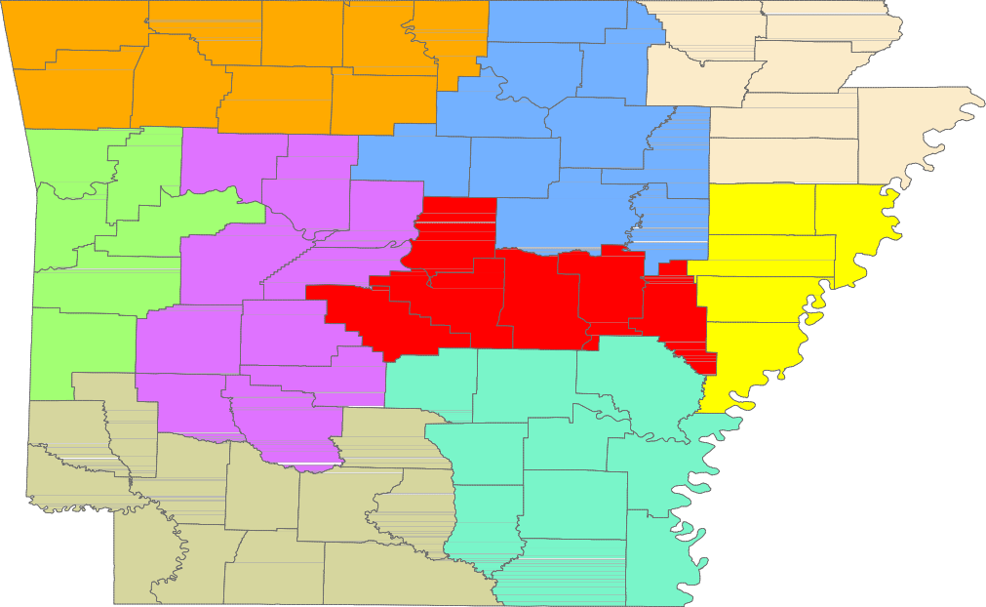

www.discover.arkansas.gov 18

