Arkansas
Labor Market
Report

April 2017

Table of Contents

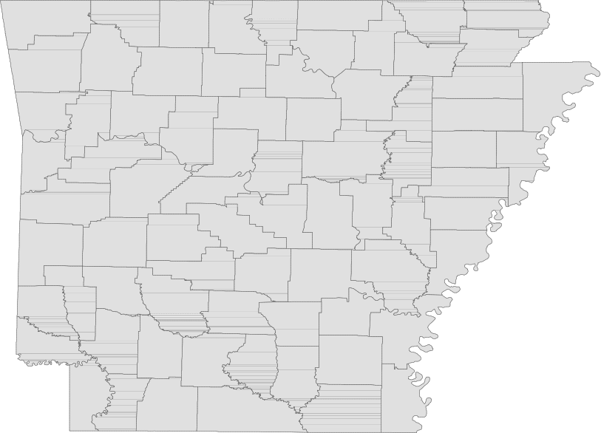Monthly Spotlight..................................................2

Arkansas Labor Force Summary.......................3

Arkansas Nonfarm Payroll Jobs........................4

Arkansas Production Workers...........................6

Metropolitan Statistical Areas...........................7

Micropolitan Statistical Areas/Cities.............14

County Labor Force Statistics..........................15

Local Workforce Development Areas..........18

Technical Notes

The Arkansas Labor Market is prepared monthly in conjunction with the U.S. Department of Labor, Bu- reau of Labor Statistics (BLS). The current month’s estimates are preliminary, while previous month’s data is subject to revision.

Estimates of nonfarm payroll jobs show the num- ber of jobs by industry and reflect employment by place of work. Hours and earnings estimates are based on payroll and worker-hour data col- lected for production workers in manufacturing industries.

Industries are classified according to the North American Industry Classification System (NAICS). All estimates are based on a first quarter 2016 benchmark.

Explanation of Terms and Concepts

Monthly Business Survey of Employers

A monthly sample survey designed to provide industry information on nonfarm payroll jobs. Data are compiled each month from mail surveys and telephone interviews conducted by the Bureau of Labor Statistics in cooperation with Department of Workforce Services. The data are based on establishment records and include all workers, full-or part-time, who received pay during the payroll period which includes the 12th of the
month. Approximately 5,000 Arkansas business
establishments are surveyed.

Metropolitan Statistical Area (MSA)

A term applied by the U.S. Office of Management and Budget to counties that have one or more central cities and that meet specified criteria of population density, commuting patterns and social and economic integration.

Current Population Survey (CPS)

A monthly sample survey of the population 16 years of age and over, designed to provide data on the labor force, the employed and the unem- ployed. The survey is conducted each month by the Bureau of the Census for BLS. The information is collected by trained interviewers from a sample of about 60,000 households. The data collected are based on the activity reported for the calendar week including the 12th of the month. Approxi- mately 800 Arkansas households are represented in the sample survey.

Civilian Labor Force

The sum of all employed and unemployed persons
16 years of age or older. Members of the Armed
Forces are excluded.
Employment

An estimate of the number of persons who worked any time for pay or profit or worked 15 hours or more as unpaid workers in a family business dur- ing the calendar week which includes the 12th of the month. Also included are those who, although not working, had some job attachment and were not looking for work, and persons involved in labor management disputes.

Unemployment

An estimate of the number of persons who did not have a job, but were available for work and actively seeking work during the calendar week which includes the 12th of the month.

Unemployment Rate

The number of unemployed as a percentage of the civilian labor force. Unemployment rates are calculated from unrounded data.

Seasonal Adjustment

A statistical technique applied to monthly data to eliminate changes that normally occur during the year due to seasonal events such as weather, major holidays, schedule shifts, harvest times, and the opening/closing of schools.

April Spotlight
Wages in Arkansas
The Quarterly Census of Employment and Wages (QCEW) is the most comprehensive data collection program utilized by the Bureau of Labor Statistics (BLS). The program is based on each state’s Unemploy- ment Insurance (UI) program, which enables BLS to produce data using every business that is covered under UI tax law. In addition to calculating covered employment, the program also tracks the wages paid to employees. Due to the comprehensive nature of the information, data can be produced at any level-- national, statewide, counties, and cities.

The information below comes from the QCEW program and provides annual average wage data for each county in Arkansas. Annual average wages are calculated using the total wages earned during the calendar year, divided by annual average employment. The wages are compiled using all industries and includes both private and government jobs, for all workers included under UI tax law. It is important to note that QCEW data is based on county of employment, not county of residency. So if an individual works in a different county than where they live, their wages are counted in the county where they work.

In 2016, average annual wages ranged from a high of $54,637, for those employed in Benton County, to a low of $25,242 in Newton County. Compared to 2015, annual average wages increased in 60 of Arkansas’ 75 counties. Fifteen counties posted a decline in wages from last year.

Wages in Arkansas by County
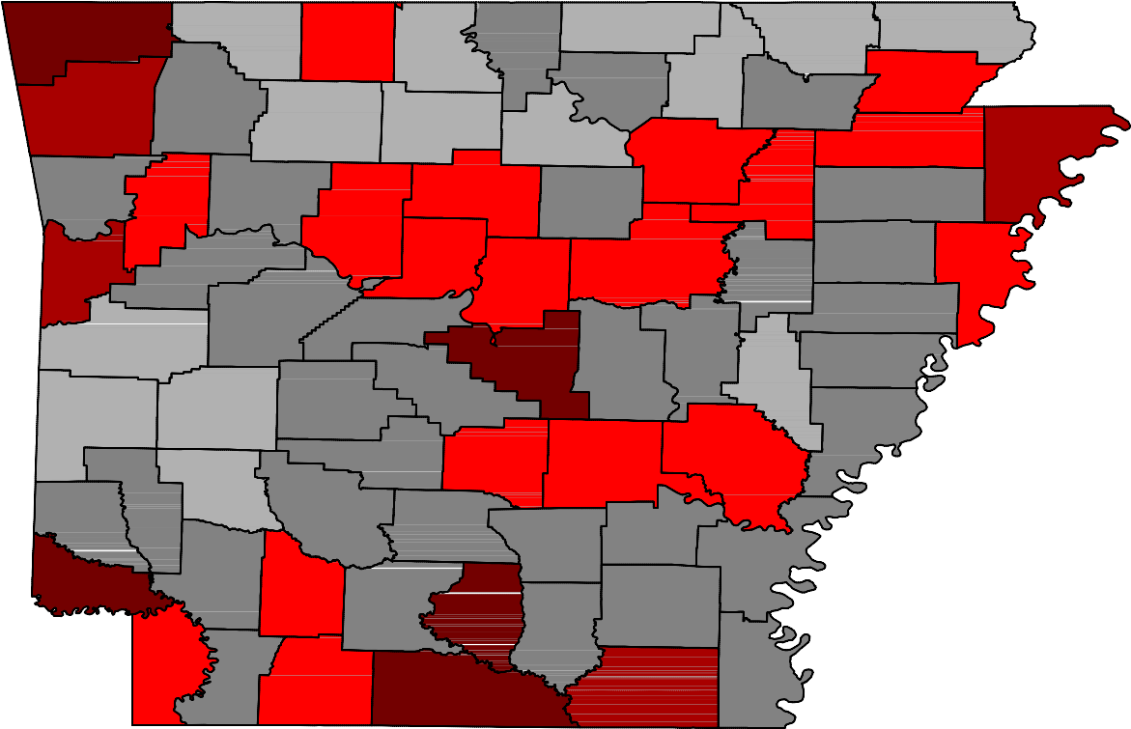2016 Annual Average

Benton

Washington
Carroll

Madison

Boone

Newton

Marion

Searcy

Baxter

Stone
Fulton

Izard

Sharp

Randolph

Lawrence
Clay

Greene

Craighead

Mississippi

Crawford

Franklin

Johnson

Pope

Van Buren

Cleburne
Independence

Jackson

Poinsett

Cross

Sebastian

Scott
Logan

Yell
Conway

Perry

Saline

Faulkner

Pulaski
White

Lonoke

Prairie

Woodruff

Monroe

St. Francis

Lee
Crittenden

Polk

Sevier
Montgomery

Pike
Howard
Garland

Hot Spring

Clark
Dallas

Grant

Jefferson

Lincoln
Cleveland

Arkansas

Desha

Phillips

Wages
< $25,000 [NONE]

$25,000 - $30,000

Little River
Hempstead

Miller
Nevada

Ouachita

Calhoun

Bradley

Drew

Chicot
Chicot

$30,000 - $35,000

$35,000 - $40,000

Lafayette
Columbia

Union
Ashley
$40,000 - $45,000

> $45,000

Civilian Labor Force Summar y

Labor force data, produced by the U.S. Department of Labor, Bureau of Labor Statistics and released by the Arkansas Department of Workforce Services, show Arkansas’ seasonally adjusted unemploy- ment rate declined one-tenth of a percentage point, from 3.6 percent in March to 3.5 percent in April. Arkansas’ civilian labor force rose 6,782, a result of 7,693 more employed and 911 fewer unemployed Arkansans. At 4.4 percent, the United States’ jobless rate also declined one-tenth of a percentage point between March and April.

BLS Program Operations Manager Susan Price said, “For the fourth month in a row, Arkansas’ unem- ployment rate has declined to record setting lows. Starting the year at 3.8 percent, the rate has de- creased one-tenth of a percentage point each month to 3.5 percent in April.”

Civilian Labor Force Estimates

Seasonally Adjusted Not Seasonally Adjusted

Civilian Labor Force | Apr 17  1,347,934 | Mar 17  1,341,152 | Apr 16  1,345,119 | Civilian Labor Force | Apr 17  1,353,270 | Mar 17  1,343,003 | Apr 16  1,343,967
Employment | 1,300,237 | 1,292,544 | 1,290,523 | Employment | 1,311,919 | 1,295,170 | 1,295,493
Unemployment | 47,697 | 48,608 | 54,596 | Unemployment | 41,351 | 47,833 | 48,474
Unemployment Rate | 3.5 | 3.6 | 4.1 | Unemployment Rate | 3.1 | 3.6 | 3.6
U.S. Unemployment | 4.4 | 4.5 | 5.0 | U.S. Unemployment | 4.1 | 4.6 | 4.7

12.0
Unemployment Rates (Seasonally Adjusted)
April: 1977 - 2017

10.0

8.0

6.0

4.0

2.0

0.0

'77 '79 '81 '83 '85 '87 '89 '91 '93 '95 '97 '99 '01 '03 '05 '07 '09 '11 '13 '15 '17

Nonfarm Payroll Jobs

Not Seasonally Adjusted
(In Thousands)

(NAICS)
Apr 17 Mar 17 Apr 16
OTM OT Y

Total Nonfarm | 1251.6 | 1240.6 | 1231.9 | 11.0 | 19.7
Goods Producing | 213.3 | 211.3 | 210.3 | 2.0 | 3.0
Mining, Logging, and Construction | 56.1 | 54.8 | 56.6 | 1.3 | -0.5
Mining & Logging | 6.0 | 6.0 | 6.3 | 0.0 | -0.3
Construction | 50.1 | 48.8 | 50.3 | 1.3 | -0.2
Specialty Trade Contractors | 31.5 | 31.3 | 32.1 | 0.2 | -0.6
Manufacturing | 157.2 | 156.5 | 153.7 | 0.7 | 3.5
Durable Goods | 73.5 | 73.6 | 74.5 | -0.1 | -1.0
Nondurable Goods | 83.7 | 82.9 | 79.2 | 0.8 | 4.5
Service Providing | 1038.3 | 1029.3 | 1021.6 | 9.0 | 16.7
Trade, Transportation & Utilities | 253.7 | 251.5 | 251.3 | 2.2 | 2.4
Wholesale Trade | 47.5 | 46.6 | 46.4 | 0.9 | 1.1
Retail Trade | 141.6 | 140.5 | 142.0 | 1.1 | -0.4
Transport, Warehousing & Utilities | 64.6 | 64.4 | 62.9 | 0.2 | 1.7
Information | 13.1 | 13.1 | 13.6 | 0.0 | -0.5
Financial Activities | 51.4 | 50.9 | 51.2 | 0.5 | 0.2
Finance & Insurance | 38.3 | 37.9 | 38.0 | 0.4 | 0.3
Real Estate & Rental & Leasing | 13.1 | 13.0 | 13.2 | 0.1 | -0.1
Professional & Business Services | 149.6 | 148.0 | 143.9 | 1.6 | 5.7
Professional, Scientific & Technical | 44.6 | 44.1 | 43.2 | 0.5 | 1.4
Management of Companies | 34.3 | 34.7 | 34.4 | -0.4 | -0.1
Administrative & Support Services | 70.7 | 69.2 | 66.3 | 1.5 | 4.4
Educational & Health Services | 187.4 | 186.7 | 180.4 | 0.7 | 7.0
Educational Services | 17.1 | 17.0 | 15.3 | 0.1 | 1.8
Health Care & Social Assistance | 170.3 | 169.7 | 165.1 | 0.6 | 5.2
Ambulatory Health Care | 56.5 | 56.0 | 52.9 | 0.5 | 3.6
Social Assistance | 40.5 | 40.1 | 39.8 | 0.4 | 0.7
Leisure & Hospitality 119.2 115.1 116.7 4.1 2.5
Arts, Entertainment & Recreation | 11.5 | 10.2 | 11.5 | 1.3 | 0.0
Accommodation & Food Services | 107.7 | 104.9 | 105.2 | 2.8 | 2.5
Accommodation Services | 11.3 | 10.9 | 11.1 | 0.4 | 0.2
Food Services | 96.4 | 94.0 | 94.1 | 2.4 | 2.3
Other Services | 48.3 | 48.2 | 47.0 | 0.1 | 1.3
Government | 215.6 | 215.8 | 217.5 | -0.2 | -1.9
Federal Government | 20.1 | 20.3 | 20.2 | -0.2 | -0.1
State Government | 80.5 | 80.2 | 81.0 | 0.3 | -0.5
Local Government | 115.0 | 115.3 | 116.3 | -0.3 | -1.3

Nonfarm Payroll Job Summar y

March 2017 - April 2017

Arkansas’ nonfarm payroll jobs rose 11,000 in April to total 1,251,600. Increases were posted in eight major industry sectors. Employment in one industry sector declined, while two remained stable. Lei- sure and hospitality added 4,100 jobs. Seasonal gains occurred in both accommodation and food services (+2,800) and in arts, entertainment, and recreation (+1,300). Jobs in trade, transportation, and utilities rose 2,200, attributed in part to seasonal hiring in retail trade (+1,100). Employment in professional and business services increased 1,600. A majority of the growth occurred in administra- tive and support services (+1,500), a subsector which includes employment agencies. Construction added 1,300 jobs, a typical seasonal expansion.

April 2016 - April 2017

Compared to April 2016, nonfarm payroll jobs in Arkansas increased 19,700. Seven major industry sec- tors added jobs, while employment in four sectors declined slightly. Jobs in educational and health services rose 7,000, mostly in health care and social assistance (+5,200). Employment in professional and business services increased 5,700. Administrative and support services posted a majority of the growth (+4,400). Manufacturing added 3,500 jobs, with expansions in nondurable goods (+4,500) more than offsetting losses in durable goods (-1,000). Moderate gains were reported in leisure and hospitality (+2,500), trade-transportation-utilities (+2,400) and other services (+1,300). Jobs in government decreased 1,900. Most of the decline was in local government (-1,300), attributed in part to reported staff reductions at various public school districts across the state.

125,000
Jobs in Leisure and Hospitality (Not Seasonally Adjusted)
January 2015 - April 2017

120,000

115,000

110,000

105,000

100,000

95,000

J F M A M J J A S O N D

2015 2016 2017

Production Workers- Hours and Earnings

Manufacturing

Apr 17 Mar 17
Apr 16

Average Weekly Hours Average Hourly Earnings Average Weekly Earnings

38.6
15.96
616.06

38.6
15.85
611.81

39.5
16.20
639.90

Durable Goods and Nondurable Goods Manufacturing

Durable Goods Manufacturing Nondurable Goods Manufacturing

Apr 17 Mar 17

Apr 16

Apr 17 Mar 17
Apr 16

Average Weekly Hours Average Hourly Earnings Average Weekly Earnings

40.9
17.56
718.20

40.9
17.47
714.52

42.0
17.81
748.02

Average Weekly Hours Average Hourly Earnings Average Weekly Earnings

36.6
14.44
528.50
36.7
14.28
524.08
37.2
14.48
538.66

16.60
Manufacturing: Average Hourly Earnings
April 2014 - April 2017

16.40

16.20

16.00

15.80

15.60

15.40

15.20

15.00

Apr '14 Oct '14 Apr '15 Oct '15 Apr '16 Oct '16 Apr '17

Little Rock-Nor th Little Rock-Conway MSA

The Little Rock-North Little Rock-Conway MSA= Faulkner, Grant, Lonoke, Perry, Pulaski, & Saline counties.

Civilian Labor Force Estimates (Not Seasonally Adjusted)

 | Apr 17 | Mar 17 | Apr 16 | OTM | OT Y
Civilian Labor Force | 350,055 | 349,365 | 350,366 | 690 | -311
Employment | 340,234 | 338,087 | 339,132 | 2,147 | 1,102
Unemployment | 9,821 | 11,278 | 11,234 | -1,457 | -1,413
Unemployment Rate | 2.8 | 3.2 | 3.2 | -0.4 | -0.4

Nonfarm Payroll Jobs (Not Seasonally Adjusted)
(In Thousands)

NAICS  Total Nonfarm | Apr 17  354.6 | Mar 17  355.9 | Apr 16  355.3 | OTM  -1.3 | OT Y  -0.7
Goods Producing | 36.5 | 36.5 | 37.4 | 0.0 | -0.9
Mining, Logging & Construction | 16.5 | 16.5 | 17.2 | 0.0 | -0.7
Manufacturing | 20.0 | 20.0 | 20.2 | 0.0 | -0.2
Service Providing 318.1 319.4 317.9 -1.3 0.2
Trade, Transportation & Utilities | 70.4 | 70.5 | 69.9 | -0.1 | 0.5
Wholesale Trade | 15.0 | 14.9 | 15.2 | 0.1 | -0.2
Retail Trade | 39.5 | 39.7 | 39.2 | -0.2 | 0.3
Trans., Warehousing & Utilities | 15.9 | 15.9 | 15.5 | 0.0 | 0.4
Information | 6.1 | 6.1 | 6.4 | 0.0 | -0.3
Financial Activities | 20.4 | 20.4 | 20.4 | 0.0 | 0.0
Professional & Business Services | 47.6 | 47.9 | 47.8 | -0.3 | -0.2
Educational & Health Services | 56.0 | 56.2 | 53.6 | -0.2 | 2.4
Leisure & Hospitality | 32.4 | 32.7 | 33.8 | -0.3 | -1.4
Other Services | 14.7 | 14.7 | 14.4 | 0.0 | 0.3
Government | 70.5 | 70.9 | 71.6 | -0.4 | -1.1
Federal Government | 9.6 | 9.8 | 9.6 | -0.2 | 0.0
State Government | 35.2 | 35.3 | 35.0 | -0.1 | 0.2
Local Government | 25.7 | 25.8 | 27.0 | -0.1 | -1.3
Nonfarm Payroll Jobs by Sector (Ranked)
April 2017

Government

Trade-Transportation-Utilities

Education al & Health Services

Professional & Business Services

Lei sure & Hospitality

Financial Activities

Manufacturing

Mining-Logging-Construction

Other Services

Information

0 10,000 20,000 30,000 40,000 50,000 60,000 70,000 80,000

Fayetteville-Springdale-Rogers MSA

The Fayetteville-Springdale-Rogers MSA= Benton, Madison, & Washington counties in Arkansas & McDonald county in Missouri.

Civilian Labor Force Estimates (Not Seasonally Adjusted)

 | Apr 17 | Mar 17 | Apr 16 | OTM | OT Y
Civilian Labor Force | 272,410 | 269,245 | 262,936 | 3,165 | 9,474
Employment | 266,350 | 262,405 | 256,087 | 3,945 | 10,263
Unemployment | 6,060 | 6,840 | 6,849 | -780 | -789
Unemployment Rate | 2.2 | 2.5 | 2.6 | -0.3 | -0.4

Nonfarm Payroll Jobs (Not Seasonally Adjusted)
(In Thousands)

NAICS  Total Nonfarm | Apr 17  254.5 | Mar 17  253.2 | Apr 16  245.2 | OTM  1.3 | OT Y  9.3
Goods Producing | 38.1 | 38.1 | 37.5 | 0.0 | 0.6
Mining, Logging & Construction | 10.7 | 10.6 | 10.4 | 0.1 | 0.3
Manufacturing | 27.4 | 27.5 | 27.1 | -0.1 | 0.3
Service Providing 216.4 215.1 207.7 1.3 8.7
Trade, Transportation & Utilities | 56.2 | 55.9 | 55.4 | 0.3 | 0.8
Wholesale Trade | 12.7 | 12.6 | 12.1 | 0.1 | 0.6
Retail Trade | 26.1 | 25.9 | 26.6 | 0.2 | -0.5
Trans., Warehousing & Utilities | 17.4 | 17.4 | 16.7 | 0.0 | 0.7
Information | 1.9 | 1.9 | 2.0 | 0.0 | -0.1
Financial Activities | 7.8 | 7.8 | 7.6 | 0.0 | 0.2
Professional & Business Services | 53.3 | 53.1 | 48.6 | 0.2 | 4.7
Educational & Health Services | 28.2 | 28.0 | 27.2 | 0.2 | 1.0
Leisure & Hospitality | 25.7 | 24.9 | 24.7 | 0.8 | 1.0
Other Services | 7.7 | 7.7 | 7.5 | 0.0 | 0.2
Government | 35.6 | 35.8 | 34.7 | -0.2 | 0.9
Federal Government | 2.5 | 2.5 | 2.6 | 0.0 | -0.1
State Government | 14.2 | 14.3 | 13.4 | -0.1 | 0.8
Local Government | 18.9 | 19.0 | 18.7 | -0.1 | 0.2

280,000
Number of Employed
April: 1997 - 2017

260,000
Nonfarm Payroll Jobs
April 2015 - April 2017

260,000
255,000

240,000
250,000

220,000

245,000

200,000

240,000

180,000

235,000

160,000

230,000

140,000

225,000

120,000

100,000

'97 '98 '99 '00 '01 '02 '03 '04 '05 '06 '07 '08 '09 '10 '11 '12 '13 '14 '15 '16 '17

220,000

Apr
'15

Oct
'15

Apr
'16

Oct
'16

Apr
'17

For t Smith MSA

The Fort Smith MSA= Crawford & Sebastian counties in Arkansas & LeFlore & Sequoyah counties in Oklahoma.

Civilian Labor Force Estimates (Not Seasonally Adjusted)

 | Apr 17 | Mar 17 | Apr 16 | OTM | OT Y
Civilian Labor Force | 119,871 | 119,931 | 121,475 | -60 | -1,604
Employment | 115,483 | 115,076 | 116,189 | 407 | -706
Unemployment | 4,388 | 4,855 | 5,286 | -467 | -898
Unemployment Rate | 3.7 | 4.0 | 4.4 | -0.3 | -0.7

Nonfarm Payroll Jobs (Not Seasonally Adjusted)
(In Thousands)

NAICS  Total Nonfarm | Apr 17  113.0 | Mar 17  113.2 | Apr 16  114.3 | OTM  -0.2 | OT Y  -1.3
Goods Producing | 22.7 | 22.7 | 23.6 | 0.0 | -0.9
Mining, Logging & Construction | 5.3 | 5.2 | 5.6 | 0.1 | -0.3
Manufacturing | 17.4 | 17.5 | 18.0 | -0.1 | -0.6
Service Providing 90.3 90.5 90.7 -0.2 -0.4
Trade, Transportation & Utilities | 22.9 | 23.1 | 23.6 | -0.2 | -0.7
Wholesale Trade | 3.9 | 3.9 | 3.9 | 0.0 | 0.0
Retail Trade | 12.5 | 12.7 | 13.0 | -0.2 | -0.5
Trans., Warehousing & Utilities | 6.5 | 6.5 | 6.7 | 0.0 | -0.2
Information | 1.3 | 1.3 | 1.2 | 0.0 | 0.1
Financial Activities | 3.8 | 3.8 | 3.7 | 0.0 | 0.1
Professional & Business Services | 12.8 | 12.9 | 13.1 | -0.1 | -0.3
Educational & Health Services | 16.8 | 16.9 | 16.6 | -0.1 | 0.2
Leisure & Hospitality | 9.7 | 9.5 | 9.6 | 0.2 | 0.1
Other Services | 4.3 | 4.3 | 4.3 | 0.0 | 0.0
Government | 18.7 | 18.7 | 18.6 | 0.0 | 0.1
Federal Government | 1.3 | 1.3 | 1.3 | 0.0 | 0.0
State Government | 3.2 | 3.2 | 3.2 | 0.0 | 0.0
Local Government | 14.2 | 14.2 | 14.1 | 0.0 | 0.1

10.0
Unemployment Rates
April: 1997 - 2017

18,000
Jobs in Educational and Health Services
April: 2007 - 2017

9.0

8.0

17,000

7.0

16,000

6.0

5.0
15,000

4.0

3.0

14,000

2.0

13,000

1.0

0.0

'97 '98 '99 '00 '01 '02 '03 '04 '05 '06 '07 '08 '09 '10 '11 '12 '13 '14 '15 '16 '17
12,000

'07 '08 '09 '10 '11 '12 '13 '14 '15 '16 '17

Hot Springs MSA

The Hot Springs MSA= Garland County.

Civilian Labor Force Estimates (Not Seasonally Adjusted)

 | Apr 17 | Mar 17 | Apr 16 | OTM | OT Y
Civilian Labor Force | 41,261 | 40,617 | 40,927 | 644 | 334
Employment | 39,928 | 39,088 | 39,385 | 840 | 543
Unemployment | 1,333 | 1,529 | 1,542 | -196 | -209
Unemployment Rate | 3.2 | 3.8 | 3.8 | -0.6 | -0.6

Nonfarm Payroll Jobs (Not Seasonally Adjusted)
(In Thousands)

NAICS
Apr 17 | Mar 17 | Apr 16 | OTM | OT Y
39.2 | 38.6 | 38.8 | 0.6 | 0.4
4.5 | 4.5 | 4.4 | 0.0 | 0.1
34.7 | 34.1 | 34.4 | 0.6 | 0.3
4.6 | 4.5 | 4.8 | 0.1 | -0.2

Total Nonfarm Goods Producing Service Providing Government

41,000
Number of Employed
January 2015 - April 2017

40,000

39,000

38,000

37,000

36,000

35,000

34,000

J F M A M J J A S O N D

2015 2016 2017

Jonesboro MSA

The Jonesboro MSA= Craighead & Poinsett counties.

Civilian Labor Force Estimates (Not Seasonally Adjusted)

 | Apr 17 | Mar 17 | Apr 16 | OTM | OT Y
Civilian Labor Force | 63,398 | 62,491 | 62,375 | 907 | 1,023
Employment | 61,734 | 60,594 | 60,495 | 1,140 | 1,239
Unemployment | 1,664 | 1,897 | 1,880 | -233 | -216
Unemployment Rate | 2.6 | 3.0 | 3.0 | -0.4 | -0.4

Nonfarm Payroll Jobs (Not Seasonally Adjusted)
(In Thousands)

NAICS
Apr 17 | Mar 17 | Apr 16 | OTM | OT Y
57.0 | 56.5 | 56.0 | 0.5 | 1.0
9.4 | 9.4 | 9.0 | 0.0 | 0.4
47.6 | 47.1 | 47.0 | 0.5 | 0.6
9.2 | 9.1 | 9.1 | 0.1 | 0.1

Total Nonfarm Goods Producing Service Providing Government

50,000
Jobs in Service Providing Industries
April: 1997 - 2017

45,000

40,000

35,000

30,000

25,000

20,000

'97 '98 '99 '00 '01 '02 '03 '04 '05 '06 '07 '08 '09 '10 '11 '12 '13 '14 '15 '16 '17

Pine Bluff MSA

The Pine Bluff MSA= Cleveland, Jefferson, & Lincoln counties.

Civilian Labor Force Estimates (Not Seasonally Adjusted)

 | Apr 17 | Mar 17 | Apr 16 | OTM | OT Y
Civilian Labor Force | 35,770 | 35,683 | 35,938 | 87 | -168
Employment | 34,261 | 33,922 | 34,179 | 339 | 82
Unemployment | 1,509 | 1,761 | 1,759 | -252 | -250
Unemployment Rate | 4.2 | 4.9 | 4.9 | -0.7 | -0.7

Nonfarm Payroll Jobs (Not Seasonally Adjusted)
(In Thousands)

NAICS
Apr 17 | Mar 17 | Apr 16 | OTM | OT Y
33.3 | 33.4 | 33.5 | -0.1 | -0.2
5.9 | 6.0 | 6.1 | -0.1 | -0.2
27.4 | 27.4 | 27.4 | 0.0 | 0.0
9.6 | 9.6 | 9.7 | 0.0 | -0.1

Total Nonfarm Goods Producing Service Providing Government

4,000
Number of Unemployed
April 2014 - April 2017

3,500

3,000

2,500

2,000

1,500

1,000

500

0
Apr '14 Oct '14 Apr '15 Oct '15 Apr '16 Oct '16 Apr '17

Out-of-State MSA

Civilian Labor Force Estimates (Not Seasonally Adjusted)

Memphis, TN-MS-AR MSA

The Memphis, TN-MS-AR MSA= Fayette, Shelby, & Tipton counties in Tennessee; Benton, Desoto, Marshall, Tate, & Tunica counties in Mississippi; & Crittenden County in Arkansas.

 | Apr 17 | Mar 17 | Apr 16 | OTM | OT Y
Civilian Labor Force | 628,392 | 629,914 | 617,423 | -1,522 | 10,969
Employment | 602,062 | 598,408 | 588,307 | 3,654 | 13,755
Unemployment | 26,330 | 31,506 | 29,116 | -5,176 | -2,786
Unemployment Rate | 4.2 | 5.0 | 4.7 | -0.8 | -0.5

Texarkana MSA

The Texarkana MSA= Bowie County in Texas & Little River & Miller counties in Arkansas.

 | Apr 17 | Mar 17 | Apr 16 | OTM | OT Y
Civilian Labor Force | 64,988 | 65,229 | 65,387 | -241 | -399
Employment | 62,136 | 62,071 | 62,858 | 65 | -722
Unemployment | 2,852 | 3,158 | 2,529 | -306 | 323
Unemployment Rate | 4.4 | 4.8 | 3.9 | -0.4 | 0.5

610,000
Employment- Memphis MSA
April: 2007 - 2017

7.0
Unemployment Rates- Texarkana MSA
January 2015 - April 2017

600,000
6.0

590,000

5.0

580,000

4.0

570,000

3.0

560,000

2.0

550,000

1.0

540,000

530,000

'07 '08 '09 '10 '11 '12 '13 '14 '15 '16 '17

0.0

J F M A M J J A S O N D
2015 2016 2017

i

April 2017 March 2017 April 2016

Micro Area  Arkadelphia Micro | CLF  9,613 | Emp  9,301 | Unemp  312 | Rate  3.2 | CLF  9,539 | Emp  9,194 | Unemp  345 | Rate  3.6 | CLF  9,491 | Emp  9,120 | Unemp  371 | Rate  3.9
Batesville Micro | 16,245 | 15,700 | 545 | 3.4 | 16,128 | 15,473 | 655 | 4.1 | 16,089 | 15,370 | 719 | 4.5
Blytheville Micro | 18,085 | 17,202 | 883 | 4.9 | 17,986 | 16,935 | 1,051 | 5.8 | 17,902 | 16,812 | 1,090 | 6.1
Camden Micro | 12,315 | 11,834 | 481 | 3.9 | 12,159 | 11,640 | 519 | 4.3 | 12,231 | 11,690 | 541 | 4.4
El Dorado Micro | 16,287 | 15,529 | 758 | 4.7 | 16,284 | 15,413 | 871 | 5.3 | 16,464 | 15,644 | 820 | 5.0
Forrest City Micro | 8,979 | 8,628 | 351 | 3.9 | 8,896 | 8,467 | 429 | 4.8 | 8,867 | 8,447 | 420 | 4.7
Harrison Micro | 19,704 | 19,158 | 546 | 2.8 | 19,461 | 18,822 | 639 | 3.3 | 19,688 | 19,028 | 660 | 3.4
Helena-West Helena Micro | 6,595 | 6,284 | 311 | 4.7 | 6,564 | 6,194 | 370 | 5.6 | 6,799 | 6,433 | 366 | 5.4
Hope Micro | 13,815 | 13,400 | 415 | 3.0 | 13,628 | 13,184 | 444 | 3.3 | 13,651 | 13,200 | 451 | 3.3
Magnolia Micro | 9,116 | 8,740 | 376 | 4.1 | 9,095 | 8,641 | 454 | 5.0 | 9,400 | 8,913 | 487 | 5.2
Malvern Micro | 14,176 | 13,762 | 414 | 2.9 | 14,049 | 13,568 | 481 | 3.4 | 14,321 | 13,805 | 516 | 3.6
Mountain Home Micro | 16,404 | 15,836 | 568 | 3.5 | 16,240 | 15,585 | 655 | 4.0 | 16,154 | 15,548 | 606 | 3.8
Paragould Micro | 19,887 | 19,308 | 579 | 2.9 | 19,637 | 18,919 | 718 | 3.7 | 19,883 | 19,140 | 743 | 3.7
Russellville Micro | 38,519 | 37,290 | 1,229 | 3.2 | 38,204 | 36,716 | 1,488 | 3.9 | 38,431 | 36,888 | 1,543 | 4.0
Searcy Micro | 33,497 | 32,115 | 1,382 | 4.1 | 33,291 | 31,725 | 1,566 | 4.7 | 34,457 | 32,718 | 1,739 | 5.0

Arkadelphia Micro= Clark County Batesville Micro= Independence County Blytheville Micro= Mississippi County
Camden Micro= Calhoun & Ouachita counties
El Dorado Micro= Union County
Forrest City Micro= St. Francis County Harrison Micro= Boone & Newton counties Helena-West Helena Micro= Phillips County Hope Micro= Hempstead & Nevada counties Magnolia Micro= Columbia County
Malvern Micro= Hot Spring County Mountain Home Micro= Baxter County Paragould Micro= Greene County Russellville Micro= Pope & Yell counties Searcy Micro= White County

City Labor Force Statistics (Not Seasonally Adjusted)

April 2017 March 2017 April 2016

City  Bella Vista | CLF  12,404 | Emp  12,036 | Unemp  368 | Rate  3.0 | CLF  12,257 | Emp  11,855 | Unemp  402 | Rate  3.3 | CLF  11,958 | Emp  11,559 | Unemp  399 | Rate  3.3
Benton | 16,320 | 15,901 | 419 | 2.6 | 16,281 | 15,806 | 475 | 2.9 | 16,313 | 15,849 | 464 | 2.8
Bentonville | 24,529 | 23,920 | 609 | 2.5 | 24,198 | 23,561 | 637 | 2.6 | 23,555 | 22,973 | 582 | 2.5
Blytheville | 6,165 | 5,864 | 301 | 4.9 | 6,137 | 5,773 | 364 | 5.9 | 6,152 | 5,732 | 420 | 6.8
Cabot | 11,693 | 11,394 | 299 | 2.6 | 11,659 | 11,305 | 354 | 3.0 | 11,685 | 11,358 | 327 | 2.8
Conway | 33,019 | 32,122 | 897 | 2.7 | 32,953 | 31,920 | 1,033 | 3.1 | 33,084 | 32,020 | 1,064 | 3.2
El Dorado | 7,105 | 6,722 | 383 | 5.4 | 7,117 | 6,672 | 445 | 6.3 | 7,182 | 6,772 | 410 | 5.7
Fayetteville | 47,623 | 46,638 | 985 | 2.1 | 47,130 | 45,947 | 1,183 | 2.5 | 45,910 | 44,799 | 1,111 | 2.4
Fort Smith | 40,011 | 38,787 | 1,224 | 3.1 | 39,793 | 38,429 | 1,364 | 3.4 | 40,400 | 39,019 | 1,381 | 3.4
Hot Springs | 14,402 | 13,885 | 517 | 3.6 | 14,182 | 13,593 | 589 | 4.2 | 14,259 | 13,696 | 563 | 3.9
Jacksonville | 11,685 | 11,279 | 406 | 3.5 | 11,698 | 11,211 | 487 | 4.2 | 11,697 | 11,242 | 455 | 3.9
Jonesboro | 37,285 | 36,349 | 936 | 2.5 | 36,729 | 35,693 | 1,036 | 2.8 | 36,666 | 35,611 | 1,055 | 2.9
Little Rock | 96,535 | 93,793 | 2,742 | 2.8 | 96,389 | 93,228 | 3,161 | 3.3 | 96,545 | 93,486 | 3,059 | 3.2
North Little Rock | 29,856 | 28,923 | 933 | 3.1 | 29,765 | 28,748 | 1,017 | 3.4 | 29,838 | 28,828 | 1,010 | 3.4
Paragould | 12,481 | 12,073 | 408 | 3.3 | 12,339 | 11,830 | 509 | 4.1 | 12,481 | 11,968 | 513 | 4.1
Pine Bluff | 16,931 | 16,160 | 771 | 4.6 | 16,933 | 16,011 | 922 | 5.4 | 17,108 | 16,120 | 988 | 5.8
Rogers | 34,707 | 33,982 | 725 | 2.1 | 34,331 | 33,472 | 859 | 2.5 | 33,504 | 32,636 | 868 | 2.6
Russellville | 13,768 | 13,380 | 388 | 2.8 | 13,657 | 13,184 | 473 | 3.5 | 13,717 | 13,233 | 484 | 3.5
Searcy | 10,292 | 9,912 | 380 | 3.7 | 10,211 | 9,792 | 419 | 4.1 | 10,499 | 10,099 | 400 | 3.8
Sherwood | 15,557 | 15,167 | 390 | 2.5 | 15,535 | 15,075 | 460 | 3.0 | 15,550 | 15,117 | 433 | 2.8
Springdale | 39,456 | 38,664 | 792 | 2.0 | 38,979 | 38,090 | 889 | 2.3 | 38,075 | 37,139 | 936 | 2.5
Texarkana, AR | 13,857 | 13,299 | 558 | 4.0 | 13,861 | 13,225 | 636 | 4.6 | 13,905 | 13,417 | 488 | 3.5
Van Buren | 10,329 | 10,036 | 293 | 2.8 | 10,275 | 9,935 | 340 | 3.3 | 10,450 | 10,095 | 355 | 3.4
West Memphis | 10,768 | 10,289 | 479 | 4.4 | 10,669 | 10,127 | 542 | 5.1 | 10,613 | 10,110 | 503 | 4.7

April 2017 March 2017 April 2016

County  Arkansas | CLF  9,304 | Emp  9,062 | Unemp  242 | Rate  2.6 | CLF  9,195 | Emp  8,908 | Unemp  287 | Rate  3.1 | CLF  9,261 | Emp  8,968 | Unemp  293 | Rate  3.2
Ashley | 7,783 | 7,394 | 389 | 5.0 | 7,765 | 7,313 | 452 | 5.8 | 7,792 | 7,363 | 429 | 5.5
Baxter | 16,404 | 15,836 | 568 | 3.5 | 16,240 | 15,585 | 655 | 4.0 | 16,154 | 15,548 | 606 | 3.8
Benton | 130,624 | 127,578 | 3,046 | 2.3 | 129,045 | 125,661 | 3,384 | 2.6 | 125,827 | 122,524 | 3,303 | 2.6
Boone | 16,236 | 15,786 | 450 | 2.8 | 16,033 | 15,512 | 521 | 3.2 | 16,223 | 15,678 | 545 | 3.4
Bradley | 4,552 | 4,367 | 185 | 4.1 | 4,515 | 4,291 | 224 | 5.0 | 4,304 | 4,132 | 172 | 4.0
Calhoun | 2,413 | 2,331 | 82 | 3.4 | 2,376 | 2,287 | 89 | 3.7 | 2,410 | 2,304 | 106 | 4.4
Carroll | 13,321 | 12,959 | 362 | 2.7 | 13,085 | 12,658 | 427 | 3.3 | 12,839 | 12,431 | 408 | 3.2
Chicot | 3,545 | 3,351 | 194 | 5.5 | 3,495 | 3,252 | 243 | 7.0 | 3,617 | 3,408 | 209 | 5.8
Clark | 9,613 | 9,301 | 312 | 3.2 | 9,539 | 9,194 | 345 | 3.6 | 9,491 | 9,120 | 371 | 3.9
Clay | 5,976 | 5,761 | 215 | 3.6 | 5,896 | 5,619 | 277 | 4.7 | 6,136 | 5,820 | 316 | 5.1
Cleburne | 9,354 | 8,961 | 393 | 4.2 | 9,292 | 8,829 | 463 | 5.0 | 9,530 | 8,968 | 562 | 5.9
Cleveland | 3,338 | 3,208 | 130 | 3.9 | 3,322 | 3,171 | 151 | 4.5 | 3,340 | 3,203 | 137 | 4.1
Columbia | 9,116 | 8,740 | 376 | 4.1 | 9,095 | 8,641 | 454 | 5.0 | 9,400 | 8,913 | 487 | 5.2
Conway | 8,271 | 7,949 | 322 | 3.9 | 8,289 | 7,883 | 406 | 4.9 | 8,488 | 7,986 | 502 | 5.9
Craighead | 53,010 | 51,705 | 1,305 | 2.5 | 52,255 | 50,772 | 1,483 | 2.8 | 52,159 | 50,656 | 1,503 | 2.9
Crawford | 26,546 | 25,784 | 762 | 2.9 | 26,411 | 25,525 | 886 | 3.4 | 26,926 | 25,935 | 991 | 3.7
Crittenden | 21,710 | 20,906 | 804 | 3.7 | 21,505 | 20,577 | 928 | 4.3 | 21,431 | 20,543 | 888 | 4.1
Cross | 7,971 | 7,716 | 255 | 3.2 | 7,888 | 7,580 | 308 | 3.9 | 8,007 | 7,683 | 324 | 4.0
Dallas | 3,024 | 2,915 | 109 | 3.6 | 3,010 | 2,892 | 118 | 3.9 | 2,875 | 2,746 | 129 | 4.5
Desha | 5,411 | 5,183 | 228 | 4.2 | 5,359 | 5,092 | 267 | 5.0 | 5,480 | 5,196 | 284 | 5.2
Drew | 8,055 | 7,698 | 357 | 4.4 | 7,960 | 7,542 | 418 | 5.3 | 7,909 | 7,485 | 424 | 5.4
Faulkner | 60,262 | 58,562 | 1,700 | 2.8 | 60,185 | 58,193 | 1,992 | 3.3 | 60,565 | 58,376 | 2,189 | 3.6
Franklin | 7,415 | 7,200 | 215 | 2.9 | 7,354 | 7,111 | 243 | 3.3 | 7,396 | 7,112 | 284 | 3.8
Fulton | 4,736 | 4,566 | 170 | 3.6 | 4,643 | 4,455 | 188 | 4.0 | 4,753 | 4,563 | 190 | 4.0
Garland | 41,261 | 39,928 | 1,333 | 3.2 | 40,617 | 39,088 | 1,529 | 3.8 | 40,927 | 39,385 | 1,542 | 3.8
Grant | 8,290 | 8,073 | 217 | 2.6 | 8,257 | 8,006 | 251 | 3.0 | 8,325 | 8,047 | 278 | 3.3
Greene | 19,887 | 19,308 | 579 | 2.9 | 19,637 | 18,919 | 718 | 3.7 | 19,883 | 19,140 | 743 | 3.7
Hempstead | 10,081 | 9,786 | 295 | 2.9 | 9,946 | 9,624 | 322 | 3.2 | 9,974 | 9,642 | 332 | 3.3
Hot Spring | 14,176 | 13,762 | 414 | 2.9 | 14,049 | 13,568 | 481 | 3.4 | 14,321 | 13,805 | 516 | 3.6
Howard | 6,082 | 5,932 | 150 | 2.5 | 6,028 | 5,856 | 172 | 2.9 | 5,951 | 5,777 | 174 | 2.9
Independence | 16,245 | 15,700 | 545 | 3.4 | 16,128 | 15,473 | 655 | 4.1 | 16,089 | 15,370 | 719 | 4.5
Izard | 5,075 | 4,853 | 222 | 4.4 | 4,996 | 4,755 | 241 | 4.8 | 5,039 | 4,800 | 239 | 4.7
Jackson | 6,014 | 5,724 | 290 | 4.8 | 5,983 | 5,621 | 362 | 6.1 | 6,143 | 5,784 | 359 | 5.8
Jefferson | 28,352 | 27,131 | 1,221 | 4.3 | 28,315 | 26,880 | 1,435 | 5.1 | 28,514 | 27,063 | 1,451 | 5.1
Johnson | 10,599 | 10,261 | 338 | 3.2 | 10,548 | 10,147 | 401 | 3.8 | 10,497 | 10,047 | 450 | 4.3
Lafayette | 2,573 | 2,472 | 101 | 3.9 | 2,550 | 2,426 | 124 | 4.9 | 2,607 | 2,465 | 142 | 5.4
Lawrence | 7,030 | 6,814 | 216 | 3.1 | 6,960 | 6,714 | 246 | 3.5 | 7,038 | 6,773 | 265 | 3.8
Lee | 3,198 | 3,081 | 117 | 3.7 | 3,145 | 2,998 | 147 | 4.7 | 3,141 | 3,013 | 128 | 4.1
Lincoln | 4,080 | 3,922 | 158 | 3.9 | 4,046 | 3,871 | 175 | 4.3 | 4,084 | 3,913 | 171 | 4.2
Little River | 5,599 | 5,381 | 218 | 3.9 | 5,598 | 5,348 | 250 | 4.5 | 5,655 | 5,430 | 225 | 4.0
Logan | 9,129 | 8,854 | 275 | 3.0 | 9,055 | 8,731 | 324 | 3.6 | 9,200 | 8,790 | 410 | 4.5
Lonoke | 33,269 | 32,380 | 889 | 2.7 | 33,145 | 32,126 | 1,019 | 3.1 | 33,264 | 32,278 | 986 | 3.0
Madison | 7,493 | 7,330 | 163 | 2.2 | 7,383 | 7,195 | 188 | 2.5 | 7,293 | 7,073 | 220 | 3.0
Marion | 6,564 | 6,352 | 212 | 3.2 | 6,477 | 6,235 | 242 | 3.7 | 6,624 | 6,399 | 225 | 3.4
Miller | 19,971 | 19,249 | 722 | 3.6 | 19,972 | 19,142 | 830 | 4.2 | 20,123 | 19,420 | 703 | 3.5
(continued on Page 16)

(continued from Page 15)

April 2017 March 2017 April 2016

County  Mississippi | CLF  18,085 | Emp  17,202 | Unemp  883 | Rate  4.9 | CLF  17,986 | Emp  16,935 | Unemp  1,051 | Rate  5.8 | CLF  17,902 | Emp  16,812 | Unemp  1,090 | Rate  6.1
Monroe | 2,899 | 2,800 | 99 | 3.4 | 2,859 | 2,735 | 124 | 4.3 | 2,931 | 2,813 | 118 | 4.0
Montgomery | 3,146 | 3,024 | 122 | 3.9 | 3,051 | 2,902 | 149 | 4.9 | 3,170 | 3,023 | 147 | 4.6
Nevada | 3,734 | 3,614 | 120 | 3.2 | 3,682 | 3,560 | 122 | 3.3 | 3,677 | 3,558 | 119 | 3.2
Newton | 3,468 | 3,372 | 96 | 2.8 | 3,428 | 3,310 | 118 | 3.4 | 3,465 | 3,350 | 115 | 3.3
Ouachita | 9,902 | 9,503 | 399 | 4.0 | 9,783 | 9,353 | 430 | 4.4 | 9,821 | 9,386 | 435 | 4.4
Perry | 4,192 | 4,037 | 155 | 3.7 | 4,189 | 4,008 | 181 | 4.3 | 4,222 | 4,026 | 196 | 4.6
Phillips | 6,595 | 6,284 | 311 | 4.7 | 6,564 | 6,194 | 370 | 5.6 | 6,799 | 6,433 | 366 | 5.4
Pike | 4,278 | 4,143 | 135 | 3.2 | 4,197 | 4,034 | 163 | 3.9 | 4,224 | 4,056 | 168 | 4.0
Poinsett | 10,388 | 10,029 | 359 | 3.5 | 10,236 | 9,822 | 414 | 4.0 | 10,216 | 9,839 | 377 | 3.7
Polk | 7,896 | 7,584 | 312 | 4.0 | 7,859 | 7,475 | 384 | 4.9 | 8,249 | 7,878 | 371 | 4.5
Pope | 29,619 | 28,659 | 960 | 3.2 | 29,400 | 28,239 | 1,161 | 3.9 | 29,539 | 28,344 | 1,195 | 4.0
Prairie | 3,681 | 3,555 | 126 | 3.4 | 3,634 | 3,489 | 145 | 4.0 | 3,674 | 3,546 | 128 | 3.5
Pulaski | 187,512 | 182,097 | 5,415 | 2.9 | 187,180 | 180,999 | 6,181 | 3.3 | 187,469 | 181,501 | 5,968 | 3.2
Randolph | 6,780 | 6,549 | 231 | 3.4 | 6,752 | 6,472 | 280 | 4.1 | 6,285 | 6,019 | 266 | 4.2
St. Francis | 8,979 | 8,628 | 351 | 3.9 | 8,896 | 8,467 | 429 | 4.8 | 8,867 | 8,447 | 420 | 4.7
Saline | 56,530 | 55,085 | 1,445 | 2.6 | 56,409 | 54,755 | 1,654 | 2.9 | 56,521 | 54,904 | 1,617 | 2.9
Scott | 4,535 | 4,416 | 119 | 2.6 | 4,488 | 4,356 | 132 | 2.9 | 4,471 | 4,307 | 164 | 3.7
Searcy | 2,991 | 2,888 | 103 | 3.4 | 2,954 | 2,834 | 120 | 4.1 | 2,965 | 2,849 | 116 | 3.9
Sebastian | 57,461 | 55,684 | 1,777 | 3.1 | 57,136 | 55,171 | 1,965 | 3.4 | 58,016 | 56,017 | 1,999 | 3.4
Sevier | 5,763 | 5,554 | 209 | 3.6 | 5,725 | 5,476 | 249 | 4.3 | 5,648 | 5,399 | 249 | 4.4
Sharp | 6,175 | 5,909 | 266 | 4.3 | 6,079 | 5,769 | 310 | 5.1 | 6,106 | 5,813 | 293 | 4.8
Stone | 4,755 | 4,564 | 191 | 4.0 | 4,659 | 4,420 | 239 | 5.1 | 4,692 | 4,467 | 225 | 4.8
Union | 16,287 | 15,529 | 758 | 4.7 | 16,284 | 15,413 | 871 | 5.3 | 16,464 | 15,644 | 820 | 5.0
Van Buren | 5,826 | 5,535 | 291 | 5.0 | 5,907 | 5,556 | 351 | 5.9 | 6,123 | 5,686 | 437 | 7.1
Washington | 123,441 | 120,952 | 2,489 | 2.0 | 122,031 | 119,159 | 2,872 | 2.4 | 119,078 | 116,183 | 2,895 | 2.4
White | 33,497 | 32,115 | 1,382 | 4.1 | 33,291 | 31,725 | 1,566 | 4.7 | 34,457 | 32,718 | 1,739 | 5.0
Woodruff | 2,997 | 2,864 | 133 | 4.4 | 2,949 | 2,798 | 151 | 5.1 | 3,016 | 2,856 | 160 | 5.3
Yell | 8,900 | 8,631 | 269 | 3.0 | 8,804 | 8,477 | 327 | 3.7 | 8,892 | 8,544 | 348 | 3.9

County Labor Force Summar y

Between March and April, unemployment rates declined in all 75 Arkansas counties. Jobless rates ranged from a low of 2.0 percent in Washington County to a high of 5.5 percent in Chicot County.

In April, fifty-eight counties posted unemployment rates at or below four percent. That is up from
thirty-seven counties at or below four percent last month.

Compared to April 2016, unemployment rates are down in 72 of Arkansas’ 75 counties. Two counties-- Bradley and Miller-- rose slightly, while Nevada County was stable from last year.

Benton

Washington
Carroll

Madison

Boone

Newton

Marion

Searcy

Baxter

Stone
Fulton

Izard

Sharp

Randolph

Lawrence
Clay

Greene

Craighead

Mississippi

Crawford

Franklin

Johnson

Pope

Van Buren

Cleburne
Independence

Jackson

Poinsett

Cross

Sebastian

Scott
Logan

Yell
Conway

Perry

Saline

Faulkner

Pulaski
White

Lonoke

Prairie

Woodruff

Monroe

St. Francis

Lee
Crittenden

Polk

Sevier
Montgomery

Pike
Howard
Garland

Hot Spring

Clark
Dallas

Grant

Jefferson

Lincoln
Cleveland

Arkansas

Desha

Phillips

Unemployment Rate

Little River
Hempstead

Miller
Nevada

Ouachita

Calhoun

Bradley

Drew

Chicot
< or = 3.0%

3.1% - 5.0%

5.1% - 7.0%

Lafayette
Columbia
Union
Ashley

> 7.0% [NONE]

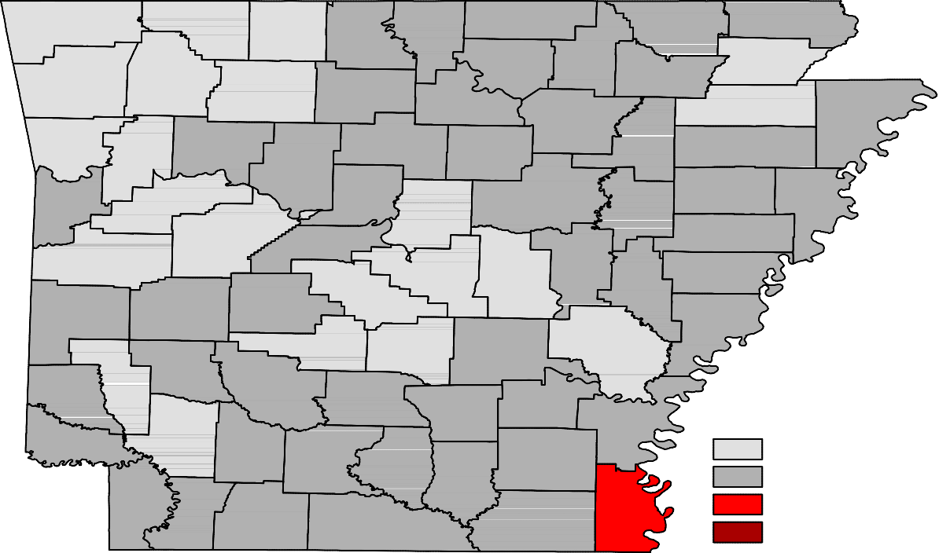Ranked by Unemployment Rates

April 2017- Not Seasonally Adjusted

Rank  1 | County  Washington | Rate  2.0 | Rank  25 | County  Cross | Rate  3.2 | Rank  49 | County  Lafayette | Rate  3.9
2 | Madison | 2.2 | 25 | Garland | 3.2 | 49 | Lincoln | 3.9
3 | Benton | 2.3 | 25 | Johnson | 3.2 | 49 | Little River | 3.9
4 | Craighead | 2.5 | 25 | Marion | 3.2 | 49 | Montgomery | 3.9
4 | Howard | 2.5 | 25 | Nevada | 3.2 | 49 | St. Francis | 3.9
6 | Arkansas | 2.6 | 25 | Pike | 3.2 | 56 | Ouachita | 4.0
6 | Grant | 2.6 | 25 | Pope | 3.2 | 56 | Polk | 4.0
6 | Saline | 2.6 | 33 | Calhoun | 3.4 | 56 | Stone | 4.0
6 | Scott | 2.6 | 33 | Independence | 3.4 | 59 | Bradley | 4.1
10 | Carroll | 2.7 | 33 | Monroe | 3.4 | 59 | Columbia | 4.1
10 | Lonoke | 2.7 | 33 | Prairie | 3.4 | 59 | White | 4.1
12 | Boone | 2.8 | 33 | Randolph | 3.4 | 62 | Cleburne | 4.2
12 | Faulkner | 2.8 | 33 | Searcy | 3.4 | 62 | Desha | 4.2
12 | Newton | 2.8 | 39 | Baxter | 3.5 | 64 | Jefferson | 4.3
15 | Crawford | 2.9 | 39 | Poinsett | 3.5 | 64 | Sharp | 4.3
15 | Franklin | 2.9 | 41 | Clay | 3.6 | 66 | Drew | 4.4
15 | Greene | 2.9 | 41 | Dallas | 3.6 | 66 | Izard | 4.4
15 | Hempstead | 2.9 | 41 | Fulton | 3.6 | 66 | Woodruff | 4.4
15 | Hot Spring | 2.9 | 41 | Miller | 3.6 | 69 | Phillips | 4.7
15 | Pulaski | 2.9 | 41 | Sevier | 3.6 | 69 | Union | 4.7
21 | Logan | 3.0 | 46 | Crittenden | 3.7 | 71 | Jackson | 4.8
21 | Yell | 3.0 | 46 | Lee | 3.7 | 72 | Mississippi | 4.9
23 | Lawrence | 3.1 | 46 | Perry | 3.7 | 73 | Ashley | 5.0
23 | Sebastian | 3.1 | 49 | Cleveland | 3.9 | 73 | Van Buren | 5.0
25 | Clark | 3.2 | 49 | Conway | 3.9 | 75 | Chicot | 5.5

Civilian Labor Force Estimates

LWDA Labor Force Estimates (Not Seasonally Adjusted)

April 2017 March 2017 April 2016

LWDA CLF Emp Unemp
Rate
CLF Emp Unemp
Rate

CLF Emp Unemp

Rate

Central (minus LR) 247,618
240,686
6,932
2.8
247,023
239,069
7,954
3.2
247,879
239,932
7,947
3.2

City of Little Rock | 96,535 | 93,793 | 2,742 | 2.8 | 96,389 | 93,228 | 3,161 | 3.3 | 96,545 | 93,486 | 3,059 | 3.2
Eastern | 48,453 | 46,615 | 1,838 | 3.8 | 47,998 | 45,816 | 2,182 | 4.5 | 48,245 | 46,119 | 2,126 | 4.4
North Central | 94,674 | 90,791 | 3,883 | 4.1 | 93,927 | 89,401 | 4,526 | 4.8 | 95,948 | 91,025 | 4,923 | 5.1
Northeast | 121,156 | 117,368 | 3,788 | 3.1 | 119,722 | 115,253 | 4,469 | 3.7 | 119,619 | 115,059 | 4,560 | 3.8
Northwest | 320,542 | 313,053 | 7,489 | 2.3 | 316,676 | 308,149 | 8,527 | 2.7 | 310,468 | 302,035 | 8,433 | 2.7
Southeast | 82,710 | 79,389 | 3,321 | 4.0 | 82,229 | 78,326 | 3,903 | 4.7 | 82,626 | 78,778 | 3,848 | 4.7
Southwest | 94,545 | 91,006 | 3,539 | 3.7 | 94,049 | 90,018 | 4,031 | 4.3 | 94,605 | 90,684 | 3,921 | 4.1
West Central | 134,055 | 129,695 | 4,360 | 3.3 | 132,683 | 127,540 | 5,143 | 3.9 | 133,771 | 128,336 | 5,435 | 4.1
Western | 112,982 | 109,522 | 3,460 | 3.1 | 112,303 | 108,369 | 3,934 | 3.5 | 114,258 | 110,039 | 4,219 | 3.7

Benton

Washington
Carroll

Madison

Boone

Newton

Marion

Searcy

Baxter

Stone
Fulton

Izard

Sharp

Randolph

Lawrence
Clay

Greene

Craighead

Mississippi

Crawford

Franklin

Johnson

Pope

Van Buren

Cleburne
Independence

Jackson

Poinsett

Cross

Sebastian

Scott
Logan

Yell
Conway

Perry

Saline

Faulkner

Pulaski
White

Lonoke

Prairie
Woodruff

Monroe

St. Francis

Lee
Crittenden

Polk

Sevier
Montgomery

Pike
Howard
Garland

Hot Spring

Clark
Dallas

Grant

Jefferson

Lincoln
Cleveland

Arkansas

Desha

Phillips

Little River
Hempstead

Miller

Nevada

Ouachita

Calhoun

Bradley

Drew

Chicot

Lafayette
Columbia
Union
Ashley

Central (minus LR) Eastern
North Central
Northeast
Northwest
Southeast
Southwest
West Central
Western

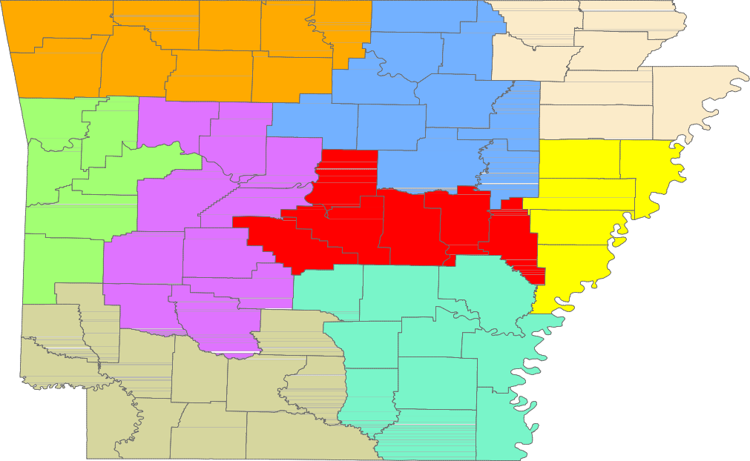

www.discover.arkansas.gov 18

