Arkansas
Labor Market
Report

February 2016

Table of Contents

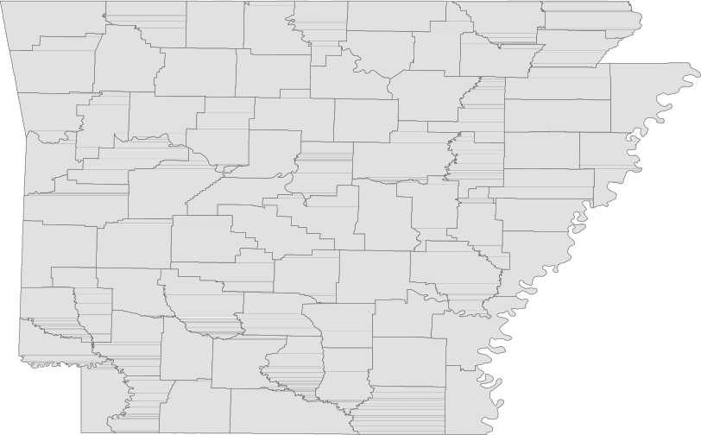Monthly Spotlight..................................................2

Arkansas Labor Force Summary.......................3

Arkansas Nonfarm Payroll Jobs........................4

Arkansas Production Workers...........................6

Metropolitan Statistical Areas...........................7

Micropolitan Statistical Areas/Cities.............14

County Labor Force Statistics..........................15

Local Workforce Development Areas..........18

Technical Notes

The Arkansas Labor Market is prepared monthly in conjunction with the U.S. Department of Labor, Bu- reau of Labor Statistics (BLS). The current month’s estimates are preliminary, while previous data are subject to revision.

Estimates of nonfarm payroll jobs show the num- ber of jobs by industry and reflect employment by place of work. Hours and earnings estimates are based on payroll and worker-hour data col- lected for production workers in manufacturing industries.

Industries are classified according to the North American Industry Classification System (NAICS). All estimates are based on a first quarter 2015 benchmark.

Explanation of Terms and Concepts

Monthly Business Survey of Employers

A monthly sample survey designed to provide industry information on nonfarm payroll jobs. Data are compiled each month from mail surveys and telephone interviews conducted by the Bureau of Labor Statistics in cooperation with Department of Workforce Services. The data are based on establishment records and include all workers, full-or part-time, who received pay during the payroll period which includes the 12th of the
month. Approximately 5,000 Arkansas business
establishments are surveyed.

Metropolitan Statistical Area (MSA)

A term applied by the U.S. Office of Management and Budget to counties that have one or more central cities and that meet specified criteria of population density, commuting patterns and social and economic integration.

Current Population Survey (CPS)

A monthly sample survey of the population 16 years of age and over, designed to provide data on the labor force, the employed and the unem- ployed. The survey is conducted each month by the Bureau of the Census for BLS. The information is collected by trained interviewers from a sample of about 60,000 households. The data collected are based on the activity reported for the calendar week including the 12th of the month. Approxi- mately 800 Arkansas households are represented in the sample survey.

Civilian Labor Force

The sum of all employed and unemployed persons
16 years of age or older. Members of the Armed
Forces are excluded.
Employment

An estimate of the number of persons who worked any time for pay or profit or worked 15 hours or more as unpaid workers in a family business dur- ing the calendar week which includes the 12th of the month. Also included are those who, although not working, had some job attachment and were not looking for work, and persons involved in labor management disputes.

Unemployment

An estimate of the number of persons who did not have a job, but were available for work and actively seeking work during the calendar week which includes the 12th of the month.

Unemployment Rate

The number of unemployed as a percentage of the civilian labor force. Unemployment rates are calculated from unrounded data.

Seasonal Adjustment

A statistical technique applied to monthly data to eliminate changes that normally occur during the year due to seasonal events such as weather, major holidays, schedule shifts, harvest times, and the opening/closing of schools.

February Spotlight
A Comparative Look at Unemployment Rates

Due to differing economies and labor force conditions in various parts of the country, unemployment rates vary greatly from state to state. In February 2016, state jobless rates ranged from a low of 2.7 percent in New Hampshire and South Dakota to a high of 6.6 percent in Alaska. The unemployment rate in Arkansas in February declined to 4.2 percent, a ranking of 15 out of 51 states. By looking at the map below, it becomes apparent that trends exist among states that are located within the same region. While there are some exceptions, western states tend to have higher jobless rates than states located in the midwest. Similarly, states located in the northeast generally experience lower unemployment rates than states located in the southeast. These regional trends occur because states often experience economic similarities based on shared industries, work forces, and climates.

Unemployment Rates, Ranked by State (Seasonally Adjusted)
February 2016

Rank
State
Rate Rank State Rate Rank State Rate

1 New Hampshire
1 South Dakota
3 North Dakota
4 Colorado
4 Nebraska
6 Hawaii
7 Utah
7 Vermont
9 Maine
10 Iowa
10 Minnesota
12 Idaho
13 Kansas
14 Virginia
15 Arkansas
15 Missouri
15 Montana
2.7
2.7
2.9
3.0
3.0
3.1
3.4
3.4
3.6
3.7
3.7
3.9
4.0
4.1
4.2
4.2
4.2
15 Oklahoma
19 New Jersey
20 Texas
21 Massachusetts
22 Delaware
22 Pennsylvania
22 Wisconsin
25 Indiana
25 Maryland
27 Michigan
27 New York
27 Oregon
30 Florida
30 Ohio
30 Tennessee
33 Wyoming
34 Georgia
4.2
4.3
4.4
4.5
4.6
4.6
4.6
4.7
4.7
4.8
4.8
4.8
4.9
4.9
4.9
5.0
5.4
34 Rhode Island
36 Arizona
36 California
36 Connecticut
36 North Carolina
36 South Carolina
41 Kentucky
41 Washington
43 Louisiana
43 Nevada
45 Alabama
46 Illinois
46 New Mexico
48 District of Columbia
48 Mississippi
48 West Virginia
51 Alaska
5.4
5.5
5.5
5.5
5.5
5.5
5.8
5.8
5.9
5.9
6.2
6.4
6.4
6.5
6.5
6.5
6.6

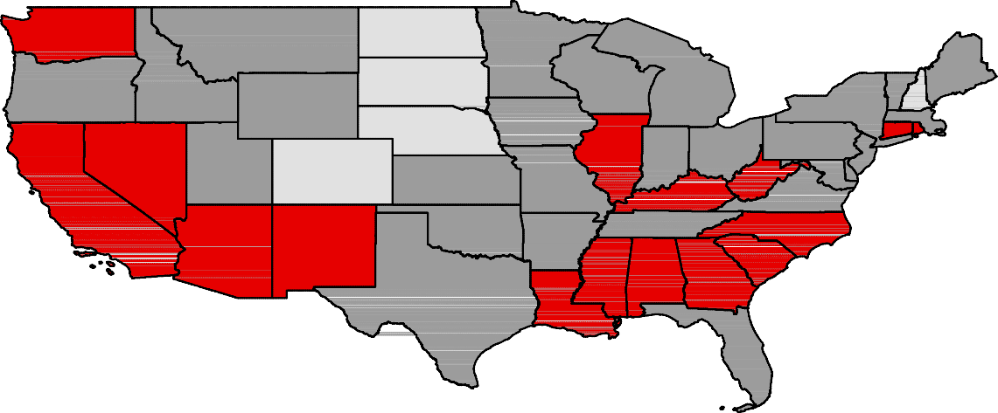U.S. Unemployment Rate = 4.9 Percent

Washington

Oregon

Idaho

Montana

Wyoming
North Dakota

South Dakota

Minnesota

Wisconsin

Michigan

Vermont
New York

Maine
New Hampshire

Nebraska
Iowa

Illinois Indiana

Ohio
Massachusetts
Pennsylvania Connecticut
New Jersey

Nevada

California
Utah
Colorado
Kansas

Missouri

Kentucky
West VirginiaMaryland
Virginia

Arizona

New Mexico
Oklahoma

Arkansas
Tennessee North Carolina

South Carolina

Continental U.S. Only

Texas
MississippiAlabama Georgia
Louisiana

Florida
Unemployment Rates
< or = 3.0%

3.1% - 5.0%
5.1% - 7.0%
> 7.0% [NONE]

Civilian Labor Force Summar y

Labor force data, produced by the U.S. Department of Labor, Bureau of Labor Statistics and released by the Arkansas Department of Workforce Services, show Arkansas’ seasonally adjusted unemployment rate declined two-tenths of a percentage point, from 4.4 percent in January to 4.2 percent in February. Arkansas’ civilian labor force gained 8,360, a result of 10,702 more employed and 2,342 fewer unem- ployed Arkansans. The United States’ jobless rate remained stable at 4.9 percent in February.

BLS Program Operations Manager Susan Price said, “Arkansas’ unemployment rate has been in a steady decline, down one and four-tenths of a percentage point over the year. The state is now seven-tenths of a percentage point lower than the national rate.”

Civilian Labor Force Estimates

Seasonally Adjusted Not Seasonally Adjusted

Civilian Labor Force | Feb 16  1,351,766 | Jan 16  1,343,406 | Feb 15  1,322,981 | Civilian Labor Force | Feb 16  1,354,104 | Jan 16  1,330,719 | Feb 15  1,315,170
Employment | 1,294,595 | 1,283,893 | 1,249,403 | Employment | 1,290,530 | 1,268,269 | 1,235,168
Unemployment | 57,171 | 59,513 | 73,578 | Unemployment | 63,574 | 62,450 | 80,002
Unemployment Rate | 4.2 | 4.4 | 5.6 | Unemployment Rate | 4.7 | 4.7 | 6.1
U.S. Unemployment | 4.9 | 4.9 | 5.5 | U.S. Unemployment | 5.2 | 5.3 | 5.8

7.5
Unemployment Rates (Seasonally Adjusted vs. Not Seasonally Adjusted)
February 2014 - February 2016

7.0

6.5

6.0

5.5

5.0

4.5

4.0
 | Feb | May | Aug | Nov | Feb | May | Aug | Nov | Feb
 | '14 | '14 | '14 | '14 | '15 | '15 | '15 | '15 | '16
Seasonally Adjusted Not Seasonally Adjusted

Nonfarm Payroll Jobs

Not Seasonally Adjusted
(In Thousands)

(NAICS)
Feb 16 Jan 16 Feb 15
OTM OT Y

Total Nonfarm | 1220.5 | 1209.2 | 1193.3 | 11.3 | 27.2
Goods Producing | 208.9 | 208.2 | 210.5 | 0.7 | -1.6
Mining, Logging, and Construction | 54.8 | 54.0 | 54.9 | 0.8 | -0.1
Mining & Logging 7.1 7.1 8.7 0.0 -1.6
Construction | 47.7 | 46.9 | 46.2 | 0.8 | 1.5
Specialty Trade Contractors | 31.0 | 30.2 | 29.3 | 0.8 | 1.7
Manufacturing | 154.1 | 154.2 | 155.6 | -0.1 | -1.5
Durable Goods | 74.9 | 74.9 | 77.1 | 0.0 | -2.2
Nondurable Goods | 79.2 | 79.3 | 78.5 | -0.1 | 0.7
Service Providing | 1011.6 | 1001.0 | 982.8 | 10.6 | 28.8
Trade, Transportation & Utilities | 255.1 | 254.5 | 245.5 | 0.6 | 9.6
Wholesale Trade | 47.7 | 47.3 | 46.6 | 0.4 | 1.1
Retail Trade | 141.9 | 142.5 | 136.3 | -0.6 | 5.6
Transport, Warehousing & Utilities | 65.5 | 64.7 | 62.6 | 0.8 | 2.9
Information | 13.7 | 13.7 | 13.2 | 0.0 | 0.5
Financial Activities | 49.5 | 49.7 | 48.7 | -0.2 | 0.8
Finance & Insurance | 36.4 | 36.6 | 35.9 | -0.2 | 0.5
Real Estate & Rental & Leasing | 13.1 | 13.1 | 12.8 | 0.0 | 0.3
Professional & Business Services | 139.4 | 138.3 | 137.2 | 1.1 | 2.2
Professional, Scientific & Technical | 44.2 | 43.7 | 42.2 | 0.5 | 2.0
Management of Companies | 34.1 | 34.1 | 32.4 | 0.0 | 1.7
Administrative & Support Services | 61.1 | 60.5 | 62.6 | 0.6 | -1.5
Educational & Health Services | 179.4 | 178.3 | 173.3 | 1.1 | 6.1
Educational Services | 15.4 | 14.6 | 14.6 | 0.8 | 0.8
Health Care & Social Assistance | 164.0 | 163.7 | 158.7 | 0.3 | 5.3
Ambulatory Health Care | 52.1 | 52.3 | 50.1 | -0.2 | 2.0
Social Assistance | 41.0 | 40.0 | 38.0 | 1.0 | 3.0
Leisure & Hospitality 114.1 111.4 106.1 2.7 8.0
Arts, Entertainment & Recreation | 9.6 | 9.5 | 9.2 | 0.1 | 0.4
Accommodation & Food Services | 104.5 | 101.9 | 96.9 | 2.6 | 7.6
Accommodation Services | 10.8 | 10.5 | 10.4 | 0.3 | 0.4
Food Services | 93.7 | 91.4 | 86.5 | 2.3 | 7.2
Other Services | 44.1 | 43.8 | 43.0 | 0.3 | 1.1
Government | 216.3 | 211.3 | 215.8 | 5.0 | 0.5
Federal Government | 20.2 | 20.2 | 20.1 | 0.0 | 0.1
State Government | 80.1 | 75.5 | 79.5 | 4.6 | 0.6
Local Government | 116.0 | 115.6 | 116.2 | 0.4 | -0.2

Nonfarm Payroll Job Summar y

Januar y 2016 - Februar y 2016

Arkansas’ nonfarm payroll employment rose 11,300 in February to total 1,220,500. Seven major indus- try sectors posted gains, while two sectors declined and two were unchanged. Government posted the greatest increase (+5,000). Additions in state (+4,600) and local (+400) government were attributed to the return of public school employees from winter break. Jobs in leisure and hospitality rose 2,700, a typical seasonal expansion. Educational and health services added 1,100 jobs. Most of the gains occurred in educational services (+800). Employment in professional and business services increased
1,100. Hiring was reported in administrative-support services (+600) and professional-scientific-techni-
cal services (+500).

Februar y 2015 - Februar y 2016

Since February 2015, nonfarm payroll jobs in Arkansas are up 27,200. Nine major industry sectors posted job growth, while employment in two sectors declined. Trade, transportation, and utilities added 9,600 jobs. Gains were reported across all subsectors, with retail trade up 5,600. Employment in leisure and hospitality increased 8,000. A majority of the expansion occurred in food services (+7,200). Jobs in educational and health services rose 6,100, mostly in health care and social assis- tance (+5,300). Professional and business services added 2,200 jobs. Professional-scientific-technical services (+2,000) and management of companies (+1,700) reported gains. Employment in mining and logging (-1,600) and manufacturing (-1,500) both declined over the year.

260,000
Jobs in Trade, Transportation, and Utilities (Not Seasonally Adjusted)
February: 2006 - 2016

255,000

250,000

245,000

240,000

235,000

230,000

225,000

220,000

215,000

Production Workers- Hours and Earnings

Manufacturing

Feb 16 Jan 16
Feb 15

Average Weekly Hours Average Hourly Earnings Average Weekly Earnings

39.1
16.05
627.56

39.7
16.08
638.38

41.4
16.00
662.40

Durable Goods and Nondurable Goods Manufacturing

Durable Goods Manufacturing Nondurable Goods Manufacturing

Feb 16 Jan 16

Feb 15

Feb 16

Jan 16
Feb 15

Average Weekly Hours Average Hourly Earnings Average Weekly Earnings

40.5
17.66
715.23

40.0
17.68
707.20

40.2
17.24
693.05

Average Weekly Hours Average Hourly Earnings Average Weekly Earnings

37.7
14.40
542.88
39.5
14.55
574.73
42.5
14.86
631.55

$750.00
Average Weekly Earnings in Durable Goods Manufacturing
February: 2006 - 2016

$700.00

$650.00

$600.00

$550.00

$500.00

Little Rock-Nor th Little Rock-Conway MSA

The Little Rock-North Little Rock-Conway MSA= Faulkner, Grant, Lonoke, Perry, Pulaski, & Saline counties.

Civilian Labor Force Estimates (Not Seasonally Adjusted)

 | Feb 16 | Jan 16 | Feb 15 | OTM | OT Y
Civilian Labor Force | 352,843 | 346,621 | 341,951 | 6,222 | 10,892
Employment | 338,163 | 332,636 | 323,471 | 5,527 | 14,692
Unemployment | 14,680 | 13,985 | 18,480 | 695 | -3,800
Unemployment Rate | 4.2 | 4.0 | 5.4 | 0.2 | -1.2

Nonfarm Payroll Jobs (Not Seasonally Adjusted)
(In Thousands)

NAICS  Total Nonfarm | Feb 16  351.7 | Jan 16  349.2 | Feb 15  345.9 | OTM  2.5 | OT Y  5.8
Goods Producing | 36.9 | 36.8 | 36.6 | 0.1 | 0.3
Mining, Logging & Construction | 16.6 | 16.4 | 16.4 | 0.2 | 0.2
Manufacturing | 20.3 | 20.4 | 20.2 | -0.1 | 0.1
Service Providing 314.8 312.4 309.3 2.4 5.5
Trade, Transportation & Utilities | 69.1 | 69.4 | 66.9 | -0.3 | 2.2
Wholesale Trade | 15.2 | 15.0 | 15.2 | 0.2 | 0.0
Retail Trade | 39.2 | 39.7 | 37.5 | -0.5 | 1.7
Trans., Warehousing & Utilities | 14.7 | 14.7 | 14.2 | 0.0 | 0.5
Information | 6.3 | 6.3 | 6.2 | 0.0 | 0.1
Financial Activities | 20.5 | 20.6 | 20.3 | -0.1 | 0.2
Professional & Business Services | 45.9 | 45.6 | 46.3 | 0.3 | -0.4
Educational & Health Services | 52.4 | 51.9 | 52.3 | 0.5 | 0.1
Leisure & Hospitality | 34.3 | 33.0 | 31.5 | 1.3 | 2.8
Other Services | 15.0 | 14.9 | 14.7 | 0.1 | 0.3
Government | 71.3 | 70.7 | 71.1 | 0.6 | 0.2
Federal Government | 9.6 | 9.6 | 9.6 | 0.0 | 0.0
State Government | 35.0 | 34.5 | 34.7 | 0.5 | 0.3
Local Government | 26.7 | 26.6 | 26.8 | 0.1 | -0.1

360,000
Jobs in Service Providing Industries vs. Goods Producing Industries
February: 1996 - 2016

340,000

320,000

300,000

280,000

260,000

240,000

220,000

200,000

'96 '97 '98 '99 '00 '01 '02 '03 '04 '05 '06 '07 '08 '09 '10 '11 '12 '13 '14 '15 '16
Service Pro viding Good s Prod ucing

Fayetteville-Springdale-Rogers MSA

The Fayetteville-Springdale-Rogers MSA= Benton, Madison, & Washington counties in Arkansas & McDonald county in Missouri.

Civilian Labor Force Estimates (Not Seasonally Adjusted)

 | Feb 16 | Jan 16 | Feb 15 | OTM | OT Y
Civilian Labor Force | 262,828 | 255,142 | 247,269 | 7,686 | 15,559
Employment | 254,061 | 246,838 | 236,305 | 7,223 | 17,756
Unemployment | 8,767 | 8,304 | 10,964 | 463 | -2,197
Unemployment Rate | 3.3 | 3.3 | 4.4 | 0.0 | -1.1

Nonfarm Payroll Jobs (Not Seasonally Adjusted)
(In Thousands)

NAICS Feb 16 Jan 16 Feb 15
OTM OT Y

Total Nonfarm
Goods Producing
Mining, Logging & Construction
Manufacturing
Service Providing
Trade, Transportation & Utilities
Wholesale Trade
Retail Trade
Trans., Warehousing & Utilities
Information
Financial Activities
Professional & Business Services
Educational & Health Services
Leisure & Hospitality
Other Services
Government
Federal Government
State Government
Local Government
241.7
35.8
9.7
26.1
205.9
55.2
12.0
26.8
16.4
2.1
6.8
48.5
26.5
25.0
7.2
34.6
2.6
13.4
18.6
236.7
35.8
9.6
26.2
200.9
54.7
12.0
26.4
16.3
2.1
6.8
47.4
26.2
23.8
7.1
32.8
2.6
11.8
18.4
230.4
36.3
9.0
27.3
194.1
52.0
11.4
25.0
15.6
2.0
6.6
45.6
25.1
22.1
7.1
33.6
2.6
12.7
18.3
5.0
0.0
0.1
-0.1
5.0
0.5
0.0
0.4
0.1
0.0
0.0
1.1
0.3
1.2
0.1
1.8
0.0
1.6
0.2
11.3
-0.5
0.7
-1.2
11.8
3.2
0.6
1.8
0.8
0.1
0.2
2.9
1.4
2.9
0.1
1.0
0.0
0.7
0.3

260,000
Number of Employed
February 2014 - February 2016

250,000
Nonfarm Payroll Jobs
February: 2006 - 2016

255,000
240,000

250,000

230,000

220,000

245,000

210,000

240,000
200,000

235,000
190,000

230,000

180,000

170,000

225,000

160,000

220,000

Feb '14 May '14 Aug '14 Nov '14 Feb '15 May '15 Aug '15 Nov '15 Feb '16
150,000

'06 '07 '08 '09 '10 '11 '12 '13 '14 '15 '16

For t Smith MSA

The Fort Smith MSA= Crawford & Sebastian counties in Arkansas & LeFlore & Sequoyah counties in Oklahoma.

Civilian Labor Force Estimates (Not Seasonally Adjusted)

 | Feb 16 | Jan 16 | Feb 15 | OTM | OT Y
Civilian Labor Force | 122,540 | 120,783 | 120,181 | 1,757 | 2,359
Employment | 116,267 | 114,611 | 112,764 | 1,656 | 3,503
Unemployment | 6,273 | 6,172 | 7,417 | 101 | -1,144
Unemployment Rate | 5.1 | 5.1 | 6.2 | 0.0 | -1.1

Nonfarm Payroll Jobs (Not Seasonally Adjusted)
(In Thousands)

NAICS  Total Nonfarm | Feb 16  113.0 | Jan 16  112.5 | Feb 15  112.5 | OTM  0.5 | OT Y  0.5
Goods Producing | 23.6 | 23.5 | 24.1 | 0.1 | -0.5
Mining, Logging & Construction | 5.7 | 5.8 | 6.3 | -0.1 | -0.6
Manufacturing | 17.9 | 17.7 | 17.8 | 0.2 | 0.1
Service Providing 89.4 89.0 88.4 0.4 1.0
Trade, Transportation & Utilities | 23.9 | 23.9 | 23.4 | 0.0 | 0.5
Wholesale Trade | 4.2 | 4.2 | 4.1 | 0.0 | 0.1
Retail Trade | 13.0 | 12.9 | 12.5 | 0.1 | 0.5
Trans., Warehousing & Utilities | 6.7 | 6.8 | 6.8 | -0.1 | -0.1
Information | 1.2 | 1.2 | 1.2 | 0.0 | 0.0
Financial Activities | 3.7 | 3.8 | 3.8 | -0.1 | -0.1
Professional & Business Services | 11.6 | 11.6 | 12.3 | 0.0 | -0.7
Educational & Health Services | 16.8 | 16.7 | 16.2 | 0.1 | 0.6
Leisure & Hospitality | 9.2 | 9.1 | 8.9 | 0.1 | 0.3
Other Services | 4.2 | 4.3 | 4.3 | -0.1 | -0.1
Government | 18.8 | 18.4 | 18.3 | 0.4 | 0.5
Federal Government | 1.3 | 1.3 | 1.3 | 0.0 | 0.0
State Government | 3.1 | 2.8 | 3.1 | 0.3 | 0.0
Local Government | 14.4 | 14.3 | 13.9 | 0.1 | 0.5

12.0
Unemployment Rates
February: 2006 - 2016

90,000
Jobs in Service Providing Industries
February: 2006 - 2016

10.0
88,000

8.0
86,000

6.0
84,000

4.0
82,000

2.0
80,000

0.0

'06 '07 '08 '09 '10 '11 '12 '13 '14 '15 '16
78,000

'06 '07 '08 '09 '10 '11 '12 '13 '14 '15 '16

Hot Springs MSA

The Hot Springs MSA= Garland County.

Civilian Labor Force Estimates (Not Seasonally Adjusted)

 | Feb 16 | Jan 16 | Feb 15 | OTM | OT Y
Civilian Labor Force | 40,735 | 40,169 | 39,381 | 566 | 1,354
Employment | 38,728 | 38,163 | 36,835 | 565 | 1,893
Unemployment | 2,007 | 2,006 | 2,546 | 1 | -539
Unemployment Rate | 4.9 | 5.0 | 6.5 | -0.1 | -1.6

Nonfarm Payroll Jobs (Not Seasonally Adjusted)
(In Thousands)

NAICS
Feb 16 | Jan 16 | Feb 15 | OTM | OT Y
37.8 | 37.7 | 37.0 | 0.1 | 0.8
4.4 | 4.4 | 4.4 | 0.0 | 0.0
33.4 | 33.3 | 32.6 | 0.1 | 0.8
4.7 | 4.7 | 4.6 | 0.0 | 0.1

Total Nonfarm Goods Producing Service Providing Government

34,500
Jobs in Service Providing Industries
January 2014 - February 2016

34,000

33,500

33,000

32,500

32,000

31,500

J F M A M J J A S O N D

2014 2015 2016

Jonesboro MSA

The Jonesboro MSA= Craighead & Poinsett counties.

Civilian Labor Force Estimates (Not Seasonally Adjusted)

 | Feb 16 | Jan 16 | Feb 15 | OTM | OT Y
Civilian Labor Force | 62,461 | 61,824 | 59,683 | 637 | 2,778
Employment | 59,882 | 59,252 | 56,330 | 630 | 3,552
Unemployment | 2,579 | 2,572 | 3,353 | 7 | -774
Unemployment Rate | 4.1 | 4.2 | 5.6 | -0.1 | -1.5

Nonfarm Payroll Jobs (Not Seasonally Adjusted)
(In Thousands)

NAICS
Feb 16 | Jan 16 | Feb 15 | OTM | OT Y
55.1 | 55.0 | 53.1 | 0.1 | 2.0
8.8 | 8.8 | 8.6 | 0.0 | 0.2
46.3 | 46.2 | 44.5 | 0.1 | 1.8
9.0 | 8.9 | 8.8 | 0.1 | 0.2

Total Nonfarm Goods Producing Service Providing Government

62,000
Number of Employed
February: 1996 - 2016

60,000

58,000

56,000

54,000

52,000

50,000

48,000

46,000

44,000

42,000

'96 '97 '98 '99 '00 '01 '02 '03 '04 '05 '06 '07 '08 '09 '10 '11 '12 '13 '14 '15 '16

Pine Bluff MSA

The Pine Bluff MSA= Cleveland, Jefferson, & Lincoln counties.

Civilian Labor Force Estimates (Not Seasonally Adjusted)

 | Feb 16 | Jan 16 | Feb 15 | OTM | OT Y
Civilian Labor Force | 36,946 | 36,054 | 36,852 | 892 | 94
Employment | 34,628 | 33,748 | 33,941 | 880 | 687
Unemployment | 2,318 | 2,306 | 2,911 | 12 | -593
Unemployment Rate | 6.3 | 6.4 | 7.9 | -0.1 | -1.6

Nonfarm Payroll Jobs (Not Seasonally Adjusted)
(In Thousands)

NAICS
Feb 16 | Jan 16 | Feb 15 | OTM | OT Y
33.7 | 33.1 | 33.9 | 0.6 | -0.2
6.1 | 6.0 | 6.3 | 0.1 | -0.2
27.6 | 27.1 | 27.6 | 0.5 | 0.0
9.6 | 9.3 | 9.6 | 0.3 | 0.0

Total Nonfarm Goods Producing Service Providing Government

45,000
Nonfarm Payroll Jobs
February: 2006 - 2016

40,000

35,000

30,000

25,000

20,000

'06 '07 '08 '09 '10 '11 '12 '13 '14 '15 '16

Out-of-State MSA

Civilian Labor Force Estimates (Not Seasonally Adjusted)

Memphis, TN-MS-AR MSA

The Memphis, TN-MS-AR MSA= Fayette, Shelby, & Tipton counties in Tennessee; Benton, Desoto, Marshall, Tate, & Tunica counties in Mississippi; & Crittenden County in Arkansas.

 | Feb 16 | Jan 16 | Feb 15 | OTM | OT Y
Civilian Labor Force | 619,725 | 616,029 | 610,892 | 3,696 | 8,833
Employment | 588,782 | 581,845 | 569,886 | 6,937 | 18,896
Unemployment | 30,943 | 34,184 | 41,006 | -3,241 | -10,063
Unemployment Rate | 5.0 | 5.5 | 6.7 | -0.5 | -1.7

Texarkana MSA

The Texarkana MSA= Bowie County in Texas & Little River & Miller counties in Arkansas.

 | Feb 16 | Jan 16 | Feb 15 | OTM | OT Y
Civilian Labor Force | 65,579 | 65,219 | 64,153 | 360 | 1,426
Employment | 62,619 | 62,136 | 60,604 | 483 | 2,015
Unemployment | 2,960 | 3,083 | 3,549 | -123 | -589
Unemployment Rate | 4.5 | 4.7 | 5.5 | -0.2 | -1.0

55,000
Unemployment- Memphis MSA
February 2014 - February 2016

68,000
Number of Employed- Texarkana MSA
February: 2006 - 2016

50,000
66,000

45,000
64,000

40,000

62,000

35,000

60,000

30,000

58,000

25,000

Feb
'14

Aug
'14

Feb
'15

Aug
'15

Feb
'16

56,000

'06 '07 '08 '09 '10 '11 '12 '13 '14 '15 '16

Micropolitan Labor Force Estimates (Not Seasonally Adjusted)

February 2016 January 2016 February 2015

Micro Area CLF Emp Unemp

Rate

CLF Emp Unemp
Rate

CLF Emp Unemp

Rate

Arkadelphia Micro | 9,683 | 9,227 | 456 | 4.7 | 9,480 | 9,010 | 470 | 5.0 | 9,430 | 8,843 | 587 | 6.2
Batesville Micro | 15,775 | 14,819 | 956 | 6.1 | 15,602 | 14,598 | 1,004 | 6.4 | 15,574 | 14,369 | 1,205 | 7.7
Blytheville Micro | 17,946 | 16,568 | 1,378 | 7.7 | 17,846 | 16,495 | 1,351 | 7.6 | 18,618 | 16,719 | 1,899 | 10.2
Camden Micro | 12,311 | 11,605 | 706 | 5.7 | 12,188 | 11,472 | 716 | 5.9 | 12,225 | 11,305 | 920 | 7.5
El Dorado Micro | 17,049 | 16,036 | 1,013 | 5.9 | 16,803 | 15,837 | 966 | 5.7 | 16,583 | 15,377 | 1,206 | 7.3
Forrest City Micro | 8,971 | 8,356 | 615 | 6.9 | 8,886 | 8,265 | 621 | 7.0 | 8,929 | 8,143 | 786 | 8.8
Harrison Micro | 19,271 | 18,370 | 901 | 4.7 | 19,003 | 18,126 | 877 | 4.6 | 19,067 | 17,891 | 1,176 | 6.2
Helena-West Helena Micro | 6,897 | 6,387 | 510 | 7.4 | 6,893 | 6,361 | 532 | 7.7 | 7,072 | 6,411 | 661 | 9.3
Magnolia Micro | 9,660 | 9,049 | 611 | 6.3 | 9,432 | 8,866 | 566 | 6.0 | 9,601 | 8,924 | 677 | 7.1
Malvern Micro | 14,624 | 13,945 | 679 | 4.6 | 14,411 | 13,752 | 659 | 4.6 | 13,978 | 13,162 | 816 | 5.8
Mountain Home Micro | 16,508 | 15,675 | 833 | 5.0 | 16,345 | 15,495 | 850 | 5.2 | 16,173 | 15,102 | 1,071 | 6.6
Paragould Micro | 20,523 | 19,521 | 1,002 | 4.9 | 20,219 | 19,215 | 1,004 | 5.0 | 19,881 | 18,615 | 1,266 | 6.4
Russellville Micro | 39,082 | 37,119 | 1,963 | 5.0 | 38,520 | 36,515 | 2,005 | 5.2 | 38,755 | 36,491 | 2,264 | 5.8
Searcy Micro | 35,018 | 32,815 | 2,203 | 6.3 | 34,520 | 32,291 | 2,229 | 6.5 | 34,523 | 31,958 | 2,565 | 7.4

Arkadelphia Micro= Clark County Batesville Micro= Independence County Blytheville Micro= Mississippi County
Camden Micro= Calhoun & Ouachita counties
El Dorado Micro= Union County
Forrest City Micro= St. Francis County Harrison Micro= Boone & Newton counties Helena-West Helena Micro= Phillips County Magnolia Micro= Columbia County
Malvern Micro= Hot Spring County
Mountain Home Micro= Baxter County Paragould Micro= Greene County Russellville Micro= Pope & Yell counties Searcy Micro= White County

City Labor Force Statistics (Not Seasonally Adjusted)

February 2016 January 2016 February 2015

City CLF Emp Unemp
Rate
CLF Emp Unemp
Rate

CLF Emp Unemp

Rate

Bella Vista | 12,115 | 11,607 | 508 | 4.2 | 11,764 | 11,268 | 496 | 4.2 | 11,373 | 10,786 | 587 | 5.2
Benton | 16,214 | 15,604 | 610 | 3.8 | 15,923 | 15,346 | 577 | 3.6 | 15,720 | 14,920 | 800 | 5.1
Bentonville | 22,595 | 21,815 | 780 | 3.5 | 21,922 | 21,179 | 743 | 3.4 | 21,095 | 20,272 | 823 | 3.9
Blytheville | 6,161 | 5,657 | 504 | 8.2 | 6,115 | 5,632 | 483 | 7.9 | 6,520 | 5,708 | 812 | 12.5
Cabot | 11,818 | 11,378 | 440 | 3.7 | 11,606 | 11,203 | 403 | 3.5 | 11,423 | 10,906 | 517 | 4.5
Conway | 33,180 | 31,793 | 1,387 | 4.2 | 32,574 | 31,275 | 1,299 | 4.0 | 32,053 | 30,413 | 1,640 | 5.1
El Dorado | 7,392 | 6,915 | 477 | 6.5 | 7,303 | 6,830 | 473 | 6.5 | 7,177 | 6,631 | 546 | 7.6
Fayetteville | 45,665 | 44,268 | 1,397 | 3.1 | 44,311 | 42,978 | 1,333 | 3.0 | 42,985 | 41,135 | 1,850 | 4.3
Fort Smith | 40,411 | 38,609 | 1,802 | 4.5 | 39,713 | 37,929 | 1,784 | 4.5 | 39,609 | 37,300 | 2,309 | 5.8
Hot Springs | 14,196 | 13,462 | 734 | 5.2 | 14,019 | 13,266 | 753 | 5.4 | 13,808 | 12,804 | 1,004 | 7.3
Jacksonville | 11,916 | 11,315 | 601 | 5.0 | 11,721 | 11,128 | 593 | 5.1 | 11,565 | 10,820 | 745 | 6.4
Jonesboro | 36,334 | 34,913 | 1,421 | 3.9 | 35,940 | 34,536 | 1,404 | 3.9 | 34,692 | 32,809 | 1,883 | 5.4
Little Rock | 97,332 | 93,421 | 3,911 | 4.0 | 95,720 | 91,874 | 3,846 | 4.0 | 94,393 | 89,327 | 5,066 | 5.4
North Little Rock | 30,346 | 28,982 | 1,364 | 4.5 | 29,818 | 28,502 | 1,316 | 4.4 | 29,554 | 27,712 | 1,842 | 6.2
Paragould | 12,796 | 12,154 | 642 | 5.0 | 12,606 | 11,964 | 642 | 5.1 | 12,356 | 11,590 | 766 | 6.2
Pine Bluff | 17,586 | 16,363 | 1,223 | 7.0 | 17,162 | 15,935 | 1,227 | 7.1 | 17,602 | 16,032 | 1,570 | 8.9
Rogers | 33,351 | 32,250 | 1,101 | 3.3 | 32,342 | 31,310 | 1,032 | 3.2 | 31,548 | 29,970 | 1,578 | 5.0
Russellville | 13,913 | 13,238 | 675 | 4.9 | 13,678 | 13,015 | 663 | 4.8 | 13,786 | 13,006 | 780 | 5.7
Searcy | 10,663 | 10,113 | 550 | 5.2 | 10,468 | 9,951 | 517 | 4.9 | 10,494 | 9,849 | 645 | 6.1
Sherwood | 15,643 | 15,073 | 570 | 3.6 | 15,332 | 14,824 | 508 | 3.3 | 15,108 | 14,413 | 695 | 4.6
Springdale | 38,277 | 37,078 | 1,199 | 3.1 | 37,132 | 35,998 | 1,134 | 3.1 | 35,975 | 34,454 | 1,521 | 4.2
Texarkana, AR | 13,927 | 13,258 | 669 | 4.8 | 13,782 | 13,114 | 668 | 4.8 | 13,421 | 12,609 | 812 | 6.1
Van Buren | 10,564 | 10,079 | 485 | 4.6 | 10,395 | 9,907 | 488 | 4.7 | 10,428 | 9,746 | 682 | 6.5
West Memphis | 10,810 | 10,189 | 621 | 5.7 | 10,636 | 10,064 | 572 | 5.4 | 10,654 | 9,751 | 903 | 8.5

February 2016 January 2016 February 2015

County CLF Emp Unemp
Rate
CLF Emp Unemp
Rate

CLF Emp Unemp

Rate

Arkansas | 9,432 | 9,041 | 391 | 4.1 | 9,376 | 8,976 | 400 | 4.3 | 9,348 | 8,861 | 487 | 5.2
Ashley | 8,323 | 7,754 | 569 | 6.8 | 8,273 | 7,691 | 582 | 7.0 | 8,185 | 7,401 | 784 | 9.6
Baxter | 16,508 | 15,675 | 833 | 5.0 | 16,345 | 15,495 | 850 | 5.2 | 16,173 | 15,102 | 1,071 | 6.6
Benton | 125,042 | 120,753 | 4,289 | 3.4 | 121,314 | 117,231 | 4,083 | 3.4 | 117,616 | 112,215 | 5,401 | 4.6
Boone | 15,866 | 15,133 | 733 | 4.6 | 15,643 | 14,928 | 715 | 4.6 | 15,697 | 14,734 | 963 | 6.1
Bradley | 4,661 | 4,431 | 230 | 4.9 | 4,637 | 4,402 | 235 | 5.1 | 4,386 | 4,066 | 320 | 7.3
Calhoun | 2,376 | 2,244 | 132 | 5.6 | 2,360 | 2,223 | 137 | 5.8 | 2,340 | 2,194 | 146 | 6.2
Carroll | 12,408 | 11,766 | 642 | 5.2 | 12,261 | 11,552 | 709 | 5.8 | 12,308 | 11,482 | 826 | 6.7
Chicot | 3,660 | 3,366 | 294 | 8.0 | 3,654 | 3,345 | 309 | 8.5 | 3,741 | 3,297 | 444 | 11.9
Clark | 9,683 | 9,227 | 456 | 4.7 | 9,480 | 9,010 | 470 | 5.0 | 9,430 | 8,843 | 587 | 6.2
Clay | 6,311 | 5,862 | 449 | 7.1 | 6,321 | 5,830 | 491 | 7.8 | 6,358 | 5,808 | 550 | 8.7
Cleburne | 9,661 | 8,922 | 739 | 7.6 | 9,493 | 8,786 | 707 | 7.4 | 9,538 | 8,745 | 793 | 8.3
Cleveland | 3,438 | 3,258 | 180 | 5.2 | 3,361 | 3,184 | 177 | 5.3 | 3,437 | 3,199 | 238 | 6.9
Columbia | 9,660 | 9,049 | 611 | 6.3 | 9,432 | 8,866 | 566 | 6.0 | 9,601 | 8,924 | 677 | 7.1
Conway | 8,803 | 8,226 | 577 | 6.6 | 8,617 | 8,116 | 501 | 5.8 | 8,573 | 7,993 | 580 | 6.8
Craighead | 51,981 | 49,936 | 2,045 | 3.9 | 51,421 | 49,396 | 2,025 | 3.9 | 49,587 | 46,927 | 2,660 | 5.4
Crawford | 27,193 | 25,905 | 1,288 | 4.7 | 26,740 | 25,462 | 1,278 | 4.8 | 26,736 | 25,050 | 1,686 | 6.3
Crittenden | 21,802 | 20,646 | 1,156 | 5.3 | 21,523 | 20,393 | 1,130 | 5.3 | 21,400 | 19,759 | 1,641 | 7.7
Cross | 8,107 | 7,656 | 451 | 5.6 | 8,033 | 7,564 | 469 | 5.8 | 8,043 | 7,491 | 552 | 6.9
Dallas | 2,947 | 2,772 | 175 | 5.9 | 2,908 | 2,734 | 174 | 6.0 | 2,869 | 2,610 | 259 | 9.0
Desha | 5,528 | 5,133 | 395 | 7.1 | 5,499 | 5,101 | 398 | 7.2 | 5,510 | 4,983 | 527 | 9.6
Drew | 8,149 | 7,621 | 528 | 6.5 | 8,033 | 7,515 | 518 | 6.4 | 8,009 | 7,310 | 699 | 8.7
Faulkner | 60,863 | 58,024 | 2,839 | 4.7 | 59,652 | 57,079 | 2,573 | 4.3 | 58,750 | 55,506 | 3,244 | 5.5
Franklin | 7,581 | 7,201 | 380 | 5.0 | 7,475 | 7,121 | 354 | 4.7 | 7,390 | 6,953 | 437 | 5.9
Fulton | 4,840 | 4,592 | 248 | 5.1 | 4,794 | 4,552 | 242 | 5.0 | 4,723 | 4,429 | 294 | 6.2
Garland | 40,735 | 38,728 | 2,007 | 4.9 | 40,169 | 38,163 | 2,006 | 5.0 | 39,381 | 36,835 | 2,546 | 6.5
Grant | 8,445 | 8,068 | 377 | 4.5 | 8,304 | 7,946 | 358 | 4.3 | 8,182 | 7,737 | 445 | 5.4
Greene | 20,523 | 19,521 | 1,002 | 4.9 | 20,219 | 19,215 | 1,004 | 5.0 | 19,881 | 18,615 | 1,266 | 6.4
Hempstead | 9,940 | 9,478 | 462 | 4.6 | 9,806 | 9,367 | 439 | 4.5 | 9,814 | 9,212 | 602 | 6.1
Hot Spring | 14,624 | 13,945 | 679 | 4.6 | 14,411 | 13,752 | 659 | 4.6 | 13,978 | 13,162 | 816 | 5.8
Howard | 6,104 | 5,864 | 240 | 3.9 | 6,009 | 5,788 | 221 | 3.7 | 6,224 | 5,919 | 305 | 4.9
Independence | 15,775 | 14,819 | 956 | 6.1 | 15,602 | 14,598 | 1,004 | 6.4 | 15,574 | 14,369 | 1,205 | 7.7
Izard | 5,092 | 4,742 | 350 | 6.9 | 4,968 | 4,630 | 338 | 6.8 | 4,935 | 4,551 | 384 | 7.8
Jackson | 6,235 | 5,766 | 469 | 7.5 | 6,187 | 5,720 | 467 | 7.5 | 6,183 | 5,556 | 627 | 10.1
Jefferson | 29,293 | 27,412 | 1,881 | 6.4 | 28,572 | 26,695 | 1,877 | 6.6 | 29,212 | 26,857 | 2,355 | 8.1
Johnson | 10,610 | 10,018 | 592 | 5.6 | 10,529 | 9,921 | 608 | 5.8 | 10,288 | 9,594 | 694 | 6.7
Lafayette | 2,659 | 2,475 | 184 | 6.9 | 2,623 | 2,447 | 176 | 6.7 | 2,668 | 2,434 | 234 | 8.8
Lawrence | 7,096 | 6,718 | 378 | 5.3 | 7,017 | 6,635 | 382 | 5.4 | 7,094 | 6,556 | 538 | 7.6
Lee | 3,235 | 3,042 | 193 | 6.0 | 3,210 | 3,001 | 209 | 6.5 | 3,269 | 2,984 | 285 | 8.7
Lincoln | 4,215 | 3,958 | 257 | 6.1 | 4,121 | 3,869 | 252 | 6.1 | 4,203 | 3,885 | 318 | 7.6
Little River | 5,741 | 5,455 | 286 | 5.0 | 5,704 | 5,398 | 306 | 5.4 | 5,560 | 5,191 | 369 | 6.6
Logan | 9,314 | 8,829 | 485 | 5.2 | 9,184 | 8,714 | 470 | 5.1 | 9,021 | 8,469 | 552 | 6.1
Lonoke | 33,571 | 32,246 | 1,325 | 3.9 | 33,004 | 31,750 | 1,254 | 3.8 | 32,578 | 30,908 | 1,670 | 5.1
Madison | 7,422 | 7,144 | 278 | 3.7 | 7,240 | 6,970 | 270 | 3.7 | 7,028 | 6,706 | 322 | 4.6
Marion | 6,531 | 6,199 | 332 | 5.1 | 6,467 | 6,133 | 334 | 5.2 | 6,440 | 6,025 | 415 | 6.4
Miller | 20,105 | 19,195 | 910 | 4.5 | 19,934 | 18,987 | 947 | 4.8 | 19,407 | 18,256 | 1,151 | 5.9
(continued on Page 16)

(continued from Page 15)
County | CLF | Februa  Emp | ry 2016  Unemp | Rate | CLF | Januar  Emp | y 2016  Unemp | Rate | CLF | Febru  Emp | ry 2015  Unemp | Rate
Mississippi | 17,946 | 16,568 | 1,378 | 7.7 | 17,846 | 16,495 | 1,351 | 7.6 | 18,618 | 16,719 | 1,899 | 10.2
Monroe | 2,980 | 2,810 | 170 | 5.7 | 2,969 | 2,787 | 182 | 6.1 | 3,020 | 2,791 | 229 | 7.6
Montgomery | 3,205 | 3,003 | 202 | 6.3 | 3,172 | 2,961 | 211 | 6.7 | 3,153 | 2,886 | 267 | 8.5
Nevada | 3,685 | 3,525 | 160 | 4.3 | 3,637 | 3,480 | 157 | 4.3 | 3,631 | 3,418 | 213 | 5.9
Newton | 3,405 | 3,237 | 168 | 4.9 | 3,360 | 3,198 | 162 | 4.8 | 3,370 | 3,157 | 213 | 6.3
Ouachita | 9,935 | 9,361 | 574 | 5.8 | 9,828 | 9,249 | 579 | 5.9 | 9,885 | 9,111 | 774 | 7.8
Perry | 4,307 | 4,045 | 262 | 6.1 | 4,233 | 3,984 | 249 | 5.9 | 4,197 | 3,876 | 321 | 7.6
Phillips | 6,897 | 6,387 | 510 | 7.4 | 6,893 | 6,361 | 532 | 7.7 | 7,072 | 6,411 | 661 | 9.3
Pike | 4,186 | 3,965 | 221 | 5.3 | 4,163 | 3,941 | 222 | 5.3 | 4,138 | 3,841 | 297 | 7.2
Poinsett | 10,480 | 9,946 | 534 | 5.1 | 10,403 | 9,856 | 547 | 5.3 | 10,096 | 9,403 | 693 | 6.9
Polk | 8,415 | 7,943 | 472 | 5.6 | 8,315 | 7,861 | 454 | 5.5 | 8,296 | 7,744 | 552 | 6.7
Pope | 29,961 | 28,441 | 1,520 | 5.1 | 29,531 | 27,961 | 1,570 | 5.3 | 29,674 | 27,941 | 1,733 | 5.8
Prairie | 3,798 | 3,620 | 178 | 4.7 | 3,760 | 3,585 | 175 | 4.7 | 3,784 | 3,581 | 203 | 5.4
Pulaski | 189,483 | 181,653 | 7,830 | 4.1 | 186,231 | 178,645 | 7,586 | 4.1 | 183,832 | 173,691 | 10,141 | 5.5
Randolph | 6,036 | 5,657 | 379 | 6.3 | 5,967 | 5,566 | 401 | 6.7 | 6,238 | 5,639 | 599 | 9.6
St. Francis | 8,971 | 8,356 | 615 | 6.9 | 8,886 | 8,265 | 621 | 7.0 | 8,929 | 8,143 | 786 | 8.8
Saline | 56,174 | 54,127 | 2,047 | 3.6 | 55,197 | 53,232 | 1,965 | 3.6 | 54,412 | 51,753 | 2,659 | 4.9
Scott | 4,593 | 4,400 | 193 | 4.2 | 4,557 | 4,365 | 192 | 4.2 | 4,486 | 4,241 | 245 | 5.5
Searcy | 3,096 | 2,937 | 159 | 5.1 | 3,074 | 2,909 | 165 | 5.4 | 2,928 | 2,691 | 237 | 8.1
Sebastian | 58,115 | 55,526 | 2,589 | 4.5 | 57,115 | 54,548 | 2,567 | 4.5 | 56,922 | 53,643 | 3,279 | 5.8
Sevier | 5,684 | 5,351 | 333 | 5.9 | 5,604 | 5,285 | 319 | 5.7 | 5,557 | 5,180 | 377 | 6.8
Sharp | 6,022 | 5,606 | 416 | 6.9 | 5,972 | 5,555 | 417 | 7.0 | 5,961 | 5,433 | 528 | 8.9
Stone | 4,550 | 4,258 | 292 | 6.4 | 4,552 | 4,239 | 313 | 6.9 | 4,610 | 4,234 | 376 | 8.2
Union | 17,049 | 16,036 | 1,013 | 5.9 | 16,803 | 15,837 | 966 | 5.7 | 16,583 | 15,377 | 1,206 | 7.3
Van Buren | 6,645 | 6,146 | 499 | 7.5 | 6,532 | 6,066 | 466 | 7.1 | 6,414 | 5,887 | 527 | 8.2
Washington | 119,231 | 115,503 | 3,728 | 3.1 | 115,664 | 112,136 | 3,528 | 3.1 | 112,002 | 107,327 | 4,675 | 4.2
White | 35,018 | 32,815 | 2,203 | 6.3 | 34,520 | 32,291 | 2,229 | 6.5 | 34,523 | 31,958 | 2,565 | 7.4
Woodruff | 3,032 | 2,815 | 217 | 7.2 | 3,023 | 2,808 | 215 | 7.1 | 3,087 | 2,840 | 247 | 8.0
Yell | 9,121 | 8,678 | 443 | 4.9 | 8,989 | 8,554 | 435 | 4.8 | 9,081 | 8,550 | 531 | 5.8

a

County Labor Force Summar y

Between January and February, unemployment rates declined in 36 of Arkansas’ 75 counties. Twenty-three counties posted rate increases, while unemployment rates remained stable in six- teen counties. Jobless rates ranged from a low of 3.1 percent in Washington County to a high of
8.0 percent in Chicot County.

In February, seven counties posted unemployment rates below four percent. No county reported
a jobless rate above eight percent.

Compared to February 2015, unemployment rates are down in all 75 Arkansas counties.

Benton

Washington
Carroll

Madison

Boone

Newton

Marion

Searcy

Baxter

Stone
Fulton

Izard

Sharp

Randolph

Lawrence
Clay

Greene

Craighead

Mississippi

Crawford

Franklin

Johnson

Pope

Van Buren

Cleburne
Independence

Jackson

Poinsett

Cross

Sebastian

Scott
Logan

Yell
Conway

Perry

Saline

Faulkner

Pulaski
White

Lonoke

Prairie
Woodruff

Monroe

St. Francis

Lee
Crittenden

Polk

Sevier
Montgomery

Pike
Howard
Garland

Hot Spring

Clark
Dallas

Grant

Jefferson

Lincoln
Cleveland

Arkansas

Desha

Phillips

Unemployment Rates

Little River
Hempstead

Miller
Nevada

Ouachita

Calhoun

Bradley

Drew

Chicot
< or = 4.0%
4.1% - 6.0%
6.1% - 8.0%

Lafayette
Columbia
Union
Ashley

> 8.0% [NONE]

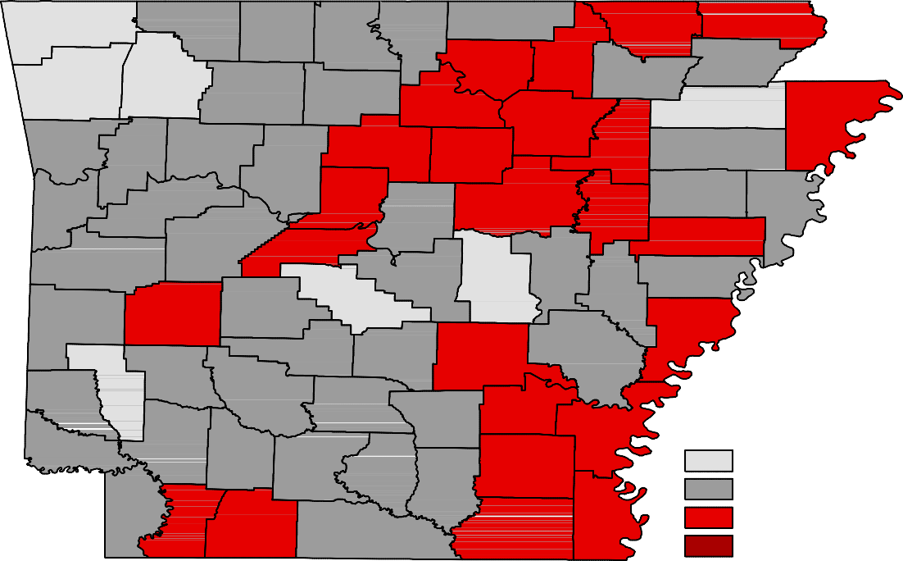Ranked by Unemployment Rates

Februar y 2016- Not Seasonally Adjusted

Rank  1 | County  Washington | Rate  3.1 | Rank  22 | County  Yell | Rate  4.9 | Rank  51 | County  Independence | Rate  6.1
2 | Benton | 3.4 | 27 | Baxter | 5.0 | 51 | Lincoln | 6.1
3 | Saline | 3.6 | 27 | Franklin | 5.0 | 51 | Perry | 6.1
4 | Madison | 3.7 | 27 | Little River | 5.0 | 54 | Columbia | 6.3
5 | Craighead | 3.9 | 30 | Fulton | 5.1 | 54 | Montgomery | 6.3
5 | Howard | 3.9 | 30 | Marion | 5.1 | 54 | Randolph | 6.3
5 | Lonoke | 3.9 | 30 | Poinsett | 5.1 | 54 | White | 6.3
8 | Arkansas | 4.1 | 30 | Pope | 5.1 | 58 | Jefferson | 6.4
8 | Pulaski | 4.1 | 30 | Searcy | 5.1 | 58 | Stone | 6.4
10 | Scott | 4.2 | 35 | Carroll | 5.2 | 60 | Drew | 6.5
11 | Nevada | 4.3 | 35 | Cleveland | 5.2 | 61 | Conway | 6.6
12 | Grant | 4.5 | 35 | Logan | 5.2 | 62 | Ashley | 6.8
12 | Miller | 4.5 | 38 | Crittenden | 5.3 | 63 | Izard | 6.9
12 | Sebastian | 4.5 | 38 | Lawrence | 5.3 | 63 | Lafayette | 6.9
15 | Boone | 4.6 | 38 | Pike | 5.3 | 63 | St. Francis | 6.9
15 | Hempstead | 4.6 | 41 | Calhoun | 5.6 | 63 | Sharp | 6.9
15 | Hot Spring | 4.6 | 41 | Cross | 5.6 | 67 | Clay | 7.1
18 | Clark | 4.7 | 41 | Johnson | 5.6 | 67 | Desha | 7.1
18 | Crawford | 4.7 | 41 | Polk | 5.6 | 69 | Woodruff | 7.2
18 | Faulkner | 4.7 | 45 | Monroe | 5.7 | 70 | Phillips | 7.4
18 | Prairie | 4.7 | 46 | Ouachita | 5.8 | 71 | Jackson | 7.5
22 | Bradley | 4.9 | 47 | Dallas | 5.9 | 71 | Van Buren | 7.5
22 | Garland | 4.9 | 47 | Sevier | 5.9 | 73 | Cleburne | 7.6
22 | Greene | 4.9 | 47 | Union | 5.9 | 74 | Mississippi | 7.7
22 | Newton | 4.9 | 50 | Lee | 6.0 | 75 | Chicot | 8.0

Civilian Labor Force Estimates

LWDA Labor Force Estimates (Not Seasonally Adjusted)

February 2016 January 2016 February 2015

LWDA CLF Emp Unemp
Rate
CLF Emp Unemp
Rate

CLF Emp Unemp

Rate

Central (minus LR) 249,537
239,059
10,478
4.2
245,093
235,204
9,889
4.0
241,983
228,903
13,080
5.4

City of Little Rock | 97,332 | 93,421 | 3,911 | 4.0 | 95,720 | 91,874 | 3,846 | 4.0 | 94,393 | 89,327 | 5,066 | 5.4
Eastern | 49,012 | 46,087 | 2,925 | 6.0 | 48,545 | 45,584 | 2,961 | 6.1 | 48,713 | 44,788 | 3,925 | 8.1
North Central | 96,870 | 90,481 | 6,389 | 6.6 | 95,643 | 89,245 | 6,398 | 6.7 | 95,548 | 88,002 | 7,546 | 7.9
Northeast | 120,373 | 114,208 | 6,165 | 5.1 | 119,194 | 112,993 | 6,201 | 5.2 | 117,872 | 109,667 | 8,205 | 7.0
Northwest | 309,509 | 298,347 | 11,162 | 3.6 | 301,368 | 290,552 | 10,816 | 3.6 | 293,562 | 279,439 | 14,123 | 4.8
Southeast | 85,144 | 80,042 | 5,102 | 6.0 | 83,830 | 78,724 | 5,106 | 6.1 | 84,213 | 77,596 | 6,617 | 7.9
Southwest | 95,885 | 90,805 | 5,080 | 5.3 | 94,648 | 89,661 | 4,987 | 5.3 | 94,139 | 87,826 | 6,313 | 6.7
West Central | 135,235 | 128,276 | 6,959 | 5.1 | 133,294 | 126,363 | 6,931 | 5.2 | 131,893 | 123,521 | 8,372 | 6.3
Western | 115,211 | 109,804 | 5,407 | 4.7 | 113,386 | 108,071 | 5,315 | 4.7 | 112,851 | 106,100 | 6,751 | 6.0

Benton

Washington
Carroll

Madison

Boone

Newton

Marion

Searcy

Baxter

Stone
Fulton

Izard

Sharp

Randolph

Lawrence
Clay

Greene

Craighead

Mississippi

Crawford

Franklin

Johnson

Pope

Van Buren

Cleburne
Independence

Jackson

Poinsett

Cross

Sebastian

Scott
Logan

Yell
Conway

Perry

Saline

Faulkner

Pulaski
White

Lonoke

Prairie
Woodruff

Monroe

St. Francis

Lee
Crittenden

Polk

Sevier
Montgomery

Pike
Howard
Garland

Hot Spring

Clark
Dallas

Grant

Jefferson

Lincoln
Cleveland

Arkansas

Desha

Phillips

Little River
Hempstead

Miller

Nevada

Ouachita

Calhoun

Bradley

Drew

Chicot

Lafayette
Columbia
Union
Ashley

Central (minus LR) Eastern
North Central
Northeast
Northwest
Southeast
Southwest
West Central
Western

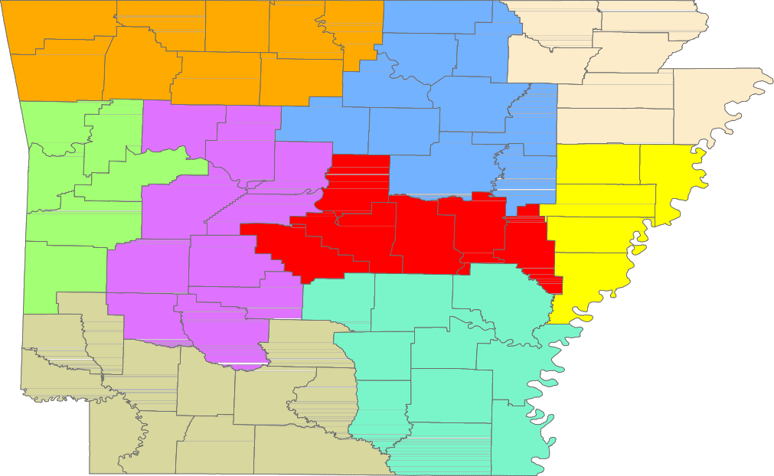

www.discover.arkansas.gov 18

